Medway Safeguarding Children Partnership (MSCP) Summer Edition: July 2025

# Welcome to the MSCP Bulletin - July 2025

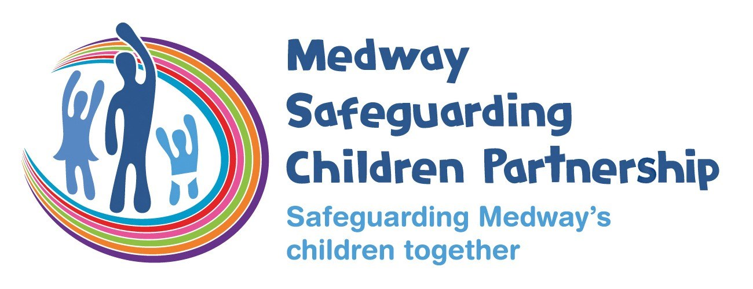

Welcome to an extra edition of the MSCP bulletin.  Ahead of the school summer holiday, this edition includes information you can share with children and families as well as some reminders.

# Who are MSCP and what is their role?

[Medway Council](https://www.medway.gov.uk/), [Kent Police](https://www.kent.police.uk/) and the [NHS Kent and Medway](https://www.kentandmedwayccg.nhs.uk/)are the three safeguarding partners that make up MSCP. We aim to support and enable local organisations and agencies to work together in a system where:-

* children are safeguarded and their welfare promoted
* partner organisations and agencies collaborate, share and co-own the vision for how to achieve improved outcomes for vulnerable children
* organisations and agencies challenge appropriately and hold one another to account effectively
* there is early identification and analysis of new safeguarding issues and emerging threats
* learning is promoted and embedded in a way that local services for children and families can become more reflective and implement changes to practice
* information is shared effectively to facilitate more accurate and timely decision-making for children and families.

# July Content:

* Activities & Support for Children & Families
* MSCP Priority - Contextual Safeguarding & Trauma Informed Practice:-
* Kent and Medway Child Exploitation Identification Tool
* Empowering Engagement - National Resources
* The WIZZ App - an update from Kent Police
* MSCP Priority - Effective Early Help:-
* Hidden Harm
* Time to refresh your safeguarding knowledge?
* MSCP Training Dates
* Contacts

# Activities and support for children and families.

Here are some online places where children and families can get information on activities, events, help and support:

Medway Family Hub App

Have you heard of the Medway Family Hub App?  It’s a free mobile phone app to provide support and advice for families across Medway.  The app brings together a wealth of resources and information into one place to make it easier for families living in Medway to access help, support, and advice.  The app allows residents to find out about local events and activities as well as allow families to connect with each and build their support networks so a great resource for the summer holiday. [For more information](https://www.medway.gov.uk/news/article/1678/new_app_to_support_medway_s_families).

Kent and Medway NHS Bump, Birth and Beyond

[The Kent and Medway Bump, Birth and Beyond](https://www.kentandmedwaylms.nhs.uk/) is a great website for new and expectant parents.  It includes the DadPad resource, a range of advice and guidance, contacts for Health Visitors and Midwives and details of local services.

Child Friendly Medway

Child Friendly Medway offer a variety of activities and events for children, young people and families in Medway.  Details can be found on the [website](https://www.medway.gov.uk/childfriendly) or follow them on, [Instagram](https://www.instagram.com/childfriendlymedway/) and [Facebook](https://www.facebook.com/ChildFriendlyMedway/).

Medway Youth Service

Medway Youth Service provide programmes and activities for young people ages 8 to 19 and up to 25 with additional needs.  Details of the summer activity holiday programme are below.

MedwayGo

[MedwayGo](https://go.medway.gov.uk/) is where families can book holiday activities for children from Reception to Yr 11.  Children who are currently receiving benefits-related free school

meals can attend free.

Medway Council

Medway Council have a dedicated summer space on their [website](https://www.medway.gov.uk/summer). It includes information on things to do, activities for children and staying well in summer.

Medway Foodbank

Operating all year round, the [website](https://medway.foodbank.org.uk/get-help/) includes information on how to get foodbank vouchers and what is in their food parcel.

Medway Youth Service - Summer Youth Programme 2025

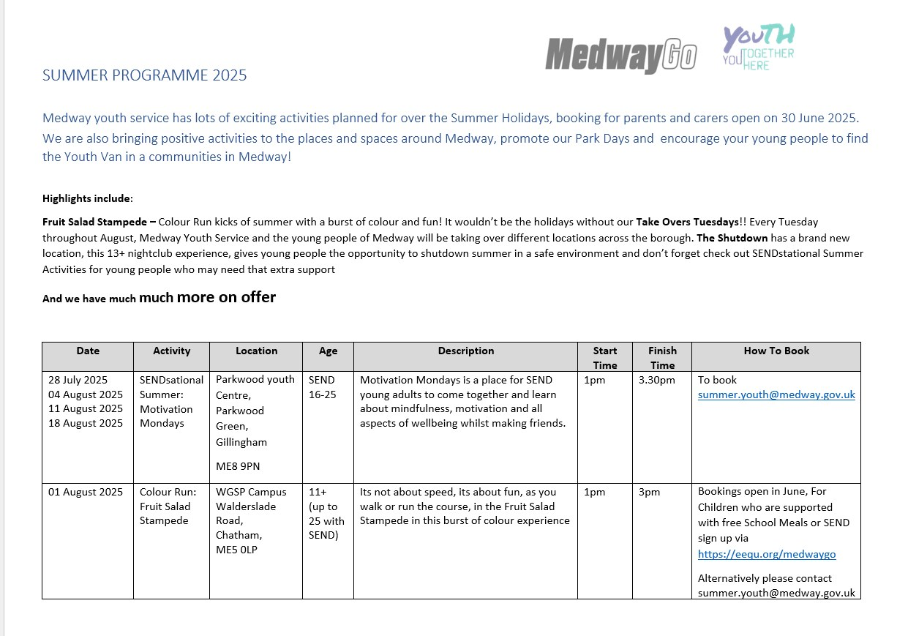

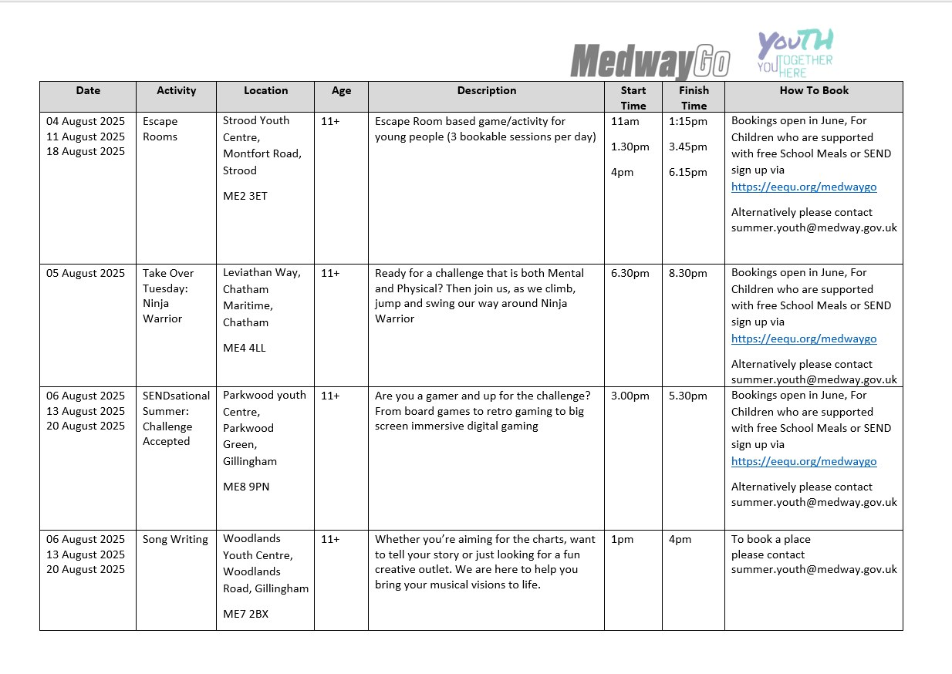

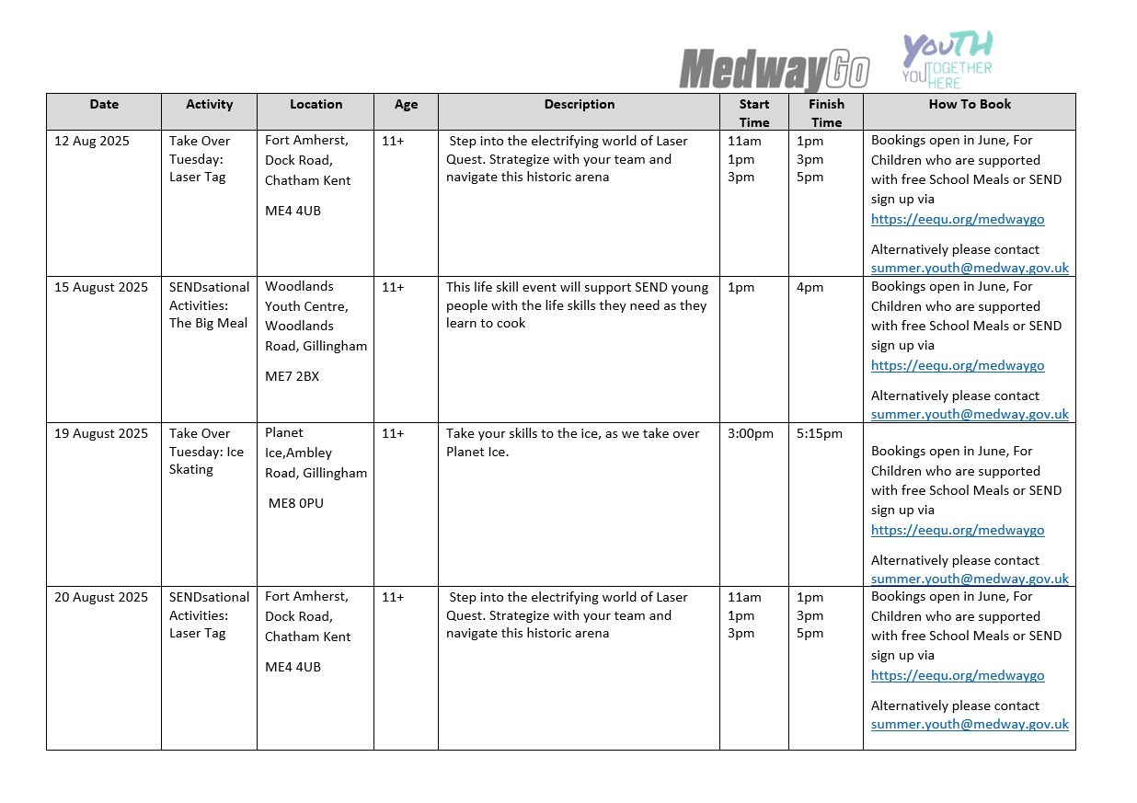

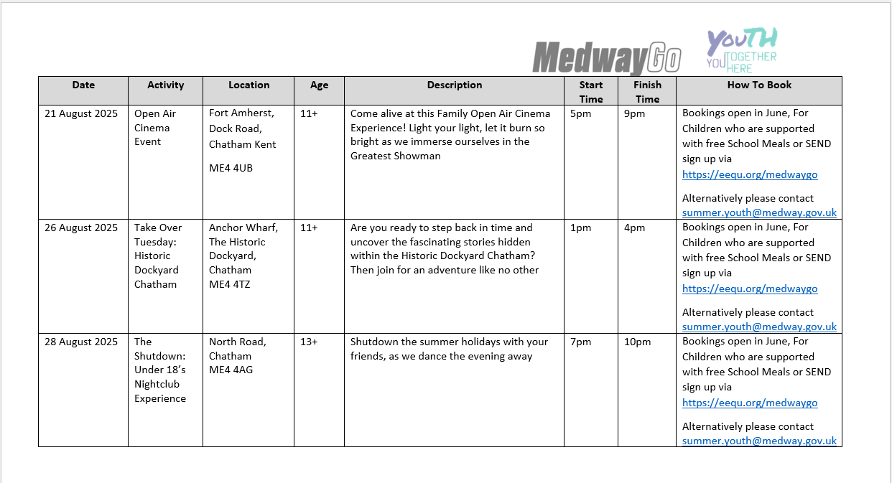

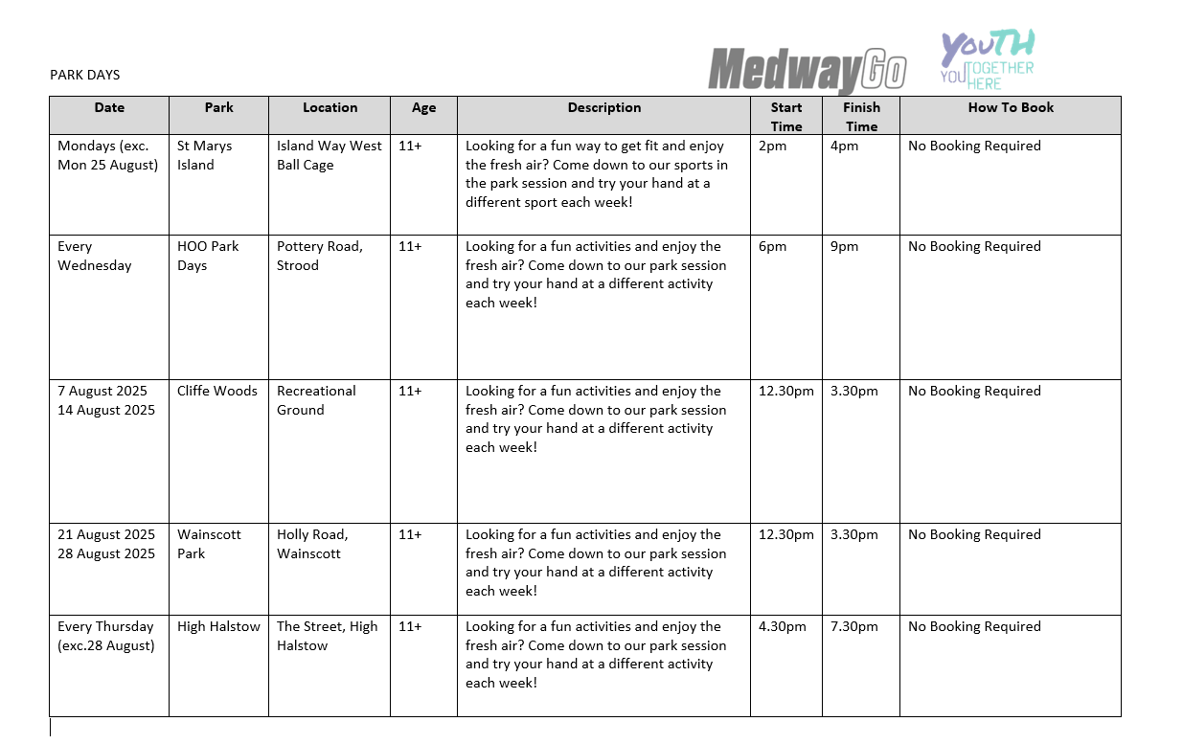

# MSCP Priority - Contextual Safeguarding and trauma informed practice

Kent and Medway Child Exploitation Identification Tool

Kent and Medway, along with partner agencies, have worked together to produce a [child exploitation identification tool](https://www.medwayscp.org.uk/download/downloads/id/674/kent-and-medway-child-exploitation-identification-tool.docx).  The tool is designed to assist practitioners in identifying whether a child may be experiencing, or be vulnerable to, exploitation.

Guidance on how to use the child exploitation identification tool can be found within the document on pages 3 to 5.

Empowering Engagement - National Resources

Is an evidence-based practice resource for professionals, developed from the evidence of the Verge of Harming Phase 2 research report. The resource is recommended when supporting young people aged 10-25 who are using harmful behaviours in their intimate or family relationships. The resource offers clear guidance, practical tools, and a trauma-informed approach to support young people throughout the beginning, middle and end phases of the intervention. It also includes essential information on risk management and safeguarding, as well as a new preparation phase designed for practitioners.

More information relating to who this resource is for, what it's designed to do and what's included can be found by visiting <https://safelives.org.uk/resources-library/verge-of-harming-resource/>

The WIZZ App - an update from Kent Police

You may have heard of the WIZZ app for iOS and android and is known as the ‘Tinder for Teens’

It is aimed at children aged 12 and over, enabling them to set up a profile and find friends and contacts based on their age and preferences.

It was recently reported that when a young person installed the app, they quickly had dozens of messages from males reporting to be around the age of 14 offering to travel from all over the country to meet in person.

A quick google search highlights a lot of exploitation concerns.

# MSCP Priority - Effective Early help

Hidden Harm

The Hidden Harm Service is up and running, working with young people in Medway who are affected by Parent / Carer Substance Use.

Whether the Young Person requires Substance Misuse Support for themselves or Hidden Harm Support. Any referrals should be sent to [YP-Medway@openroad.org.uk](mailto:YP-Medway@openroad.org.uk)

Time to refresh your safeguarding knowledge?

August can be a great time to catch up on those things that get pushed down the ‘to do’ list.  If you need to refresh your safeguarding knowledge, the MSCP has a range of e-Learning courses including safeguarding levels 1, 2 and 3 and topics such as trauma awareness and domestic abuse.  These courses are free and can be completed at your own pace.  If you are not already registered with MeLearning, [create an account](https://app.melearning.co.uk/auth/self-registration/FXJKSRNW) and you can access a range of e-Learning courses. If you have any queries regarding Me Learning or training, please email mscptraining@medway.gov.uk.

# MSCP Training Dates

The MSCP has a range of virtual and in person training coming up:

* Working with men and fathers, Monday 8th September 2025, 10:00am – 12:00pm, Microsoft Teams
* Signs of safety, Tuesday 16th September 2025, 9:30am – 12:00pm, Microsoft Teams
* Medway Local Authority Designated Officer (LADO) MSCP Training, Wednesday 17th September 2025, 13:00pm – 16:00pm Microsoft Teams
* Thresholds: Making referrals, understanding and applying thresholds in Medway, Monday 22nd September 2025, 9:30am – 11:30am, Microsoft Teams

If you are interested in any training, you can enrol by [logging into your Me Learning account](https://app.melearning.co.uk/auth/login) or you can create a Me Learning account.

[Create a Me Learning account if your organisation is based in both Kent and Medway.](https://app.melearning.co.uk/auth/validate-key?registerKey=KGJDCTSX)

[Create a Me Learning account if your organisation is based in only Medway.](https://app.melearning.co.uk/auth/validate-key?registerKey=WKCTHRBF)

If you have any queries regarding Me Learning or training please email [mscptraining@medway.gov.uk](mailto:mscptraining@medway.gov.uk).

Contacts

For general enquires email [mscp@medway.gov.uk](mailto:mscp@medway.gov.uk)

For training enquires email [mscptraining@medway.gov.uk](mailto:mscptraining@medway.gov.uk)

Social Media

[X](https://twitter.com/MedwaySCP)

[Linkedin](https://uk.linkedin.com/company/medway-safeguarding-children-partnership-mscp)

[YouTube](https://www.youtube.com/@medwaysafeguardingchildren7786)