Medway Safeguarding Children Partnership (MSCP) May 2025

# Welcome to the MSCP Bulletin - May 2025

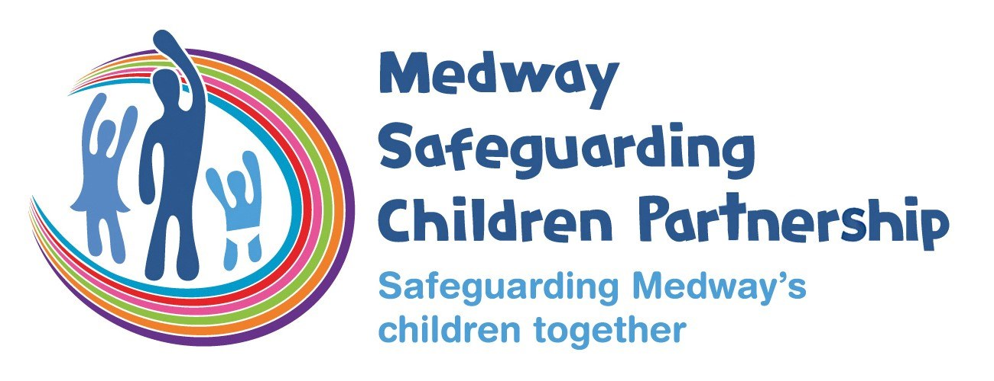

# Who are MSCP and what is their role?

[Medway Council](https://www.medway.gov.uk/), [Kent Police](https://www.kent.police.uk/) and the [NHS Kent and Medway](https://www.kentandmedwayccg.nhs.uk/)are the three safeguarding partners that make up MSCP. We aim to support and enable local organisations and agencies to work together in a system where:-

* children are safeguarded and their welfare promoted
* partner organisations and agencies collaborate, share and co-own the vision for how to achieve improved outcomes for vulnerable children
* organisations and agencies challenge appropriately and hold one another to account effectively
* there is early identification and analysis of new safeguarding issues and emerging threats
* learning is promoted and embedded in a way that local services for children and families can become more reflective and implement changes to practice
* information is shared effectively to facilitate more accurate and timely decision-making for children and families.

# May Content:

* Factsheet Spotlight: Professional Curiosity
* Local Child Safeguarding Practice Review (LCSPR): Video Explainer
* The Children's Society: #LookCloser Programme
* Understanding Emojis...for Parents & Carers
* Kent & Medway Prevent - Incel Updates
* MSCP Child Safety Week
* Giving Children the Best Start in Life
* Early Help & Prevention Strategy
* Responding to Child Sexual Abuse
* Family Community Work Coaches
* New Practice Guidance: Kent & Medway Perplexing Presentation, Fabricated & Induced Illness
* Product Safety Alert: Water Beads
* Medway Domestic Abuse Assessment Reflection Aid
* Graded Care Profile 2 (GCP2)
* MSCP Training Dates

# Factsheet Spotlight

The MSCP produce [fact sheets](https://www.medwayscp.org.uk/info/4/professionals/157/mscp-fact-sheets) where there is learning from local or national child safeguarding reviews or developing areas of practice. The factsheets are reviewed and agreed by the Learning Lessons sub-group.

The spotlight for the May bulletin is [professional curiosity](https://www.medwayscp.org.uk/info/6/training-professionals/170/professional-curiosity)

The importance of professional curiosity has been identified as a point of learning across Medway multi-agency audits as well as in local and national local child safeguarding practice reviews. The term professional curiosity is often interchanged with "respectful uncertainty", "professional courage", "professional/healthy scepticism", "thinking the unthinkable", "finding the why" and "questioning minds". Professional curiosity is an essential skill for professionals working with families to support keeping children, and their families, safe.

# MSCP Priority - Effective Partnerships

# LCSPR Laura – Video Explainer

In the March 2025 bulletin, we updated that the MSCP had published the local child safeguarding practice review (LCSPR) Laura.  You will now find a video explainer on the [MSCP YouTube channel](https://www.youtube.com/watch?v=WzLjW9IPa_4) which sets out what a LCSPR is, the background to this review, the review findings, good practice and recommendations.  The recommendations relate to several areas of practice relevant to different roles, therefore, it is important that all those working with children in Medway make time to watch the video explainer.

# MSCP Priority - Contextual Safeguarding and trauma informed practice

# The Children's Society & #LookCloser Programme

The Children’s Society have a #LookCloser Programme of Learning events taking place up until September 2025, all of which are free of charge.    #LookCloser is a partnership campaign between The Children’s Society, the National County Lines Co-ordination Centre and the British Transport Police aiming to raise awareness of child exploitation and abuse and to encourage the public and businesses to better identify and report concerns. The campaign also seeks to challenge assumptions and victim stereotypes, highlighting that child exploitation can happen anywhere, and any young person can be a victim.

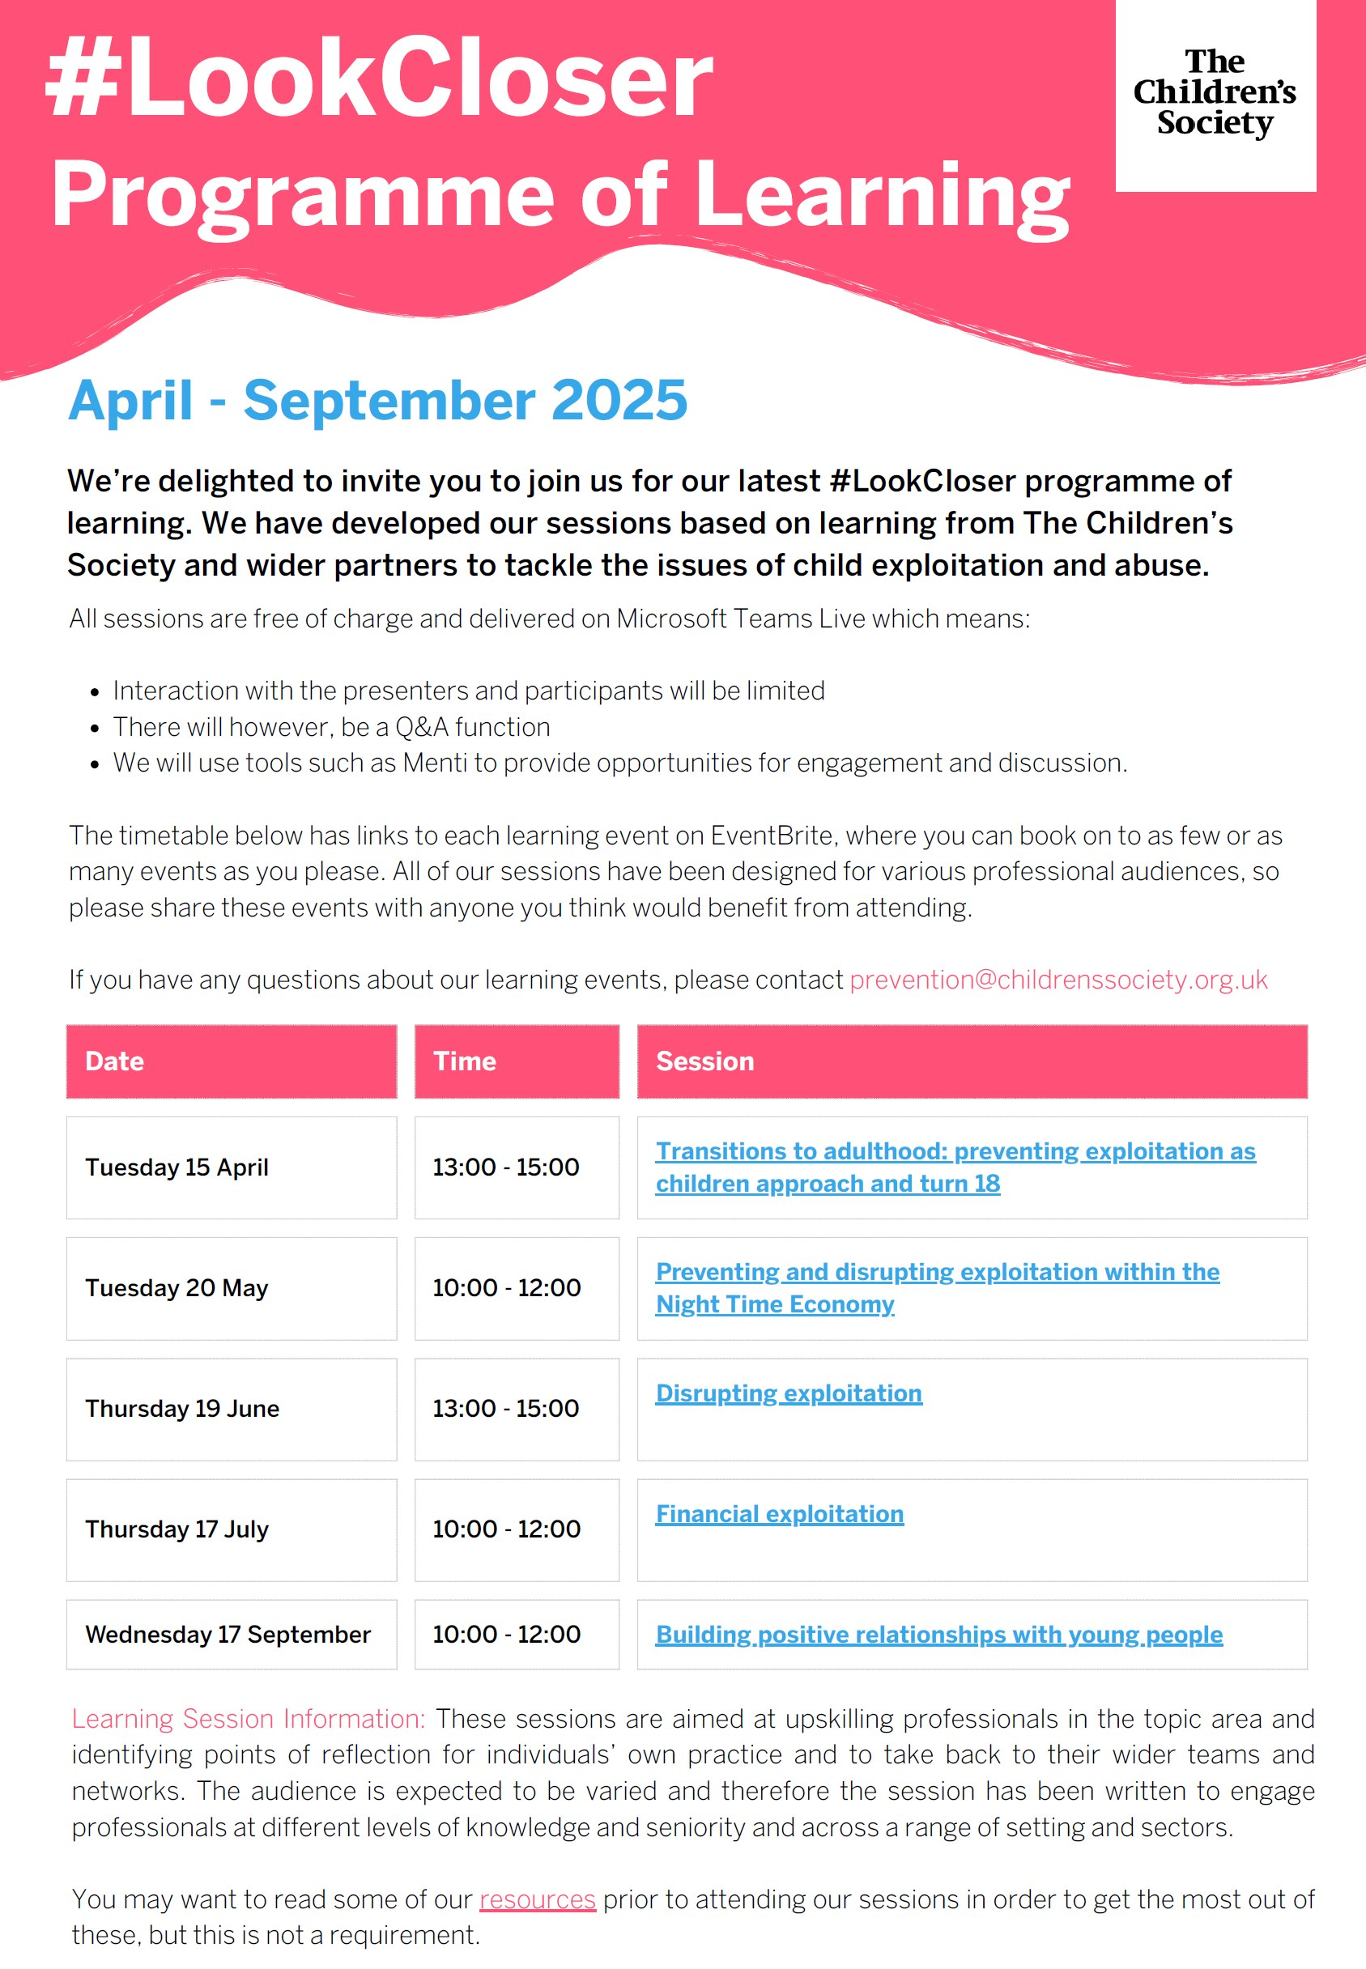

# Understanding Emojis....for parents/carers



The series Adolescence has certainly got us and social media talking about several issues relating to contextual safeguarding and beyond.  The role of the internet and digital technology has been one of the areas of discussion for practitioners and parents/carers.

Keeping up to date with children in the digital and online space is a challenge for us adults, but there are resources out there to support.  The organisation Working Parents has produced an [Understanding Emojis guide for parents/carers](https://forworkingparents.com/).  Please share with your networks and the parents/carers you are supporting. A copy of the periodic table in relation to emoji meanings and codes is also available to download.

# Kent & Medway Prevent



Incel Updates

Available training and useful resources include:-

* [Men Who Hate Women](https://www.waterstones.com/book/men-who-hate-women/laura-bates/9781398504653) - a book by Laura Bates
* [Incels: A Guide to Symbols and Terminology](https://ccwestt-ccfsimt.org/incels-a-guide-to-symbols-and-terminology/) used within the incel community
* [Inside the Secret World of Incels](https://www.bbc.co.uk/programmes/p07fvhmw) - a BBC documentary
* [Incels: a first scan of the phenomenon (in the EU) and its Relevance and Challenges for P/CVE, Oct 21](https://home-affairs.ec.europa.eu/whats-new/publications/incels-first-scan-phenomenon-eu-and-its-relevance-and-challenges-pcve-october-2021_en) - A report by the European Commission
* [The Dangerous Rise of Andrew Tate](https://www.bbc.co.uk/iplayer/episodes/m001q1nf/andrew-tate) - available on BBC iPlayer. Investigating the controversial figure and his influence on young men
* [Hope Not Hate Report on Andrew Tate](https://hopenothate.org.uk/2024/07/24/plugged-in-tate-religion/)
* [Incels: A new terror threat to the UK](https://www.bbc.co.uk/news/uk-58207064) - BBC News report
* [A short introduction to the involuntary celibate sub-culture](https://crestresearch.ac.uk/resources/a-short-introduction-to-the-involuntary-celibate-sub-culture/) - An overview by Crest University
* [ISD Algorithms Report](https://www.isdglobal.org/isd-publications/algorithm-inspection-and-regulatory-access/) - examining how algorithms on social media platforms can promote extremist content
* [Sexism Study in Schools](https://neu.org.uk/latest/library/its-just-everywhere)
* [The incelosphere](https://counterhate.com/research/incelosphere/) - Exposing pathways into incel communities and the harms they pose to women and children
* [Incels: ISD Report](https://www.isdglobal.org/wp-content/uploads/2022/10/Incels-External-Sept-2022.pdf)
* [Overview of incel and misogynist violent extremism in the U.S](https://ciac.colorado.gov/files/D2DF00000/066.pdf)
* [Incels: A short guide for those teaching Year 10 and above](https://www.educateagainsthate.com/wp-content/uploads/2024/11/Incels-A-guide-for-those-teaching-Year-10-and-above-1-1.pdf) - What is the incel sub-culture and signs to look out for in a young person
* [Not Just a Joke](https://perilresearch.com/wp-content/uploads/2024/12/121024_IP_PERIL-Preventing-Gender-and-Sexuality-Based-Bigotry-Report-final.pdf) - Understanding and preventing gender and sexuality based bigotry
* [Misogynistic algorithms as a weapon against women](https://www.isdglobal.org/isd-publications/algorithms-as-a-weapon-against-women-how-youtube-lures-boys-and-young-men-into-the-manosphere/) includes research that documents how algorithms contribute to the promotion of misogynistic, anti-feminist and other extremist content to young boys and men

Prevent & Serious Organised Crime Awareness Week - October 2025

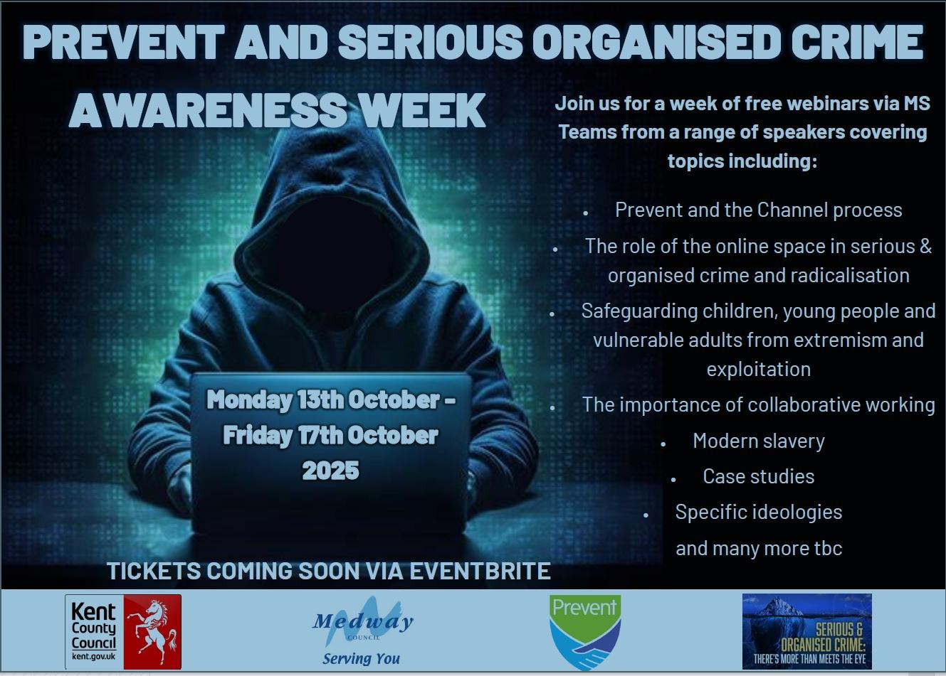

2025 Kent & Medway Prevent Training Offer

All sessions can be tailored to suit agency's or service needs and sessions can be combined. [To book training](https://prevent@kent.gov.uk), contact Jess Harman, Prevent & Channel Manager or Nadine Pernaul, Prevent Community Engagement Officer.

* Prevent Awareness & Radicalisation
* Extremist Ideology - Overview
* Extremist Ideology - Extreme Right-Wing (ERW) Ideology
* Understanding Antisemitism
* Channel Panel Understanding
* Understanding Islamist Extremism
* Channel Panel Induction
* Extremist Ideology - Emerging & Other Extremist Ideologies
* Understanding Left-Wing & Single Anarchist Terrorism (LASIT)
* Extremist Identities Online & Online Spaces
* InCels: Online Subculture of Misogyny
* Prevent Venue Hire - Guidance for Partners
* Prevent Stickers & Graffiti Awareness for Partners
* Domestic Abuse & Extremism

# MSCP Priority - Effective Early help

# Child Safety Week - Monday 2nd to Thursday 5th June 2025 (One Hour Webinars)

The MSCP is hosting a range of one hour webinars to mark Child Safety Week.  Learn from a range of professionals across the partnership including:

* Monday 2nd June: 12pm to 1pm - Where does baby sleep?
* Tuesday 3rd June: 12pm to 1pm - Home safety and child health with babies and early years
* Wednesday 4th June: 10am to 11am - The impact of domestic abuse and parental vulnerabilities on the early years
* Thursday 5th June: 10am to 11am - Exploring vulnerabilities in pregnancy and pre-birth procedures

The sessions will draw on learning from Medway child safeguarding practice reviews and good practice.

These webinars are for all those working with Medway children and their families whether you home visit or come into contact with them in the community.

Register your place using the [sign up form](https://forms.office.com/Pages/ResponsePage.aspx?id=kz5QaOc8Ikq_xf_uQhofV7JLwJ0JMeNPj-5sV3VYAo5UQTVFVDcxTjBZRFlaQlU1QUQ5UEVZMTRIUS4u). Alternatively, pleaseemail [MSCP Training](https://mscptraining@medway.gov.uk)

# Giving Children the Best Start in Life - A Course for Professionals

This course is for any professionals that work with Medway families. [The Giving Children the Best Start in Life is a one-day free training](https://healthtraining.medway.gov.uk/training-courses/8d61c860-69da-11ef-97ed-4957201ccf40/giving-children-the-best-start-in-life-1) course and is designed to equip you with the knowledge and skills to support healthy pregnancies, child development, positive parenting, and overall family well-being.

💡 What You’ll Learn: • Importance of giving children the best start in life • Introduction to Family Hubs & Start for Life • Key health messaging on infant feeding, mental health, child development, and more • Resources and signposting information for additional support • Effective communication techniques, including motivational interviewing and active listening

# Early Help & Prevention Strategy

Early Help and Prevention Strategy

The MSCP Early Help Partnership Board are pleased to introduce the [Medway Early Help and Prevention strategy 2025 – 2027](https://www.medwayscp.org.uk/info/4/professionals/21/early-help). The strategy is for all agencies and practitioners in Medway to ensure children and families get the right help at the right time.  It represents the joint commitment to ensure that partners work in the most effective, co-ordinated way as early as possible when children and families need support and help. The Early Help and Prevention strategy brings together the collective vision for early help and prevention in Medway where families are empowered as equal partners, taking a strengths-based approach that is open and honest.  It also sets out our principles that underpin the drive for Medway to be a place where children are safe from harm in their homes, families and communities.

# Responding to Child Sexual Abuse

Responding to Child Sexual Abuse

Recent case review learning in Medway has identified the need to consider how we are responding to children who have been sexually abused and continue to support the child and their family.

Victims and survivors of intra-familial child sexual abuse can, and do, recover from their abuse, especially when supported by professionals who are trained to best support them and their families.

[The Centre of expertise on child sexual abuse](https://www.csacentre.org.uk/) has fantastic tools for communicating with children, supporting parents and carers, working with sibling sexual abuse and behaviour, managing risk and trauma after online sexual offending and many more.

You can also find the [Child Sexual Abuse Response Pathway](https://www.csacentre.org.uk/child-sexual-abuse-response-pathway/) a step by step resource centred on children’s needs , how they are feeling and what they hope will happen.

The Response Pathway sets out how to respond to concerns of child sexual abuse at key points: from first concerns and early help safeguarding through to child protection and criminal justice responses. Throughout, it focuses on meeting the needs of children and their families.

You can also sign up for a [free one hour webinar](https://www.csacentre.org.uk/events/) to look at putting the child sexual abuse response pathway into practice.

There’s also a free 90-minute eLearning course for all professionals [Identifying and responding to intra-familial child sexual abuse](https://www.csacentre.org.uk/training-events/elearning/)

# Family Community Work Coaches (previously known as the Supporting Families Employment Advisers SFEAs)

Clare Osborne, one of the dedicated Family Community Work Coaches is delivering overview sessions, explaining who they are and how they can support the families you are working with, alongside the work you are doing.

The next date is 9 July 2025 @15:30 via Teams. [Join the meeting](https://teams.microsoft.com/l/meetup-join/19%3ameeting_Y2FiMTM2OTAtZmY4Zi00MzM3LTg0ZjAtNTA1OGRhOTY3ODVi%40thread.v2/0?context=%7b%22Tid%22%3a%2296f1f6e9-1057-4117-ac28-80cdfe86f8c3%22%2c%22Oid%22%3a%2212f37cc6-e304-4eb0-bdac-cd2d2f3d3961%22%7d)

Meeting ID: 330 013 425 174

Passcode: Cz2jm7Jt

# New Practice Guidance: Kent & Medway Perplexing Presentations (PP) / Fabricated & Induced Illness (FII) in Children

New Practice Guidance: Kent and Medway Perplexing Presentations / Fabricated and Induced Illness in Children

Following on from the publication of the Kent and Medway Perplexing Presentations / Fabricated and induced Illness in Children [practice guidance](https://view.officeapps.live.com/op/view.aspx?src=https%3A%2F%2Ftrixcms.trixonline.co.uk%2Fapi%2Fassets%2Fkentandmedway%2F30d54975-fa40-46dd-a744-f78f5fcedabb%2Ffinal-kent-and-medway-safeguarding-practice-guidance-pp-and-fii-in-children-.docx&wdOrigin=BROWSELINK) we have recorded one of the multi-agency launch sessions to help support professionals to implement the guidance.

The session, available on the [MSCP YouTube channel](https://www.youtube.com/@medwaysafeguardingchildren7786), looks at what is meant by Perplexing Presentations and our local response, including building chronologies and moving on to Health and Education rehabilitation Plans (HERPs). It also gives useful examples of Perplexing Presentations and the alerting signs to help you in your practice. We also look at what is meant by Fabricated and Induced Illness and the local response in line with our safeguarding procedures.

# Water Beads - Product Safety Alert

Have you seen the product safety alert relating to water beads?  Water beads are small plastic balls that expand on contact with liquid and can become up to 400 times bigger. They are sold for various purposes, including toys. If swallowed, water beads can cause a blockage in the gastrointestinal tract that requires surgical removal but because they will not show up on X-ray, it makes them difficult to detect. If accidently inhaled, they can lead to coughing and choking. Please take 5 minutes to read the [product safety alert from the government](https://www.gov.uk/product-safety-alerts-reports-recalls/product-safety-alert-water-beads-psa7)  and share with the parents/carers you are working with.

Key Safety Messages:

• Water beads should be kept away from young children, under 5 years of age.

• They should only be used by older children under close supervision of an adult.

• If you possess water beads, always store them out of sight and reach of children.

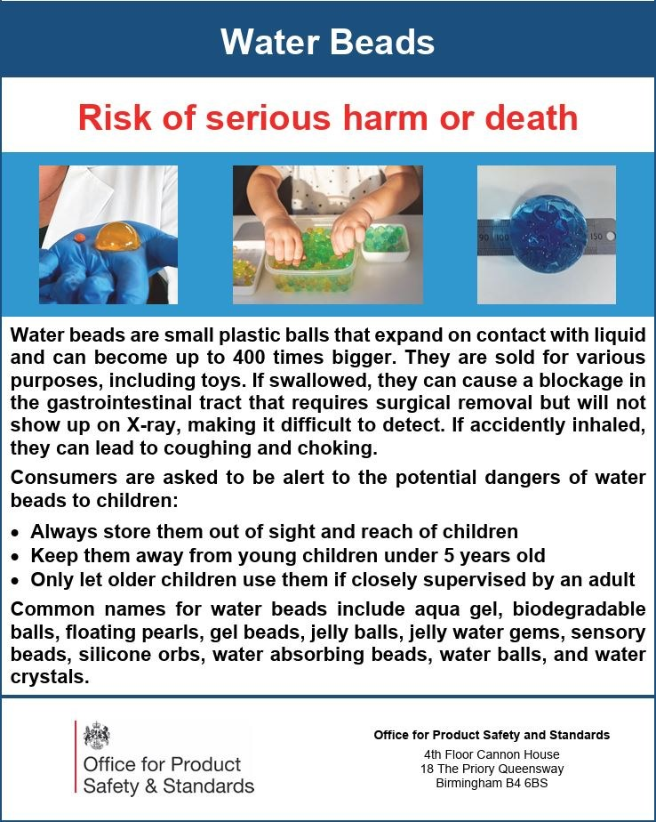

# MSCP Priority - Domestic Abuse

# Medway Domestic Abuse Assessment Reflection Aid

Medway Domestic Abuse Assessment Reflection Aid for working with children and families

In collaboration with the Medway Domestic Abuse Forum, we would like to introduce you to the new [Medway Domestic Abuse Assessment Reflection Aid](https://www.medwayscp.org.uk/downloads/file/667/final-medway-domestic-abuse-assessment-reflection-aid-for-children-and-families-v4-march-2025) for working with children and families.

The aim of this assessment reflection aid is to support professionals in their approach and assessments where domestic abuse has been identified, to promote professionals’ curiosity and it is also a helpful aid for reflective practice to support supervision practices.

The aid identifies potential protective factors that may have been identified in homes where there is, or has been, domestic abuse. It also identifies risk factors, considerations and professional prompts to be reflected on for children, victims/parents and perpetrators where identified protective factors are being relied on.

The aid will support thinking about risks and needs of victims (including children) and perpetrators as individuals, intervention and prevention strategies and other influences on risk.

This aid has been developed for professionals working in Medway, hyperlinks throughout the document will take you to localised guidance/information and toolkits.

# MSCP Priority - Neglect

Graded Care Profile 2 (GCP2)

At the beginning of the year, we shared an update from Medway Children’s Services that a GCP2 should accompany contacts into the Medway First Response Single Point of Access (SPA) where neglect is a concern.

As a reminder, the GCP2 has been developed by the NSPCC, and here in Medway is the agreed partnership tool used by practitioners where neglect is suspected or known.  As a licensed tool, practitioners must complete a [1-day training course](https://www.medwayscp.org.uk/info/6/training/42/graded-care-profile-training) that the MSCP offer.   Your agency might also offer this training, so ask your line manager and/or designated safeguarding lead.

Following feedback and interest in the GCP2 we’ve produced a video explainer to help managers and leaders decide which roles are best placed to undertake the training and support staff already trained.  You can find the GCP2 video explainer on the [MSCP YouTube channel](https://www.youtube.com/@medwaysafeguardingchildren7786) and more information on neglect and GCP2 on the [MSCP website](https://www.medwayscp.org.uk/info/4/advice-resources-professionals/26/neglect).

# Training Dates

The MSCP has a range of virtual and in person training coming up:

* Where does baby sleep webinar, Monday 2nd June 2025, 12:00 pm – 13:00 pm, Microsoft Teams
* Intermediate safeguarding children training, Tuesday 3rd June 2025, 9:30 am – 16:00 pm, In-person
* Home safety and early years webinar, Tuesday 3rd June 2025, 12:00 pm – 13:00 pm, Microsoft Teams
* The impact of domestic abuse and parental vulnerabilities on babies and children webinar, Wednesday 4th June 2025, 10:00 am – 11:00 am, Microsoft Teams
* Pregnancy and pre-birth concerns webinar, Thursday 5th June 2025, 10:00 am – 11:00 am, Microsoft Teams
* Domestic abuse and safeguarding children training, Thursday 12th June 2025, 9:30 am – 16:00 pm, In-person
* Graded Care Profile 2 (GCP2), Tuesday 17th June 2025, 9:30 am – 16:00 pm, In-person
* Graded Care Profile 2 Refresher (GCP2), Wednesday 18th June 2025, 9:30 am – 12:30 pm, Microsoft Teams
* Graded Care Profile 2 (GCP2), Tuesday 15th July 2025, 9:30 am – 16:00 pm, In-person
* Graded Care Profile 2 Refresher (GCP2), Wednesday 16th July 2025, 9:30 am – 12:30 pm, Microsoft Teams
* Medway Local Authority Designated Officer (LADO) MSCP Training, Wednesday 16th July 2025, 10:00 am – 13:00 pm, Microsoft Teams
* Working with men and fathers, Monday 8th September 2025, 10:00am – 12:00pm, Microsoft Teams
* Signs of safety, Tuesday 16th September 2025, 9:30am – 12:00pm, Microsoft Teams
* Medway Local Authority Designated Officer (LADO) MSCP Training, Wednesday 17th September 2025, 13:00pm – 16:00pm Microsoft Teams
* Thresholds: Making referrals, understanding and applying thresholds in Medway, Monday 22nd September 2025, 9:30am – 11:30am, Microsoft Teams

If you are interested in any training, you can enrol by [logging into your Me Learning account](https://app.melearning.co.uk/auth/login) or you can create a Me Learning account.

[Create a Me Learning account if your organisation is based in both Kent and Medway.](https://app.melearning.co.uk/auth/validate-key?registerKey=KGJDCTSX)

[Create a Me Learning account if your organisation is based in only Medway.](https://app.melearning.co.uk/auth/validate-key?registerKey=WKCTHRBF)

If you have any queries regarding Me Learning or training please email [mscptraining@medway.gov.uk](mailto:mscptraining@medway.gov.uk).

Contacts

For general enquires email [mscp@medway.gov.uk](mailto:mscp@medway.gov.uk)

For training enquires email [mscptraining@medway.gov.uk](mailto:mscptraining@medway.gov.uk)

Social Media

[X](https://twitter.com/MedwaySCP)

[Linkedin](https://uk.linkedin.com/company/medway-safeguarding-children-partnership-mscp)

[YouTube](https://www.youtube.com/@medwaysafeguardingchildren7786)