Medway Safeguarding Children Partnership (MSCP) March 2025

# Welcome to the MSCP Bulletin - March 2025

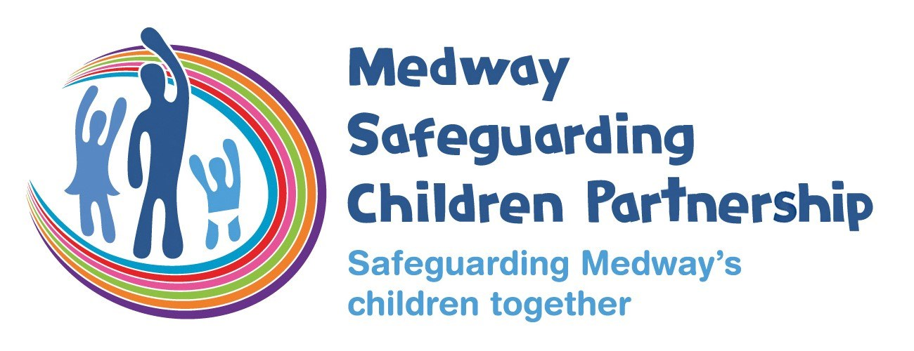

# Who are MSCP and what is their role?

[Medway Council](https://www.medway.gov.uk/), [Kent Police](https://www.kent.police.uk/) and the [NHS Kent and Medway](https://www.kentandmedwayccg.nhs.uk/)are the three safeguarding partners that make up MSCP. We aim to support and enable local organisations and agencies to work together in a system where:-

* children are safeguarded and their welfare promoted
* partner organisations and agencies collaborate, share and co-own the vision for how to achieve improved outcomes for vulnerable children
* organisations and agencies challenge appropriately and hold one another to account effectively
* there is early identification and analysis of new safeguarding issues and emerging threats
* learning is promoted and embedded in a way that local services for children and families can become more reflective and implement changes to practice
* information is shared effectively to facilitate more accurate and timely decision-making for children and families.

# March Content:

* Factsheet spotlight
* Medway Local Child Safeguarding Practice Review (LCSPR) Laura
* Capturing the Voice of the Child
* Do you attend Child Protection Conferences? Do you know Signs of Safety?
* Resolving Professional Differences: Escalation Policy and Partnership Practice Alerts
* Children Missing Education and Elective Home Education Virtual training
* Disclosure and Barring Service training programme for the Southeast (April 2025)
* Understanding and Responding to Child Sexual Abuse and Exploitation CPD - Wednesday 7th May 2025
* Kent Adult Safeguarding Concern - Online Referral Form
* The Children’s Society Prevention Programme’s first youth voice report
* Cyber Choices
* The Lullaby Trust - Safer Sleeping Week
* Early Help Lead Practitioners
* Giving Children the Best Start in Life Course
* Training Dates

# Factsheet Spotlight

The MSCP produce [factsheets](https://www.medwayscp.org.uk/info/4/professionals/157/mscp-fact-sheets) where there is learning from local or national child safeguarding reviews or developing areas of practice. The factsheets are reviewed and agreed by the Learning Lessons sub-group.

The spotlight for the March bulletin is [Home visits and dogs.](https://www.medwayscp.org.uk/info/4/professionals/163/dangerous-dogs)

Dogs and children can be great friends and having a dog can help children develop kindness, understanding and respect for living things. There can also be times when we can be worried about how safe a dog might be with children.   The factsheet includes prompts around the dog and the family context, considerations for home visits and what to do if there are concerns.

# MSCP Priority - Effective Partnerships

# Medway Local Child Safeguarding Practice Review (LCSPR) Laura

Safeguarding Children Partnerships undertake a Local Child Safeguarding Practice Review when a child dies or is seriously harmed, and it is considered that there is potential to identify improvements to practice. The purpose of such reviews is for agencies and individuals to learn lessons to improve the way in which they work both individually and collectively to safeguard and promote the welfare of children.

In February 2025 the MSCP published the LCSPR report for Laura.  The LCSPR was undertaken following the death of 20 day old Laura.  In 2023 Laura, her mother and two older siblings having been away with relatives at a caravan park returned home late, and all slept in the same bed.  The following morning, mother woke to find Laura unresponsive, she could not be revived.

The review gives an overview of the family background, identified good practice and lessons arising from the review for both individual agencies and the safeguarding children partnership.

 It is important that we all take the time to read, reflect and discuss the learning identified in the LCSPR within our teams and agencies

* [Laura Overview Report](https://www.medwayscp.org.uk/downloads/file/665/medway-lcspr-laura---final-2025)
* [Laura Briefing Sheet](https://www.medwayscp.org.uk/downloads/file/666/medway-lcspr-laura---briefing)

# Capturing the Voice of the Child

Some of you may be aware of what is referred to as the Section 11 safeguarding audit.  It’s a biannual audit of agencies safeguarding arrangements from leadership through to safe recruitment.

The audit includes a section on the voice of the children and agencies are asked to share how they gather and ‘hear’ children’s thoughts and views.

Here are some of the examples shared by a range of agencies from hospitals through to housing services.  Thank you to all the Section 11 Champions for your work this year.

The [Three Houses](https://www.mefirst.org.uk/resource/me-first-three-houses-tool/) is a tool that many agencies mentioned they used with children or young persons to assist them in identifying things in their life they feel positive about, worried about and what their hopes and goals are.

Hospital wards using 'Pants and Tops' a washing line or paper clothes that invites children to say or draw what they liked and didn't like about their hospital stay.

[Child-friendly Medway](https://www.medway.gov.uk/childfriendly) is dedicated to giving young people a voice, providing the best start in life and encouraging them to shape Medway's future. Running a range of programmes, events and activities, consulting and surveying young people. A short video here shows how '[Medway Council - Putting children first'.](https://www.youtube.com/watch?v=NvL2uvXxhiQ)

[Cafcass launched a telephone service for children and young people to share feedback or make a complaint](https://www.cafcass.gov.uk/children-and-young-people/get-touch-give-feedback-or-complain/i-want-give-feedback-or-make-complaint) 'Hear to Listen'. They provide a simple factsheet assuring children that they reply in one working day to acknowledge the concern and again in 10 working days.

# Do you attend Child Protection Conferences? Do you know Signs of Safety?

‘Signs of Safety’ is Medway’s practice framework to help in our work with children and families. It is a strengths-based approach to working children and families where the emphasis is on helping families rather than ‘intervening’.  The focus is shifted from a way of working where professionals are considered to be the experts to a constructive, relationship-based model of helping parents to change. There is an emphasis on the strengths in the child’s network, whilst the child’s safety is always the focus of any help provided.

If you attend initial and/or Review Child Protection Conferences is important that you understand scaling within the Signs of Safety framework.  This will form part of the meeting and you’ll be asked to give a view.  Sherry Copping, Service Manager for the Child Protection Conference Chairs says “scaling is key to helping everyone at conference, families and the professional network, understand each other’s level of concern, in a clear concise accessible way.  It provides an equal opportunity for all views and viewpoints to be explored discussed and considered.  I support that all attendees scale, it is an essential component of an effective conference”

You can find a bitesize video on scaling on the MSCP YouTube channel.

* [Signs of Safety Mapping](https://youtu.be/VP4B_NgoKig?si=crJJpaDd0rqtJ_5o)
* [Signs of Safety Scaling](https://youtu.be/GPtwpKLsuVA?si=HFTrqy9tggZwZ4LS)
* [Signs of Safety Strengths questions](https://youtu.be/2MuoCE8KvPs?si=xoEtJpxOcDStlRSi)

# Resolving Professional Differences: Escalation Policy and Partnership Practice Alerts

The MSCP Learning Lessons group has recently reviewed and updated the [Escalation policy.](https://www.medwayscp.org.uk/downloads/download/19/mscps-policies-and-procedures)

Effective working together depends on an open approach and honest relationships between agencies. All professionals have a duty to act assertively and proactively to ensure that a child’s welfare is the paramount consideration in all professional activity.

All professionals must be able to respectfully challenge the practice of other professionals where they are concerned that this practice is placing children at risk of harm.

This policy sets out clear routes to escalate professional concerns where the actions, inactions or decisions of another agency may be getting in the way of keeping a child safe.

Where there is multi agency learning or practice to be addressed across the partnership that is not related to an individual case, the Partnership Practice Alert can be utilised.

# Children Missing Education and Elective Home Education Virtual training

This workshop will focus on the meaning of Children Missing Education (CME and Elective Home Education (EHE), Local Authority statutory responsibility,  the risk factors, agencies working together and how to report concerns to Medway Local Authority.

The session will last around 60 minutes with time for questions at the end. This session is aimed at individuals whose roles encompass children and have concerns regarding a child’s education that are not on a school roll.

Dates/Times:

Friday 4 April 2025 10 - 11am via Teams

Wednesday 7 May 2025 10 – 11am via Teams

If you are interested, you can enrol by [logging into your Me Learning account](https://app.melearning.co.uk/auth/login) or you can create a Me Learning account instead.

[Create a Me Learning account if your organisation is based in both Kent and Medway.](https://app.melearning.co.uk/auth/validate-key?registerKey=KGJDCTSX)

[Create a Me Learning account if your organisation is based in only Medway.](https://app.melearning.co.uk/auth/validate-key?registerKey=WKCTHRBF)

# Disclosure and Barring Service training programme for the Southeast

The Disclosure and Barring Service (DBS) offers a variety of training to support safeguarding and HR professionals across different sectors – and this is our training programme for Local Authorities, LADO’s and those that work for Safeguarding boards in the Southeast! We have sessions around DBS checks (Disclosure), Barring, information gathering, and the DBS Update Service. Our training sessions will provide knowledge, skills, and confidence to aid and support those working within safer recruitment and safeguarding.

Upcoming workshops and sessions – all sessions are free:

* [Information Gathering Webinar, 26/03/2025, 13:00pm –14:30pm](https://events.teams.microsoft.com/event/a3edf6cd-7308-4515-817d-c141002a28a9@f24d93ec-b291-4192-a08a-f182245945c2)
* [Harmful behaviours outside the workplace, 02/04/2026, 10:00am – 11:30am](https://events.teams.microsoft.com/event/c1eeec89-8ead-4c58-8dbb-b9406ad1b879@f24d93ec-b291-4192-a08a-f182245945c2)
* [Update Service Masterclass, 28/03/2025, 10:00am – 11:30am](https://events.teams.microsoft.com/event/39d08658-a2bc-41d5-8e2c-d9f4228420d9@f24d93ec-b291-4192-a08a-f182245945c2)
* [Enhanced DBS Check Process, 25/03/2025, 11:00am – 12:00pm](https://events.teams.microsoft.com/event/a6c0a032-b533-43dc-a29e-4d7333e6e282@f24d93ec-b291-4192-a08a-f182245945c2)
* [Barring Referral Service, 09/04/2025, 10:am – 11:00am](https://events.teams.microsoft.com/event/65f19426-c475-4445-9fff-ee01952d4ecb@f24d93ec-b291-4192-a08a-f182245945c2)
* [Legal Duty to Refer Refresher, 01/04/2025, 11:00am – 12:00pm](https://events.teams.microsoft.com/event/c642923b-5ad2-4018-8db1-2a0d83798e63@f24d93ec-b291-4192-a08a-f182245945c2)
* [Making a Quality Referral, 11/04/2025, 10:00am – 11:30am](https://events.teams.microsoft.com/event/c7533a0c-484c-4f48-8933-1aade26df0db@f24d93ec-b291-4192-a08a-f182245945c2)

Additional information:

These training sessions cannot be recorded or transcribed without prior consent of the DBS Partnerships team.

The DBS partnerships team reserves the right to amend or cancel should it, for whatever reason, be unable to deliver an advertised training session. In these circumstances, the partnerships team will endeavour to provide adequate notice but will also ensure that a substitute date is made available. The DBS Partnerships team reserves the right to cancel a course when it is not viable due to low numbers. An alternative date will always be provided.

If you require any reasonable adjustments, please email [Kelly.Matthews@dbs.gov.uk](mailto:Kelly.Matthews@dbs.gov.uk) at least 2 weeks prior to the training session.

If you are unable to attend a course, please cancel your booking via your MS Teams Webinar link. If you are having trouble cancelling your session, please email: [Kelly.Matthews@dbs.gov.uk](mailto:Kelly.Matthews@dbs.gov.uk) .

# Kent Adult Safeguarding Concern - Online Referral Form

Introducing the revised Kent Adult Safeguarding Concern - Online Referral Form.

The form can be accessed via the following link: [How to raise an adult safeguarding concern about yourself or someone else - Kent County Council](https://www.kent.gov.uk/social-care-and-health/report-abuse)

Please direct any queries you may have regarding the revised form to [futurewaysofworkingasch@kent.gov.uk](mailto:futurewaysofworkingasch@kent.gov.uk)

# MSCP Priority - Contextual Safeguarding and trauma informed practice

# Understanding and Responding to Child Sexual Abuse and Exploitation

Kent Police are holding a CPD event at KPC on Wednesday 7th May 2025, 9.15 – 15.30. The event is focused on Understanding and Responding to Child Sexual Abuse and Exploitation.

It will include

* What is Child Sexual Abuse and Child Sexual Exploitation? Covering; the national picture, key legislation, definitions, and identification of CSE.
* Investigative tools: Real case studies will be utilised to provide context for how tools can be used effectively to drive investigative habits to solve crime.
* Prevention: This will include an input from Michael Sheath, one of the founders of the Lucy Faithful Foundation to understand prevention of CSA, and the broader impacts of offending.

[Register for this event.](https://forms.office.com/pages/responsepage.aspx?id=8Acb8_mc20CWTW_5hql-Pb-mAc7Bpq9AsBBBCbjOLE1UQU9WME9SRzQ0Mk9UVU1TSUU4VTlORVJDTSQlQCN0PWcu&route=shorturl)

# The Children’s Society prevention programme’s first youth voice report

The Children’s Society are excited to launch the Prevention Programme’s first youth voice report and to share it with you.

They wanted to understand how children and young people perceive current responses to those who are at risk of or experiencing exploitation including from both professionals and wider society. They have spoken to 324 children and young people during consultations across England and Wales, including at the annual Young Carer’s Festival hosted by the YMCA and The Children’s Society.  Hearing these insights from children and young people has been a stark reminder that there is still much work needed to ensure that all children and young people get the support they need and deserve.

We hope this report will encourage everyone, regardless of their role, to think about their own biases and assumptions and provides evidence for changes that are desperately needed.

[Download the report](https://www.childrenssociety.org.uk/information/professionals/resources/everyone-has-a-role-to-play-in-preventing-child-exploitation).

If you have found the report useful and used it in your work we would love to hear your thoughts via the webpage above.

# Cyber Choices

The Cyber Choices programme was created to help people make informed choices and to use their cyber skills in a legal way.  This is a national programme co-ordinated by the National Crime Agency and delivered locally.

The digital world can be very tempting for children for the wrong reasons. Many children get involved in cybercrime without realising that they are breaking the law. This can have serious consequences for their broader future.

The [Cyber Choices](https://www.nationalcrimeagency.gov.uk/cyber-choices) website includes lots of information for children, parents/carers and professionals including how to find out more or make a referral to the programme.  The [PHSE Associate](https://pshe-association.org.uk/resource/nca-cyber-choices) have produced a free lesson pack for KS2.

# MSCP Priority - Effective Early help

# The Lullaby Trust - [Safer Sleeping Week](https://www.lullabytrust.org.uk/about-us/our-campaigns/safer-sleep-week/)

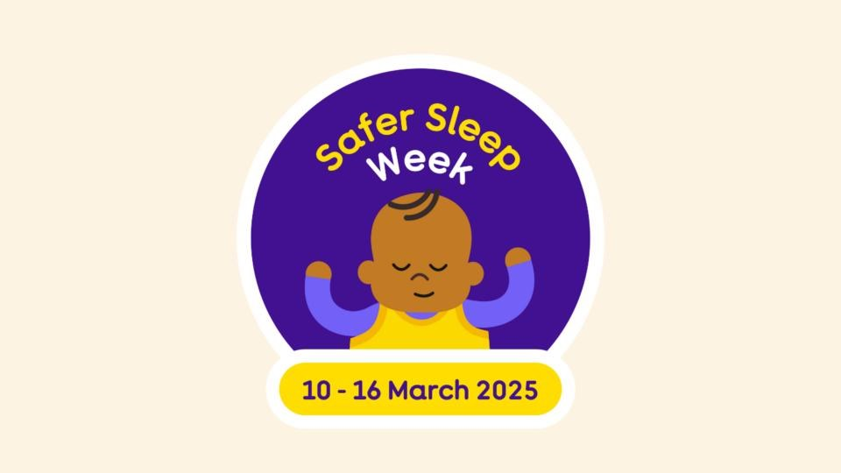

1 - safer sleep week by The Lullaby Trust

Safer Sleep Week 2025 ran from 10 – 16 March and focused on:

* Exploring baby sleep patterns. How long should your baby sleep for their age?
* Busting baby sleep myths. Are any myths backed by evidence, and what about [products](https://lullabytrust.org.uk/baby-safety/baby-product-information/) that promise to help your baby sleep for longer?
* Supporting you through your own lack of sleep. We’ll help with [sleep deprivation,](https://lullabytrust.org.uk/baby-safety/being-a-parent-or-caregiver/sleep-deprivation/) and make it easier for you to follow safer sleep with your baby, even when exhausted.

We also posted throughout the week on our [LinkedIn](https://uk.linkedin.com/company/medway-safeguarding-children-partnership-mscp) and [X account](https://x.com/MedwaySCP).

The Lullaby Trust also have resources for practitioners and professionals to use such as:

* [Baby sleep patterns poster](https://www.lullabytrust.org.uk/resource/baby-sleep-patterns-poster/)
* [Airways easy read card](https://www.lullabytrust.org.uk/resource/airways-easy-read-card/)
* [Safer sleep for babies easy read card](https://www.lullabytrust.org.uk/resource/safer-sleep-for-babies-easy-read-card/)
* [True or false flash cards](https://www.lullabytrust.org.uk/resource/true-and-false-cards/)

On our website we have a factsheet on [keeping babies safe: Safer sleeping.](https://www.medwayscp.org.uk/info/4/professionals/175/keeping-babies-safe-safer-sleeping)

# Early Help Lead Practitioners

Early help is about providing support to children and families as soon as an issue or problem emerges.  As set out in Working Together to Safeguard Children 2023, it is not a single service, but a system of support around children and families. In Medway we recognise that emerging needs within families are often best supported by practitioners known to the family, such as health visitors, schools or community-based programmes offered by the voluntary sector.

The lead practitioner will usually be the worker who is best placed to provide consistent support to the child and family and will probably have initiated the Early Help Intervention Plan (EHIP). The lead practitioner will convene EHIP meetings and work with other practitioners to provide a co-ordinated response to the child’s needs.

The lead practitioner role can be held by a range of people as the knowledge, skills and competence required to carry it out are similar regardless of professional background or role. The role has been defined by the functions and skills, rather than by particular professional or practitioner groupings.

Early Help Co-ordinators (EHC) and Early Help Partnership Officers (EHPO) are available to support lead practitioners from across partner agencies to provide early help.  EHC and EHPO can support partner agencies to:

* engage with families, including capturing the voice of the child/children who they have open on an early help plan.
* start an Early Help Intervention Plan
* identify services that could be included in an intervention plan or review meeting
* connect with external partners who are working with children and families
* use Mosaic to record interventions with children and families
* access various parenting programmes and various groups
* support with completing the Graded Care Profile 2 tool to assess levels of neglect

EHC and EHPO can be contact at the [Medway Children and Family Hubs](https://www.medway.gov.uk/familyhubs).

There are also e-Learning courses that can support you as a lead practitioner including introduction to lead practitioner role and introduction to multi-agency working. Go to [www.medwayscp.org.uk](http://www.medwayscp.org.uk/) and click on the ‘Register for Training’ Section.

# Giving Children the Best Start in Life Course

Are you a professional working with families in Medway? 👨👨👧👧

Don’t miss out on the upcoming FREE course "Giving Children the Best Start in Life”! This one-day training is designed to equip you with the knowledge and skills to support healthy pregnancies, child development, positive parenting, and overall family well-being.

📅 Date & Time:

4 April 2025 | 09:30 - 16:30 (Online)

💡 What You’ll Learn:

• Importance of giving children the best start in life

• Introduction to Family Hubs & Start for Life

• Key health messaging on infant feeding, mental health, child development, and more

• Resources and signposting information for additional support

• Effective communication techniques, including Motivational Interviewing and active listening

This course is FREE and exclusive to those who live or work in Medway. Limited spots are available, so secure your place today!

[🔗 Book Now](https://healthtraining.medway.gov.uk/training-courses/8d61c860-69da-11ef-97ed-4957201ccf40/giving-children-the-best-start-in-life-1)

# Training Dates

The MSCP has a range of virtual and in person training coming up:

* Domestic abuse and safeguarding children training, Tuesday 25th March 2025, 9:30 am – 16:30 pm, In-person
* Children Missing Education Elective Home Education Training, Friday 4th April 2925, 10:00 am – 11:00 am, Microsoft Teams
* Kent and Medway Channel Panel understanding virtual training, Tuesday 8th April 2025, 13:00 pm – 14:00 pm, Microsoft Teams
* Signs of safety, Tuesday 29th April 2025, 9:30 am – 12:00 pm, Microsoft Teams
* GCP2 Refresher, Wednesday 30th April 2025, 9:30 am – 12:30 pm, Microsoft Teams
* Children Missing Education Elective Home Education Training, Wednesday 7th May 2025, 10:00 am – 11:00 am, Microsoft Teams
* Basic safeguarding children training, Thursday 8th May 2025, 9:30 am – 16:00 pm, In-person
* Local Authority Designated Officer (LADO) awareness sessions for MEDWAY, Wednesday 14th May 2025, 13:00 pm – 16:00 pm, Microsoft Teams
* Graded Care Profile 2, Thursday 15th May 2025, 9:30 am – 16:00 pm, In-person
* Understanding Thresholds and Making Referrals, Thursday 15th May 2025, 9:30 am – 11:30 am, Microsoft Teams
* MSCP Train the Trainer, Tuesday 20th May 2025, 9:30 am – 16:00 pm, In-person
* GCP2 Refresher, Wednesday 21st May 2025, 9:30 am – 12:30 pm, Microsoft Teams
* Where does baby sleep webinar, Monday 2rd June 2025, 12:00 pm – 13:00 pm, Microsoft Teams
* Intermediate safeguarding children training, Tuesday 3rd June 2025, 9:30 am – 16:00 pm, In-person
* Homes safety and early years webinar, Tuesday 3rd June 2025, 12:00 pm – 13:00 pm, Microsoft Teams
* The impact of domestic abuse and parental vulnerabilities on babies and children webinar, Wednesday 4th June 2025, 10:00 am – 11:00 am, Microsoft Teams
* Pregnancy and pre-birth concerns webinar, Thursday 5th June 2025, 10:00 am – 11:00 am, Microsoft Teams
* Domestic abuse and safeguarding children training, Thursday 12th June 2025, 9:30 am – 16:00 pm, In-person
* Graded Care Profile 2, Tuesday 17th June 2025, 9:30 am – 16:00 pm, In-person
* GCP2 Refresher, Wednesday 18th June 2025, 9:30 am – 12:30 pm, Microsoft Teams
* Graded Care Profile 2, Tuesday 15th July 2025, 9:30 am – 16:00 pm, In-person
* GCP2 Refresher, Wednesday 16th July 2025, 9:30 am – 12:30 pm, Microsoft Teams
* Local Authority Designated Officer (LADO) awareness sessions for MEDWAY, Wednesday 16th July 2025, 10:00 am – 13:00 pm, Microsoft Teams

If you are interested in any training, you can enrol by [logging into your Me Learning account](https://app.melearning.co.uk/auth/login) or you can create a Me Learning account.

[Create a Me Learning account if your organisation is based in both Kent and Medway.](https://app.melearning.co.uk/auth/validate-key?registerKey=KGJDCTSX)

[Create a Me Learning account if your organisation is based in only Medway.](https://app.melearning.co.uk/auth/validate-key?registerKey=WKCTHRBF)

If you have any queries regarding Me Learning or training please email [mscptraining@medway.gov.uk](mailto:mscptraining@medway.gov.uk).

Contacts

For general enquires email [mscp@medway.gov.uk](mailto:mscp@medway.gov.uk)

For training enquires email [mscptraining@medway.gov.uk](mailto:mscptraining@medway.gov.uk)

Social Media

[X](https://twitter.com/MedwaySCP)

[Linkedin](https://uk.linkedin.com/company/medway-safeguarding-children-partnership-mscp)

[YouTube](https://www.youtube.com/@medwaysafeguardingchildren7786)