Medway Safeguarding Children Partnership (MSCP) November 2024

# Welcome to the MSCP Bulletin - November 2024

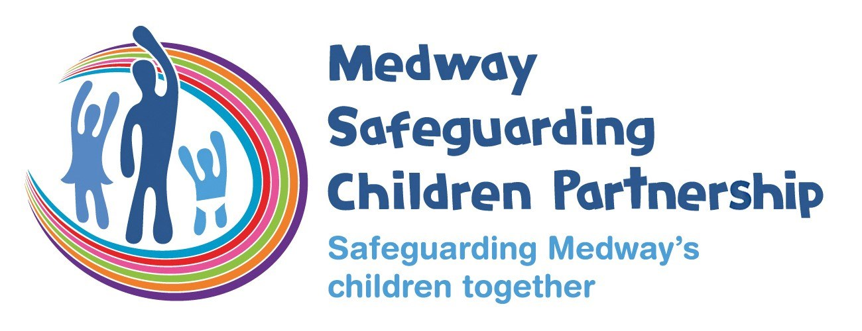

# Who are MSCP and what is their role?

[Medway Council](https://www.medway.gov.uk/), [Kent Police](https://www.kent.police.uk/) and the [NHS Kent and Medway](https://www.kentandmedwayccg.nhs.uk/)are the three safeguarding partners that make up MSCP. We aim to support and enable local organisations and agencies to work together in a system where:-

* children are safeguarded and their welfare promoted
* partner organisations and agencies collaborate, share and co-own the vision for how to achieve improved outcomes for vulnerable children
* organisations and agencies challenge appropriately and hold one another to account effectively
* there is early identification and analysis of new safeguarding issues and emerging threats
* learning is promoted and embedded in a way that local services for children and families can become more reflective and implement changes to practice
* information is shared effectively to facilitate more accurate and timely decision-making for children and families.

# Reminder about the MSCP website

Work is in progress to improve some of the functionality of the [MSCP website.](https://www.medwayscp.org.uk/) Part of this work has impacted existing links or shortcuts to different parts of the website.

What do you need to do?  If you have links to the MSCP website embedded in documents or training material for example you will need to check these are still ‘live’ and if not resave them.  We’re sorry for any inconvenience caused.

# MSCP Priority - Effective Partnerships

# Policy and Procedures Spotlight

The MSCP has several [local policies, procedures and protocols](https://kentandmedway.trixonline.co.uk/resources/local-resources) that all those who work with children and families are expected to know and follow.

The November spotlight is the protocol for the [management of actual or suspected bruising in infants and children who are not independently mobile.](https://trixcms.trixonline.co.uk/api/assets/kentandmedway/de9a3611-9450-41af-b423-a2f75c96053d/kent-and-medway-protocol-for-acutal-or-suspected-bruising-v2.2.pdf)  Bruising in babies/infants or children with complex needs that are non-mobile, is unusual and should always be explored. National and local child safeguarding practice reviews have identified the need for heightened concern about any bruising in an infant or child who is not independently mobile, and the need to pay particular attention to risk in those children who are unable to roll over. This protocol must be followed in all situations where an actual or suspected bruise is noted in an infant or child who is not independently mobile.

# Factsheet Spotlight

The MSCP produce [factsheets](https://www.medwayscp.org.uk/info/4/professionals/157/mscp-fact-sheets) where there is learning from local or national child safeguarding reviews or developing areas of practice.  The factsheets are reviewed and agreed by the Learning Lessons sub-group.

The spotlight for the November bulletin is [Professional Curiosity.](https://www.medwayscp.org.uk/info/6/training-professionals/170/professional-curiosity)  The lack of “professional’s curiosity” has been identified as a point of learning across Medway multi agency audits as well as in local and national reviews. The term professional curiosity is interchanged with “respectful uncertainty”, “professional courage”, “professional/healthy scepticism”, “thinking the unthinkable”, “finding the why” and “questioning minds”. Professional curiosity is an essential skill for professionals working with families to support keeping children, and their families, safe.

# Hateful Extremism CPD Event 26 Feb 2025

After the successes of the last 3 years this event is getting bigger and bigger and 2025 will be no exception with a number of keynote speakers. Attend online or in person.



1 - [Wed, 26 Feb 2025 09:00 - 17:00 GMT](https://www.eventbrite.com/e/in-person-kent-police-kentmedway-prevent-team-hateful-extremism-event-tickets-1023517627777) (In-person)

[Wed, 26 Feb 2025 09:00 - 17:00 GMT](https://www.eventbrite.com/e/online-kent-police-kentmedway-prevent-team-hateful-extremism-event-tickets-1023587958137) (Online)

# Child Safeguarding Practice Review Panel

The Child Safeguarding Practice Review Panel are an independent panel commissioning reviews of serious child safeguarding cases.  You can [find out more about the national panel on Gov.uk website](https://www.gov.uk/government/organisations/child-safeguarding-practice-review-panel/about).

The new kinship care ambassador

The Department for Education has appointed [Jahnine Davis](https://www.gov.uk/government/people/jahnine-davis) as the first National Kinship Care Ambassador.

The National Kinship Care Ambassador will advocate for kinship children and carers across government and work directly with local authorities to improve services.

A key message on information sharing

At recent panel meetings, they have seen a number of reviews that contain examples of practitioners not sharing safeguarding information with other agencies due to lack of consent.

As safeguarding partners and practitioners know, the effective sharing of information between practitioners, local organisations and agencies is essential for early identification of need, assessment, and service provision to keep children safe.

The Government updated the Information-Sharing Guidance for practitioners providing safeguarding services in May 2024. This guidance explains in detail the complexities of ‘consent’ and why it can cause confusion, stating explicitly that GDPR and consent do not prevent the sharing of information for the purposes of safeguarding children.

When encountering challenges about or resistance to sharing safeguarding information, please refer to statutory guidance [‘Working Together 2023’](https://www.gov.uk/government/publications/working-together-to-safeguard-children--2) and non-statutory guidance [‘Information sharing: advice for practitioners providing safeguarding services’](https://www.gov.uk/government/publications/safeguarding-practitioners-information-sharing-advice).

# Early Year's Foundation Stage Safeguarding Reforms

The Department of Education (DfE) has published its response to the consultation on proposals to strengthen Early Years Foundation Stage (EYFS) safeguarding requirements.

The DfE will proceed with implementing all the proposals consulted on, including safer recruitment, child absences, safer eating and safeguarding training.

There are also two new proposals on providing employment references and to support whistleblowing.

DfE intends to implement the EYFS safeguarding reforms from 1st September 2025.

[Early years foundation stage (EYFS) safeguarding full response.](https://www.gov.uk/government/consultations/early-years-foundation-stage-eyfs-safeguarding)

# Medway Council EYFS PVI Leaders Autumn 2024 Briefing

The changes to the EYFS will come around quickly, as they may require some adaptions to your general approaches and current policies and procedures, we encourage you to start planning now.

The Medway Council online briefing on Tuesday 3rd December at 6.30pm will include some reflections on these changes and things you can start to do now in preparation. [To attend the briefing](https://www.eventbrite.co.uk/e/medway-council-eyfs-pvi-leaders-autumn-2024-briefing-tickets-1074302480639?aff=oddtdtcreator).

 For further details about safeguarding training for PVI Early Years settings, please contact [sam@medwayearlyyears.co.uk](mailto:sam@medwayearlyyears.co.uk).

# Elective Home Education in Medway

Elective Home Education (EHE) is a term used to describe a choice by parents to provide education for their children at home, or at home and in some other way which they choose, instead of sending them to school full-time. This is different to education provided by a local authority otherwise than at a school - for example, tuition for children who are too ill to attend school.

Parents and carers have a right to educate their children at home. Section 7 of the 1996 Education Act states: “The parent of every child of compulsory school age shall cause him to receive efficient full-time education suitable – (a) to his age, ability and aptitude, and (b) to any special educational needs he may have - either by regular attendance at school or otherwise.”

Whilst parents have a legal right to make an informed choice to provide their child’s education at home, the EHE register does not accurately reflect those that have made this choice in the best interest of their child, as not a statutory requirement to register those children that are EHE with the Local Authority (LA). To ensure parents/carers receive support and access to health please inform the Elective Home Education officer of any children that parents/carers are electively home educating.

☎ 337308

✉ homeeducation@medway.gov.uk

# Children Missing Education in Medway

Statutory guidance clearly states that where any professional identifies a child who is not in education then the children missing education protocol should be followed. DfE Working Together to safeguard children is clear that: “Everyone who works with children has a responsibility for keeping them safe. No single practitioner can have a full picture of a child’s needs and circumstances and, if children and families are to receive the right help at the right time, everyone who comes into contact with them has a role to play in identifying concerns, sharing information, and taking prompt action.”

All children must be in full-time education once they reach statutory school age. This starts from the term after the child’s fifth birthday, they can leave school on the last Friday in June if they’ll be 16 by the end of the summer holidays.

If professionals are unclear about a child’s education provision, for statutory aged children please inform Medway Council Children Missing Education (CME) service.

☎ 337308

✉ cme@medway.gov.uk

# The Prevent Duty in Education

Kent and Medway is a priority area for Prevent and has a dedicated team of professionals that support sectors and intuitions to fulfil the requirements of the Prevent Duty and support those at risk of radicalisation.

The team includes two education officers, working in partnership with the Department for Education, to provide free support, training, and guidance to education settings to develop and embed a whole school approach to the Prevent duty. [More details on the team and how you can contact them](https://www.kelsi.org.uk/child-protection-and-safeguarding/The-Prevent-Duty-In-Education) can be found on their website

# MSCP Priority - Domestic Abuse and Violence Against Women and Girls

# White Ribbon Day 25th November 2024

White Ribbon is a UK charity engaging men and boys to end violence against women and girls. This year White Ribbon Day is 25 November 2024 focusing on It Starts with Men. Details of resources for this year’s White Ribbon Day, can be found on the [White Ribbon website.](https://www.whiteribbon.org.uk/wrd24)

# 16 days of Action Against Gender Based Violence

When was the last time you completed training or learning relating to domestic abuse or violence against women and girls?

It’s critical that the Medway workforce is confident in recognising and responding appropriately to the needs of children affected by domestic abuse.

The Medway Domestic Abuse Forum is happy to present a free programme of learning taking place during the international 16 days of activism against domestic abuse.

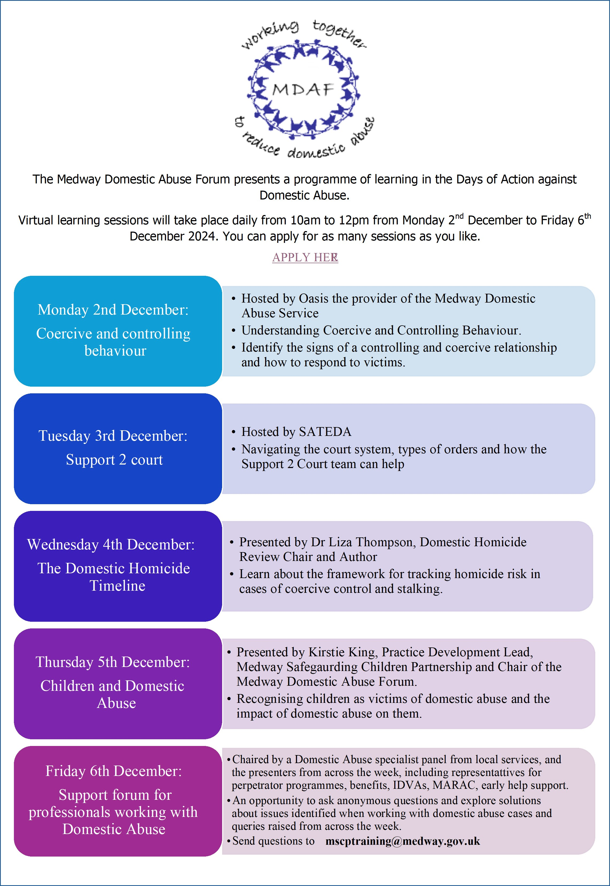

2 - [Enrol onto Medway Domestic Abuse Forum programme of learning.](https://forms.office.com/Pages/ResponsePage.aspx?id=kz5QaOc8Ikq_xf_uQhofV0pHLtRvehxNi3zNZlGDahxUQ1lTTk1MSFQ2NTlESjlMSzhQNjhNSkg2OC4u)

# NSPCC: Protecting children from domestic abuse

NSPCC's Development and Implementation Team are hosting an event that will explore protecting children from domestic abuse and will feature:

* Keynote: Nicole Jacobs, Domestic Abuse Commissioner
* What NSPCC are doing to protect children from Domestic Abuse: NSPCC Policy Team
* How DART fits and compliments local services :Amy Patterson from DASU
* Introduction to Domestic Abuse Recovering Together programme (DART)
* Supporting healthy relationships with young people: Niamh Kennedy, Talk Relationships

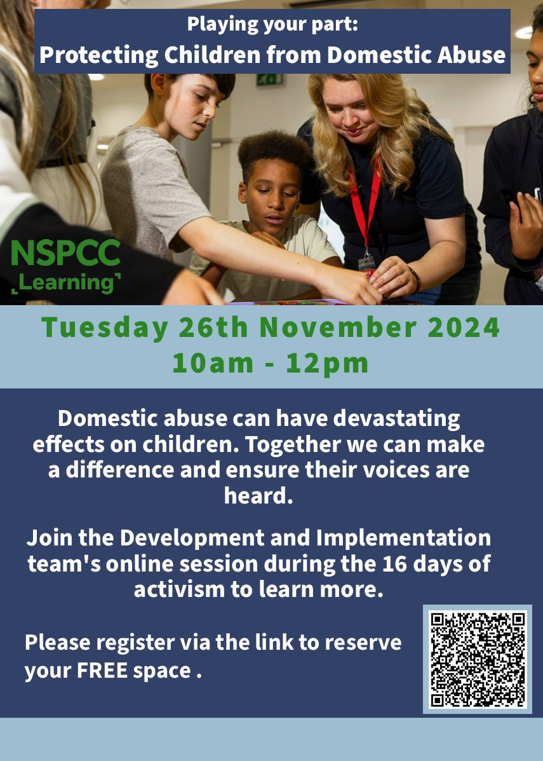

3 - Register your interested for [The Prevention of Abuse & Neglect: Protecting Children from Domestic Abuse](https://events.teams.microsoft.com/event/172af2a3-b17b-40b4-8963-6c3541a6db29@3c4f002a-8d6d-4ede-8372-faf47ca8473f) or you can scan the QR code.

# WeMatter

[WeMatter](https://www.victimsupport.org.uk/more-us/why-choose-us/specialist-services/wematter/) is a video-based digital service for children and young people (CYP) who have been affected by domestic abuse.

It provides specialist support to 8-17 year-olds who have been affected by abuse within their parent or carer’s relationship, or within the family home.

It’s not suitable for children and young people who are experiencing ongoing domestic abuse or for those who are still living with the alleged perpetrator.

From 1st April 2024, [WeMatter](https://www.victimsupport.org.uk/more-us/why-choose-us/specialist-services/wematter/) will be available across the whole of England until 31st March 2025.

WeMatter uses [Rockpool’s](https://rockpool.life/) CYP Domestic Abuse Recovery Toolkit. Delivered online via Zoom, the toolkit offers a timetable of group work programmes, which young people can access during the school day, or at home after school. Each group session is facilitated by two specialist CYP programme facilitators. Groups include up to 12 participants.

WeMatter is delivered over eight weeks, with sessions lasting around one hour. Each session uses trauma-informed cognitive behaviour therapy (CBT) based activities, games and discussions, all aimed at supporting the young person’s individual journey.

The sessions offer children and young people a safe space to:

* understand their experience of domestic abuse
* develop health coping strategies for difficult emotions
* explore future healthy and positive relationships.

Access to technology

Participants will need to access the course using a computer, laptop, or smart device. If they don’t have access to this technology, make sure to call the team on [08 08 16 89 111](tel:08%2008%2016%2089%20111) as they will explore options to help them. For the safety of the group everyone taking part will need to have their camera on throughout a group session.

Confidentiality

The service is confidential. Discussion will be encouraged within the groups, but participants will not be asked to share anything if they don’t wish to do so.

Programme facilitators will work closely with parents, carers and partner agencies. This is to ensure they are working to meet the best interests of all involved.

# MSCP Priority - Contextual Safeguarding and trauma informed practice

# Kent and Medway Child Exploitation Intelligence Portal

Did you know you can help the Police disrupt perpetrators of child exploitation by reporting soft intelligence of what you have seen and are hearing when out and about in Medway? You are some of the most important eyes and ears on the ground.

The single most important action you can take to protect children from Exploitation is to report what you see, and this can be done by using a special confidential portal. The portal is a good way for agencies to submit Exploitation concerns which are then processed as intelligence.

Are you familiar with the Child Exploitation Intelligence Portal and how to use it?  There are two ways you can find out more:

[Training video](https://www.youtube.com/watch?v=8RRcgPldw4k)

The training video is free to access, and you can complete it at your own pace. [You will find the training on YouTube.](https://youtu.be/8RRcgPldw4k?si=W3Bk0CHUnnzwJaAL)

[Video Explainer](https://www.medwayscp.org.uk/info/4/advice-resources-professionals/19/child-sexual-exploitation)

Amy Hewitt, Missing and Exploitation Lead (Medway Council Children’s Services) has produced a [video explainer on the portal](https://www.medwayscp.org.uk/info/4/advice-resources-professionals/19/child-sexual-exploitation). This is shorter than the training video and includes what the intelligence portal is, the types of exploitation that can be referred through the portal, appropriate use, and quality submissions.

It takes you through:

* what types of child exploitation can be submitted through the portal,
* understand what is meant by ‘intelligence’,
* understand what quality intelligence looks like
* when it is appropriate (or not!) to use the portal

# MSCP Priority - Neglect

# Too little, too late: A multi-agency response to identifying and tackling neglect.  Report from the NSPCC.

As you will have seen in previous bulletins neglect and identifying neglect early is a priority for the MSCP.

 In the summer the [NSPCC published a report on neglect](https://learning.nspcc.org.uk/research-resources/2024/too-little-too-late-identifying-and-tackling-neglect) drawing on research with multi-agency safeguarding professionals, online focus groups including teachers, police and healthcare professionals and insights gathered from the NSPCC helpline.  The report highlights strengths and challenges in identifying and supporting children and families experiencing neglect, along with recommendations for the UK government.

# Isabel's story

Following MSCP third annual conference, Hidden neglect, we have now published a 9-minute video explainer on our YouTube channel based on a Local Child Safeguarding Practice Review for baby Isabel.  This explainer features a new approach promoting the voice of the child and includes an imagined perspective from Isabel.  Delegates at the conference gave us positive feedback following this;

“Very powerful”

“Really bringing Isabel’s voice to life”

“It was helpful to be able to see it through a child’s eyes”

“It was an impactful way to provide insight into Isabel’s situation. I think this could be a powerful tool for safeguarding training.”

You can also read the full [Isabel report](https://www.medwayscp.org.uk/downloads/download/205/lscspr-isabel) that is available on the [MSCP website.](https://www.medwayscp.org.uk/)

We also have a [case review video regarding baby Isabel](https://youtu.be/aqNaZ8Bwry4?si=CY4DD_fi0dL7-f0L) that is available on our YouTube.

[Welcome to this MSCP video explainer about baby Isabel.

Recently we held a conference on hidden neglect where Isabel's story was featured.

To out more about Isabel:
https://www.medwayscp.org.uk/info/5/aims/31/medway-serious-case-reviews

Watch our video 'Case Review: Isabel':
https://youtu.be/aqNaZ8Bwry4?si=4K5bqD-KtGWAzW7f

For support:
The Lullaby Trust - https://www.lullabytrust.org.uk/
Child Bereavement UK - https://www.childbereavementuk.org/

Follow us on:
X - https://x.com/MedwaySCP
LinkedIn - https://uk.linkedin.com/company/medway-safeguarding-children-partnership-mscp](https://youtu.be/an0b4n_L4I8)

# MSCP training

# Multi-agency training catalogue

Alongside our [training catalogue](https://www.medwayscp.org.uk/downloads/file/647/multi-agency-training-catalogue), we now have published a YouTube video about it.

In this video you can find out:

⏺How to create a Me Learning account?

⏺How to enrol onto training?

⏺Cancellation policy

⏺The different e-learning courses we offer

⏺The different in-person training we offer

⏺The different virtual training sessions we offer

[In this video we will cover:
-how to create a Me Learning account
-how to enrol onto training
-the different e-learning courses we offer
-the different in-person training we offer
-the different virtual training sessions we offer

To find out more:
https://www.medwayscp.org.uk/info/6/training-professionals/45/register-mscb-elearning](https://youtu.be/1iUa60lY8mw)

# Autumn and Winter Training Dates

The MSCP has a range of virtual and in person training coming up in the autumn and winter.

* Thresholds: Making referrals, understanding and applying threshold in Medway, via Microsoft Teams, Thursday 14th November 2024, 9:30am-11:30am
* Thresholds: Making referrals, understanding and applying threshold in Medway Refresher, in-person, Friday 15th November 2024, 9:30am-12:00pm
* Refresher Graded Care Profile 2 Training for licenced practitioners, Wednesday 20th November 2024, 9:30am-12:00pm
* Basic Safeguarding Children Training, in-person, Thursday 5th December 2024, 9:30am-4:00pm
* Intermediate Safeguarding Children Training, in-person, Monday 9th December 2024, 9:30am-16:00pm
* Reducing Parental Conflict, in-person, Thursday 12th December 2024, 9:30am-2:30pm
* Signs of Safety via Microsoft Teams, Tuesday 21st January 2025, 9:30am -2:30pm
* Thresholds: Making referrals, understanding and applying threshold in Medway, via Microsoft Teams, Thursday 27th February 2025, 9:30am-12:00pm

If you are interested in any training, you can enrol by [logging into your Me Learning account](https://app.melearning.co.uk/auth/login) or you can [create a Me Learning account](https://app.melearning.co.uk/auth/validate-key?registerKey=RGPNBJSW) instead, if you do not already have one.

If you have any queries regarding Me Learning or training please email [mscptraining@medway.gov.uk](mailto:mscptraining@medway.gov.uk).

# Lead Practitioner - New E-learning Course

In September 2024 we added the Lead Practitioner e-Learning course.  This takes you through the roles and responsibility of a lead professional and the continuum of need.  It’s free to complete, in your own time and at your own pace.

Contacts and feedback

For general enquires email [mscp@medway.gov.uk](mailto:mscp@medway.gov.uk)

For training enquires email [mscptraining@medway.gov.uk](mailto:mscptraining@medway.gov.uk)

Social Media

[X](https://twitter.com/MedwaySCP)

[Linkedin](https://uk.linkedin.com/company/medway-safeguarding-children-partnership-mscp)

[YouTube](https://www.youtube.com/@medwaysafeguardingchildren7786)