Medway Safeguarding Children Partnership (MSCP) September 2024

# Welcome to the MSCP Bulletin - September 2024

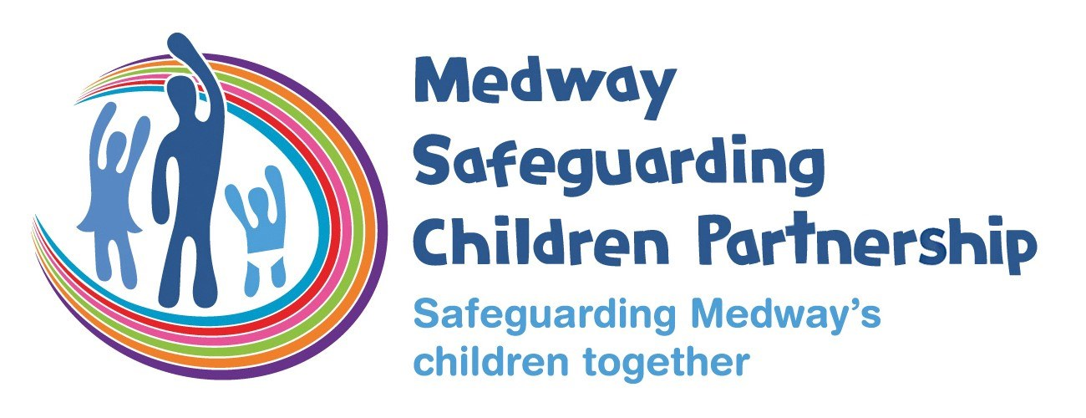

# Who are MSCP and what is their role?

[Medway Council](https://www.medway.gov.uk/), [Kent Police](https://www.kent.police.uk/) and the [NHS Kent and Medway](https://www.kentandmedwayccg.nhs.uk/)are the three safeguarding partners that make up MSCP. We aim to support and enable local organisations and agencies to work together in a system where:-

* children are safeguarded and their welfare promoted
* partner organisations and agencies collaborate, share and co-own the vision for how to achieve improved outcomes for vulnerable children
* organisations and agencies challenge appropriately and hold one another to account effectively
* there is early identification and analysis of new safeguarding issues and emerging threats
* learning is promoted and embedded in a way that local services for children and families can become more reflective and implement changes to practice
* information is shared effectively to facilitate more accurate and timely decision-making for children and families.

# MSCP website

Work is in progress to improve some of the functionality of the MSCP website. Part of this work though has impacted existing links or shortcuts to different parts of the website.

What do you need to do?  If you have links to the MSCP website embedded in documents or training material for example you will need to check these are still ‘live’ and if not resave them.  We’re sorry for any inconvenience caused.

# MSCP Priority - Effective Partnerships

Policy & Procedures Spotlight

The MSCP has a number of local polices and procedures that all those who work with children and families are expected to know and follow.

The September bulletin is focused on [pre-birth procedures](https://kentandmedway.trixonline.co.uk/resources/local-resources). This procedure is shared across Kent and Medway safeguarding children partnerships and includes information of the timeliness of referrals/requests when the unborn is at risk of significant harm, circumstances where a referral to Children Social Care must be made, Medway Maternity Safeguarding Triage Hub, unassisted birth and concealed pregnancy.

 Factsheet Spotlight

The MSCP produce [factsheets](https://www.medwayscp.org.uk/info/4/professionals/157/mscp-fact-sheets) where there is learning from local or national child safeguarding reviews or developing areas of practice.  The factsheets are reviewed and agreed by the Learning Lessons sub-group.

 The spotlight for the September bulletin is on [Involving Men and Fathers](https://www.medwayscp.org.uk/info/4/professionals/156/involving-men-fathers). The factsheet sets out the importance of involving men and fathers in support and services, along with prompts for how you can involve men and fathers.

Annual Report 2023-2024

The Medway safeguarding partners (Kent Police, Medway Council and Kent and Medway ICB) must produce an annual report setting out the activity they have undertaken in a 12-month period.  These reports should include multi-agency priorities, learning and focus for the coming year.  The [2023-2024 annual report](https://www.medwayscp.org.uk/downloads/file/648/mscp-annual-report-2023-2024) has been published. Get yourself a cup of coffee ☕ and have a look at what the MSCP has been doing and achieved in the last year.  If you have any feedback please email [mscp@medway.gov.uk](mailto:mscp@medway.gov.uk)

# Signs of Safety - New Bitesize Videos

‘Signs of Safety’ is Medway’s practice framework to help in our work with children and families. It is a strengths-based approach to working children and families where the emphasis is on helping families rather than ‘intervening’.  The focus is shifted from a way of working where professionals are considered to be the experts to a constructive, relationship-based model of helping parents to change. There is an emphasis on the strengths in the child’s network, whilst the child’s safety is always the focus of any help provided.

It’s important that everyone who works with children and families in Medway knows about and understands the Signs of Safety approach.  Our children’s social care partners have produced a set of bitesize videos on the following aspects of Signs of Safety, that can be found on the MSCP YouTube channel here:

* [scaling](https://youtu.be/GPtwpKLsuVA?si=qwlF1pdZ_N3RXTIs)
* [strengths](https://youtu.be/2MuoCE8KvPs?si=XFo0HV6FAbxBiopp)
* [mapping](https://youtu.be/VP4B_NgoKig?si=-oybC1FjbQ30vfyy)

How might you come across Signs of Safety?  If you attend child protection strategy meetings it is important that you understand scaling as this will form part of the meeting and you’ll be asked to give a view.

Not heard of Signs of Safety?  There is a Signs of Safety section on the [MSCP website](https://www.medwayscp.org.uk/info/6/training/124/signs-safety-partner-business-support-staff) and free training with the next session on Tuesday 1st October 2024 at 9:30 a.m. til 12:00 p.m. via Teams.  [Register for training.](https://app.melearning.co.uk/auth/login)

Have you visited the [MSCP YouTube Channel](https://youtube.com/@medwaysafeguardingchildren7786?si=zDfi2ePZujA0Q3iv)?

We’ve made some changes to the MSCP YouTube channel.  Videos are now organised by the MSCP priorities and themes from learning from the multi-agency case file audit process and local learning reviews.  We’ve got local and national resources to support knowledge and understanding around these key areas of practice.  We will be adding more material just Subscribe to keep up to date.

# Keeping Children Safe in Education

The latest version of [Keeping Children Safe in Education 2024](https://www.gov.uk/government/publications/keeping-children-safe-in-education--2) has now been published.

There are two areas of change to note from the May 2024 ‘for information’ version that was previously shared in the MSCP bulletin.  These changes are:

* Safer recruitment for individuals who have lived or worked outside the UK – see paragraph 286
* The definition of safeguarding has been updated to reflect the changes to the definition in Working Together to Safeguard Children 2023 – see paragraph 3.

# Reporting Extremist Graffiti and Stickering

Social Workers and our safeguarding partners play a crucial role in maintaining the well-being and safety of our community in Medway. While you are out visiting children, young people and their families, your vigilance can make a significant difference. Extremist graffiti and stickering often contain hate speech that can incite violence and create a hostile environment. These messages spread division and fear, undermining the sense of togetherness we strive to build here in Medway.

As Social Workers and safeguarding partners, your commitment to supporting and protecting the Medway community is invaluable.  By actively reporting extremist graffiti and stickering you find whilst out in the community, you help disrupt the spread of these extremist ideologies and protect those who might be influenced by them.

* If you see any extremist graffiti or stickering, please take a photo of it using your work phone. Please be assured that it is safe to do so as there is a legitimate reason and purpose for recording this material.
* Forward the photo(s) and details of the location to [Mark McCree](mailto:mark.mccree@medway.gov.uk),  Community Safety Team Leader and 'Cc' [cst@medway.gov.uk](mailto:cst@medway.gov.uk). This will then be shared with the Prevent Team and police Community Liaison Officers. Removal of the graffiti/sticker will be arranged as soon as possible.

By reporting extremist graffiti and stickering, you are helping to ensure a safe environment for everyone, preventing the potential escalation of radicalisation, violence and hate crimes.

For further guidance and training please refer to:

* [Prevent duty guidance: England and Wales (2023)](https://www.gov.uk/government/publications/prevent-duty-guidance)
* [Prevent duty training: Learn how to support people susceptible to radicalisation](https://www.support-people-susceptible-to-radicalisation.service.gov.uk/#:~:text=Prevent is one part of,terrorism to disengage and rehabilitate)
* [(Prevent) Graffiti and Sticker Awareness](https://i-share.org.uk/courses/corporate/3847/prevent-graffiti-and-sticker-a)
* [Prevent Awareness and Radicalisation](https://i-share.org.uk/courses/corporate/3663/prevent-awareness-and-radicali)

# MSCP Priority - Contextual Safeguarding and trauma informed practice

# What is transitional safeguarding and why does it matter?

# Challenging Exploitation

Debbie Taylor is the Service Manager for 16+ Care Leavers Service at Medway Council Children’s Services. Debbie has written this article on her learning and reflections on transitional safeguarding and exploitation.  Thank you to Debbie for sharing her reflections and some great resources.

[Easily accessible animation](https://vimeo.com/794130649) from Research in Practice – please watch this [video](https://vimeo.com/794130649) to get an overview on what this is.

 Transitional Safeguarding is an approach to safeguarding adolescents and young adults across developmental stages which builds on the best available evidence, learns from both children’s and adult safeguarding practices and which prepares young people for their adult lives.

 We all know harm does not stop at 18 neither do the traumatic effects of experienced harm. Research shows that young people develop until their mid-twenties so why does the professional safeguarding response generally end, or dramatically change, at 18? There are currently 2 different safeguarding systems – for those under 18 and for those over 18 – neither designed solely for the complexities of teenagers and young adults (with additional considerations if also care-experienced).

 Having the official date of becoming an adult as 18 can be considered, if being frank, harmful. A child is legally accountable for a crime at age 10 in England. The age of consent for both heterosexual and same-sex relationships is 16. You can join the Armed Forces at 16. You can have a driving license from 17. By law a young person is presumed to have capacity to make decisions about any area of their life from 16 (unless deemed not to have mental capacity). However, in safeguarding the 18th birthday is the key date when the safeguarding approach offered will change and go from the Children Act 1989 to the Care Act 2014 (only if they meet criteria). The available services at this point do not often meet their developmental needs or circumstances, and at 18 there is the risk they will not be deemed eligible.

 Transitional Safeguarding is a concept that challenges the systems and their inadequacies to enable us to think differently about how we safeguard adolescents and young adults.

 The first book on Transitional Safeguarding was published in April 2024, with the inspirational Dez Holmes and Rebekah Pierre involved.

The book and the recent event I attended reviewed 59 serious case reviews and safeguarding adult reviews following the death or serious injury of care experienced young people aged between 15 and 25 (between 2024 and 2021). The below themes sadly aren’t a surprise to read:

* Young people’s risks & vulnerabilities were not recognised especially when involved in exploitation – the young person was treated as an ‘offender’ & criminalised, rather than a ‘victim’ worked with under a safeguarding umbrella (adultification is an issue).
* Evident from reviews that practitioners sometimes did not understand & address the young person’s needs and behaviours within a developmental context – practice constrained to individualistic approach due to the way services were designed / way thresholds were applied locally.
* Often there are many different professionals and services involved in young people’s lives – added layer of complications– Professionals did not always talk to each other, share information, keep adequate/full records (especially when out of area / working across service borders).
* Professionals generally focused on individual crises, not underlying causes or reasons for behaviours (sometimes procedures not followed e.g. ‘missing episodes’ or chronologies).
* Referrals to adults’ mental health / social care sent / accepted late.
* Lack of understanding about complex safeguarding needs – perceived as ‘lifestyle choices’ (substance/alcohol use; CCE, CSE).
* Safeguarding problems at transition points meant services were not always responsive e.g. between children and adult LA services, & CAMHS and adult MH services.

 “Children’s social care and Adults social care should develop protocols together to address the safeguarding needs of young people aged 18 or over who are assessed as vulnerable or at risk, particularly at transition and specifically for care leavers, and ensure that social work staff have a clear escalation process if there are disagreements between children’s and adult’s services about safeguarding young people and adults”.

 The key lines of inquiry in another adult safeguarding review about “Madeleine” included: the infrastructure for transition; cross borough working; mental health service provision; the effectiveness of multi-agency working; and gaps/barriers in service provision, including the impact of Covid-19.

* Madeleine had complex needs, including a long history of mental health concerns (including autism) and substance misuse, which compounded her experience of services.
* She had an Education, Health and Care Plan but despite this had been excluded from schools.
* At 16 her parents were told that CAMHS had ‘tried everything’ so they should ask for help from social care.
* She was first assessed by social care services when she was 12 and at 16 she was taken into care.
* She experienced 8 different placements in 5 months and was then placed in secure accommodation in Scotland.
* Shortly before her 18th birthday she moved from there to an Independent Living placement (‘out of borough’ unregulated placement as part of her leaving care provision).
* Despite having reached adulthood, coordination of her care needs remained the responsibility of the placing LA Children’s Social Care without support from the adult services (not in the area where she was then living).
* She was 18 years old when she died (suicide).

 The SAR goes on to say that multi-agency support was not robust in transition planning particularly around mental health and placement provision. Transitional Safeguarding issues across the children’s and adults divide were not fully understood for Madeleine. The SAR emphasises that practitioners should not walk away and close down involvement when support is declined which is what happened for Madeleine. Practitioners should remain curious and tenacious in seeking ways to engage young people particularly where there are complexities, e.g. mental health and substance misuse.  There were many gaps in the service that Madeleine received. Some of these issues should have been referred or at least discussed with post-18 services at an earlier point in her journey.

 Also of interest and significance, within an analysis of the first year of Ofsted giving separate judgement for care leaver services we are starting to see explicit reference to transitional safeguarding practices –

The criteria is- “Care leavers feel safe. The local authority works effectively with its partners to respond to risks associated with young people offending, misusing drugs or alcohol, going missing or being sexually or criminally exploited. Young people receive help to reduce the risk of harm or actual harm and are helped to understand how they can keep themselves safe.”

 Good or Outstanding LA’S had comments from Ofsted such as -  “Care leavers have help to keep safe, and robust safety plans help mitigate risk and concerns. For example, there is good support to help protect young adults in unhealthy and unsafe relationships. Likewise, there are high levels of support to protect young adults from exploitation. These safety plans are underpinned by appropriate partnership working with probation, adult services and domestic abuse agencies.”

And “When risks are particularly complex or serious, multiagency transitional safeguarding arrangements are set up to help care leavers stay safer within the community. Transitional safeguarding plans are regularly reviewed and involve adult services, police, specialist drug and alcohol services and housing staff working effectively together to help safeguard care leavers.”

 Children under the age of 18 are robustly supported through child protection processes such as strategy discussions and child protection conferences. Post-18 vulnerability and risk does not end but statutory safeguarding processes do. It is important that we consider how to address the risks for young adults so that there is a strategic multiagency approach to disrupting risky situations faced by our young people so that the risk is reduced to a safe level. This would provide holistic consideration to all needs of a young person and a collective responsibility to work towards a reduction of risk, pre- and post-18.

 So why am I telling you all of this if you don’t work currently with young people over 18? The 15-year-old you work with who is on the edge of care may become looked after and will, hopefully, turn 18 at some point. The 13-year-old waiting for a CAMHS appointment who is self-harming, hopefully, will turn 18 at some point. The 16-year-old who you keep meaning to complete the exploitation assessment and NRM for will, hopefully, turn 18 at some point. Our children need to know they are being supported now and in the future. What can we each do now for our children and young people to support them to have access to the right support, involvement, therapy, advice, listening ear, safe person/place so that they WILL turn 18, 21, 25, 30, 40, 100, and have the best opportunities available to them? Wherever we are in the system, we can influence change and do the best for each and every child and young person in Medway.

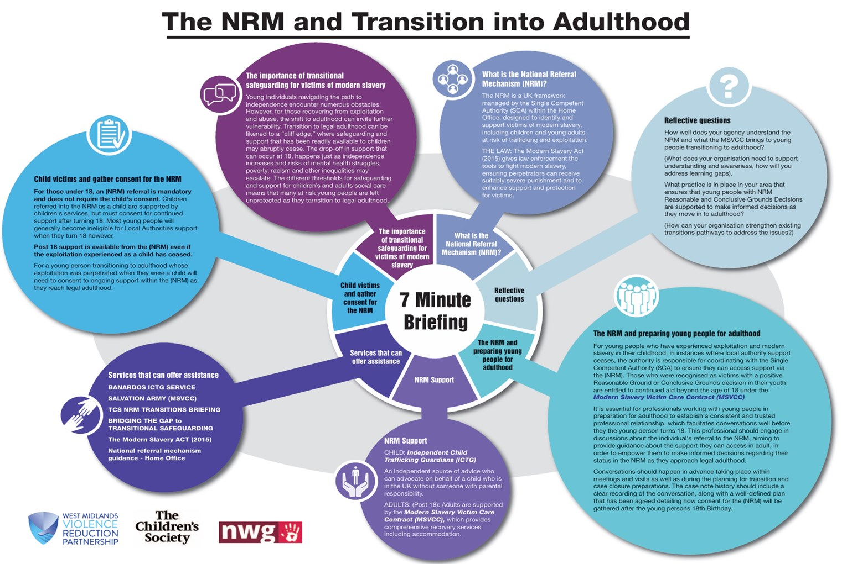

1 - This diagram is a helpful overview of the NRM, for pre- and post-18 young people.

# Speak Out Toolkit - Creating Safe Spaces to Challenge Narratives of Division & Hatred

This toolkit is designed to be used with young people aged 11+ to stimulate discussion, thought and reflection around key themes such as identity, belonging, diversity and community. Actively addressing these issues encourages young people to build meaningful relationships with their peers and develop a strong sense of identity, therefore reducing the risk posed by extremist narratives. Activities require minimal resources to enable them to be used in a variety of settings.

The activities in this toolkit have been themed into three sections, with the aim of being simple to plan and deliver. They all encouraged learning through ding dialogue and having un together.

[Building a stronger Britain toolkit - Speak Out](https://nya.org.uk/document/building-a-stronger-britain-toolkit-speak-out/)

# Child Exploitation Intel Portal for Contextual Safeguarding – Training Video

Child Exploitation Intelligence Portal

In the summer edition of the MSCP bulletin we shared a video explainer on the Child Exploitation Intelligence Portal.  In this edition we have the link to a video from one of the Intelligence portal training sessions delivered by Kent Police.  It takes you through:

* what types of child exploitation can be submitted through the portal,
* understand what is meant by ‘intelligence’,
* understand what quality intelligence looks like
* when it is appropriate (or not!) to use the portal

 The training video is free to access, and you can complete it at your own pace.  You will find the training video here

[This is a training video regarding the Child Exploitation Intelligence Portal.

This video was recorded from a training session with trainers from Kent Police.

#kentpolice](https://youtu.be/8RRcgPldw4k)

# #LookCloser to Spot Exploitation – Learning Programme

The Children’s Society have a series of free sessions on different aspects of child exploitation.  The sessions are all online from October 2024 through to March 2025.

[For more details and to sign up to the sessions.](https://youthjusticeboard.newsweaver.co.uk/icfiles/1/1861/11612/7214862/a7596e5fe63e8f258213dcfd/_lookcloser%20programme%20of%20learning%20october%2024%20-%20march%2025.pdf)

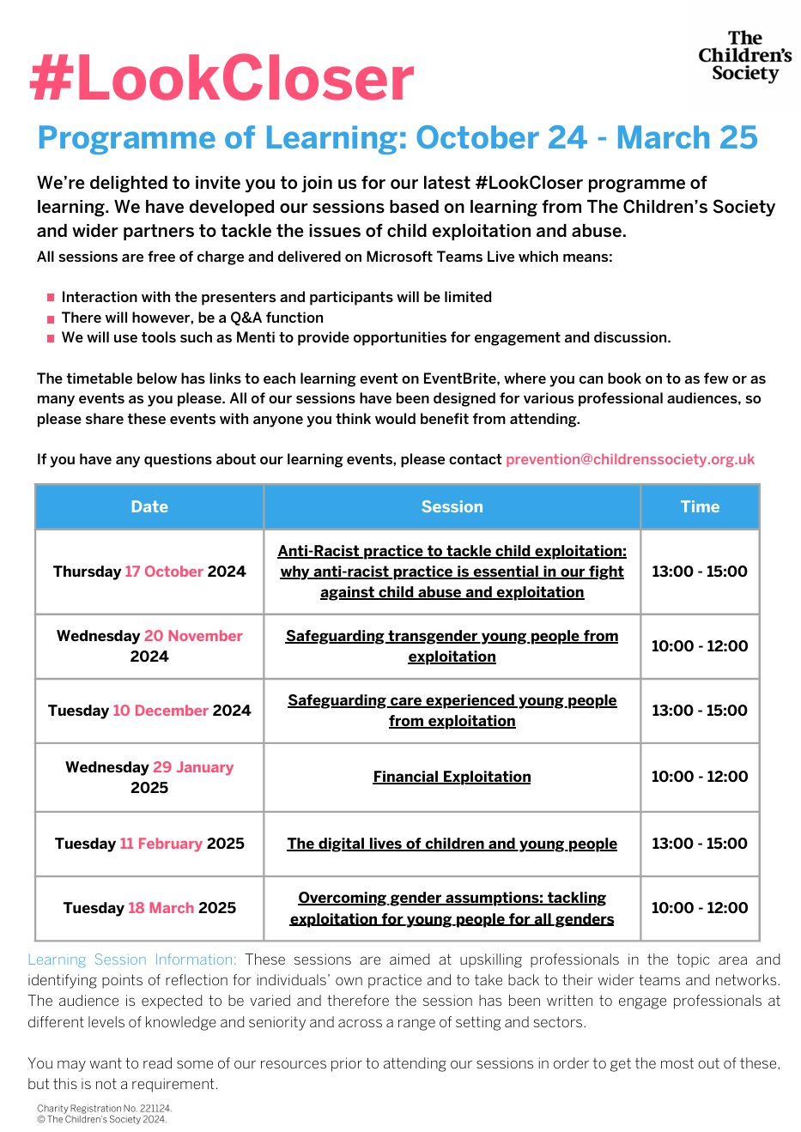

# MSCP Priority - Domestic Abuse

# Domestic Abuse: A referral Pathway for Kent and Medway

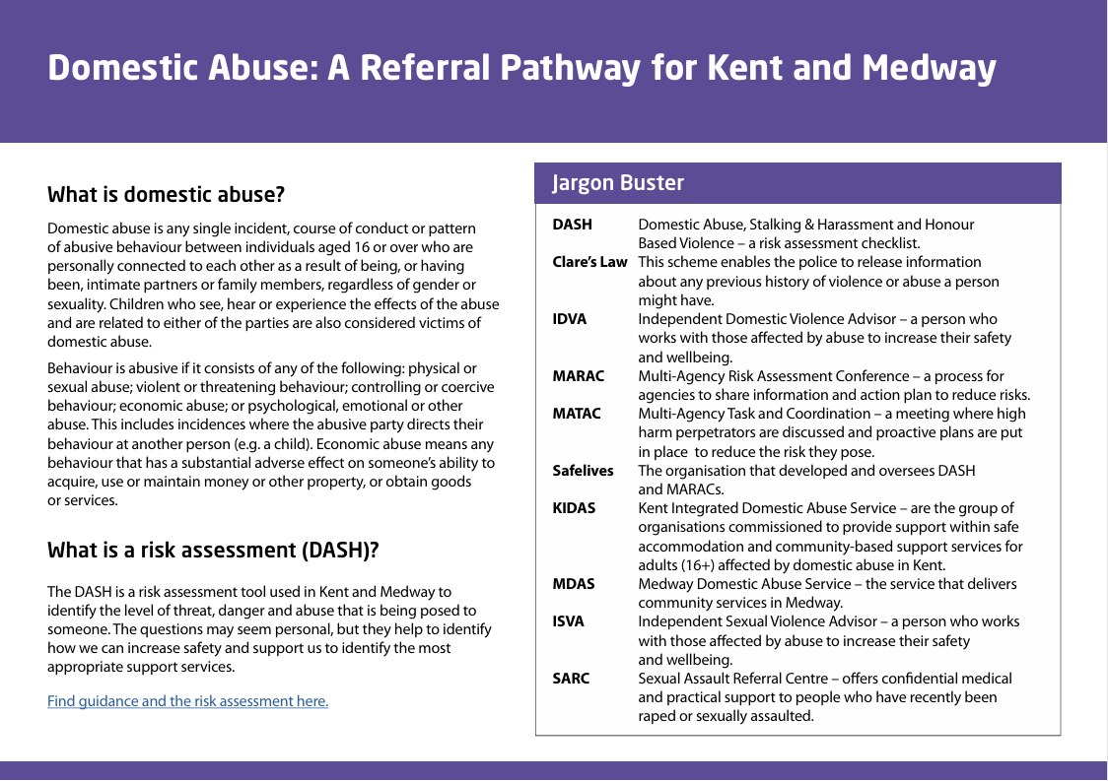

2 - [Find guidance and the risk assessment here.](https://safelives.org.uk/resources-library/dash-risk-checklist/)

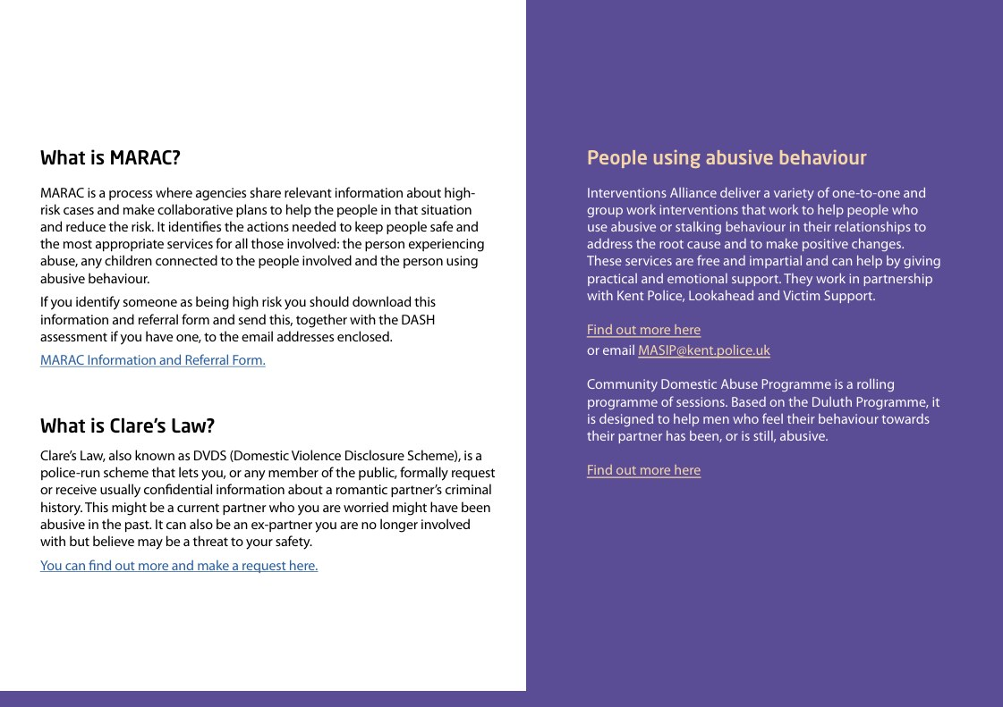

3 - [Find out more here](https://interventionsalliance.com/services/healthy-relationships-and-cobi-interventions/) or email [MASIP@kentpolice.uk](https://MASIP@kent.police.uk)

Find out more regarding [Community Domesic Abuse programme.](https://kentcdap.org/)

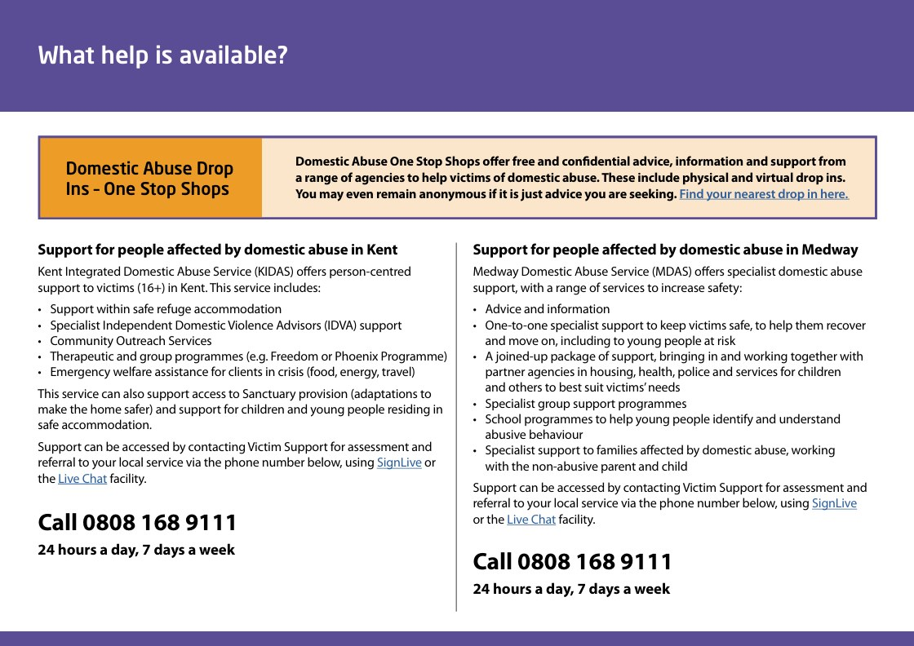

4 - [Find your nearest drop in here.](https://www.kent.gov.uk/__data/assets/pdf_file/0004/165550/One-Stop-Shop-Information.pdf)

[SignLive for Kent](https://www.victimsupport.org.uk/accessibility/contact-victim-support-using-british-sign-language-bsl/)

[SignChat for Kent](https://www.victimsupport.org.uk/resources/kent/)

[SignLive for Medway](https://www.victimsupport.org.uk/accessibility/contact-victim-support-using-british-sign-language-bsl/)

[SignChat for Medway](https://www.victimsupport.org.uk/resources/kent/)

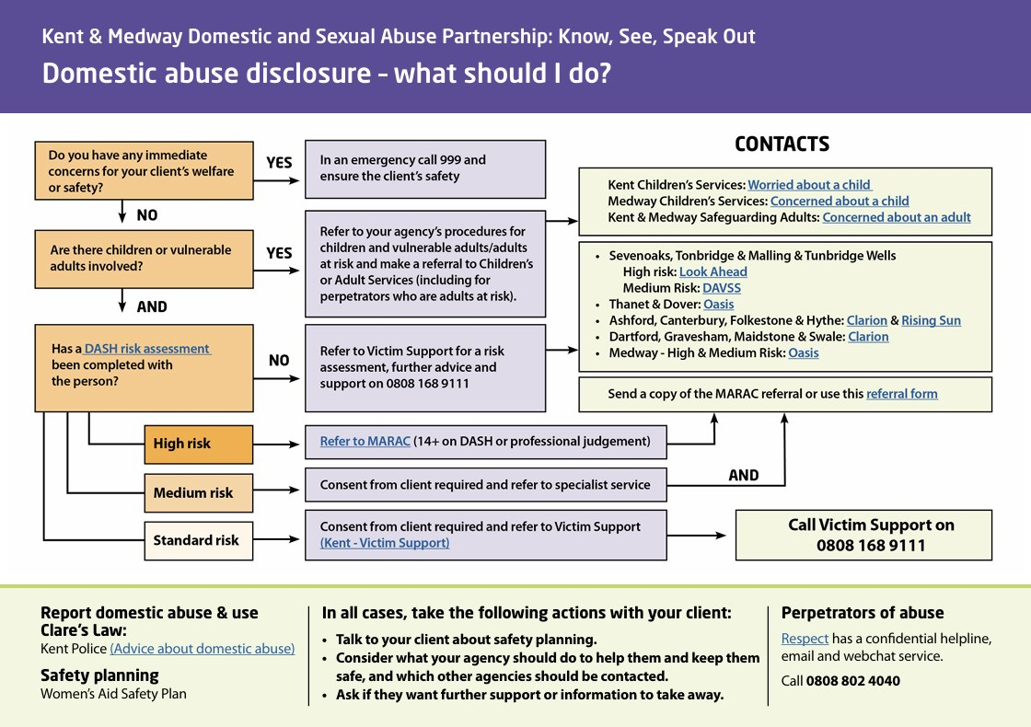

5 - [DASH Rish Assessment](https://safelives.org.uk/resources-library/dash-risk-checklist/)

[Refer to MARAC](https://www.kelsi.org.uk/__data/assets/word_doc/0020/115751/MARAC-info.docx)

[Kent Victim Support](https://www.victimsupport.org.uk/resources/kent/)

[Advice about Domestic Abuse](https://www.kent.police.uk/advice/advice-and-information/daa/domestic-abuse/)

[Respect (Confidential helpline)](https://www.respect.org.uk/pages/127-respect-phoneline)

Contacts:

Kent Children's services: [Worried about a child](https://www.kscmp.org.uk/guidance/worried-about-a-child)

Medway Children's Services: [Concerned about a child](https://www.medway.gov.uk/info/200170/children_and_families/600/concerned_about_a_child)

Kent and Medway safeguarding adults: [Concerned about an adult](https://kmsab.org.uk/worried-about-an-adult/report-abuse)

Sevenoaks, Tonbridge and Malling and Tunbridge Wells:

High risk: [Look Ahead](https://www.lookahead.org.uk/our-services/our-kent-services/)

Medium Risk: [DAVSS](https://www.davss.org.uk/)

Thanet and Dover: [Oasis](https://www.oasisdaservice.org/get-help/professionals/)

Ashford, Canterbury, Folkestone and Hythe: [Clarion](https://supported.housing@clarionhg.com) and [Rising Sun](https://www.risingsunkent.com/referrals/)

Dartford, Gravesham, Maidstone and Swale: [Oasis](https://www.oasisdaservice.org/get-help/professionals/)

[Referral form](https://www.kelsi.org.uk/__data/assets/word_doc/0020/115751/MARAC-info.docx)

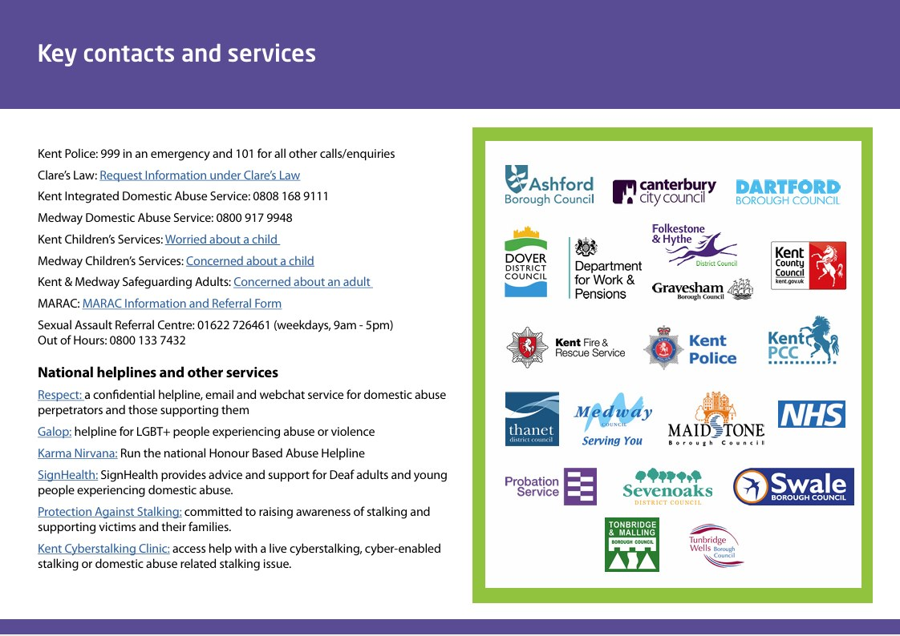

6 -  Kent Police: 999 in an emergency and 101 for all other calls/enquiries

 Clare’s Law: [Request Information under Clare’s Law](https://www.kent.police.uk/rqo/request/ri/request-information/cl/triage/v2/request-information-under-clares-law/)

Kent Integrated Domestic Abuse Service: 0808 168 9111

Medway Domestic Abuse Service: 0800 917 9948

Kent Children's services: [Worried about a child](https://www.kscmp.org.uk/guidance/worried-about-a-child)

Medway Children's Services: [Concerned about a child](https://www.medway.gov.uk/info/200170/children_and_families/600/concerned_about_a_child)

Kent and Medway safeguarding adults: [Concerned about an adult](https://kmsab.org.uk/worried-about-an-adult/report-abuse)

MARAC: [MARAC Information and Referral Form](https://www.kelsi.org.uk/__data/assets/word_doc/0020/115751/MARAC-info.docx)

Sexual Assault Referral Centre: 01622 726461 (weekdays, 9am - 5pm) Out of Hours: 0800 133 7432

National helplines and other services

[Respect:](https://www.respect.org.uk/pages/127-respect-phoneline) a confidential helpline, email and webchat service for domestic abuse perpetrators and those supporting them

[Galop:](https://galop.org.uk/) helpline for LGBT+ people experiencing abuse or violence

[Karma Nirvana:](https://karmanirvana.org.uk/) Run the national Honour Based Abuse Helpline

[SignHealth:](https://signhealth.org.uk/with-deaf-people/domestic-abuse/) SignHealth provides advice and support for Deaf adults and young people experiencing domestic abuse.

[Protection Against Stalking:](https://www.protectionagainststalking.org/) committed to raising awareness of stalking and supporting victims and their families.

[Kent Cyberstalking Clinic:](https://www.thecyberhelpline.com/cyberstalking-clinic) access help with a live cyberstalking, cyber-enabled stalking or domestic abuse related stalking issue.

# Multi-Agency Risk Assessment Conference (MARAC) Hub Update

Recruitment

The MARAC Hub Manager came into post in December 2023, one FTE MARAC Co-ordinator started in January 2024 and another FTE MARAC Co-ordinator in April 2024. A third successful FTE MARAC Co-ordinator is still going through Vetting processes. There has been a vacancy for the MARAC Supervisor role since the start of August and interviews are due to take place in September.

MARAC Hub Steering Group

Re-launched on 24th February 2024 – this group oversees the whole MARAC process and has overall accountability for this. A mix of strategic and operational staff attend to ensure our MARAC Model operates and performs the best it can, holding multi-agency partners to account if they are not performing e.g., not attending, not completing actions, low referrals rates, etc. It was agreed to create the following three Working Groups to support and feed into the MARAC Steering Group:

Operating Protocols Working Group

The purpose of this group is to review and update the MARAC Operating Protocols, especially as we transition into the new MARAC Hub Model and move to using the Case Management System. The group has focused on:

·       the operational strengths and areas for development of our MARAC

·       the recent increase in requests for Closed MARAC cases

·       preparation for transition into the new MARAC Hub Model and CMS

·       reviewing the current Operating Protocols and drafting new MARAC Hub Model Operating Protocols

Training Working Group

The remit of this group is to think about the core knowledge and competencies that we want all members of MARAC to have and create a package of easy to access training and information resources. For instance, this might cover things like the typology of abuse, counter allegations and victim blaming language as well as the purpose of MARAC and the Kent and Medway MARAC Hub. Topics have been taken away to be drafted into training slides by attendees including:

·       What is MARAC

·       What makes a good MARAC Referral

·       Good MARAC Research

·       Information Sharing

·       Knowledge base

Case Management System (CMS) Working Group

This contributes to the building, testing, and launching of the CMS, including considering policy and procedures, licence allocation, and monitoring of use after it is live. The CMS is slowly progressing, we now have a Project Manager and Technical Architect in post and a drafted a high-level Project Plan with the tasks and activities outlined giving an estimated delivery timeline, which will be revised as we progress through the milestones and capture progress at each stage of the MARAC project. We are looking at January for the CMS system and IT Works recently delivered a session where they took us through the actual Oasis On Track system so we could see how it will work in practice.

If you have any quries involving this please contact [Anthony.Sands@kent.police.uk](mailto:Anthony.Sands@kent.police.uk).

# MSCP Priority - Neglect

Did you know that Kent Fire and Rescue service offer free home safety visits?  If you are working with a family and there are worries around home conditions read more about what Kent Fire and Rescue can offer or get in touch with them directly to discuss.

# Live safer at home with a FREE Home Fire Safety visit

We offer a FREE visit to anyone who:

• is aged 70 and over

• is living with dementia

• has a long term health condition

• has young children, or is pregnant

• is a smoker

Every fire service visit includes:

• friendly advice to help reduce risk in your home

• help to make your own escape plan

• FREE smoke alarms fitted if you need them

Booking a visit is easy, and at a time to suit you Call 0800 923 7000 for more information [www.kent.fire-uk.org/homesafety](https://www.kent.fire-uk.org/safety-home)





202401-035

# Autumn Training Dates

The MSCP has a range of virtual and in person training coming up in the autumn.

* Signs of Safety, via Microsoft Teams, Tuesday 1st October 2024, 9:30am-12:00pm.
* Local Authority Designated Officer (LADO) awareness sessions for MEDWAY, via Microsoft Teams, Wednesday 9th October 2024, 1:00pm-4:00pm.
* Intermediate Safeguarding Children Training, in-person, Thursday 10th October 2024, 9:30am-4:00pm
* Working with Men and Fathers, via Microsoft Teams, Thursday 24th October 2024, 10:00am-12:00pm.
* Prevent awareness and radicalisation, via Microsoft Teams, Thursday 24th October 2024, 2:00pm-4:00pm.
* Refresher Graded Care Profile 2 Training for licenced practitioners, Wednesday 30th October 2024, 9:00am-12:00pm
* Domestic Abuse and Safeguarding Children, in-person, Thursday 31st October 2024, 9:30am-4:30pm
* Graded Care Profile 2, in-person, Thursday 7th November 2024, 9:30am-4:00pm
* Thresholds: Making referrals, understanding and applying threshold in Medway, via Microsoft Teams, Thursday 14th November 2024, 9:30am-11:30am
* Thresholds: Making referrals, understanding and applying threshold in Medway Refresher, in-person, Friday 15th November 2024, 9:30am-12:00pm
* Refresher Graded Care Profile 2 Training for licenced practitioners, Wednesday 20th November 2024, 9:30am-12:00pm
* Basic Safeguarding Children Training, in-person, Thursday 5th December 2024, 9:30am-4:00pm
* Intermediate Safeguarding Children Training, in-person, Monday 9th December 2024, 9:30am-16:00pm
* Reducing Parental Conflict, in-person, Thursday 12th December 2024, 9:30am-2:30pm
* Signs of Safety via Microsoft Teams, Tuesday 21st January 2025, 9:30am -2:30pm

If you are interested in any training, you can enrol by [logging into your Me Learning account](https://app.melearning.co.uk/auth/login) or you can [create a Me Learning account](https://app.melearning.co.uk/auth/validate-key?registerKey=RGPNBJSW) instead, if you do not already have one.

If you have any queries regarding Me Learning or training please email [mscptraining@medway.gov.uk](mailto:mscptraining@medway.gov.uk).

Contacts and feedback

For general enquires email [mscp@medway.gov.uk](mailto:mscp@medway.gov.uk)

For training enquires email [mscptraining@medway.gov.uk](mailto:mscptraining@medway.gov.uk)

Social Media

[X](https://twitter.com/MedwaySCP)

[Linkedin](https://uk.linkedin.com/company/medway-safeguarding-children-partnership-mscp)

[YouTube](https://www.youtube.com/@medwaysafeguardingchildren7786)