Medway Safeguarding Children Partnership (MSCP) Summer Edition

# Welcome to the MSCP Bulletin -

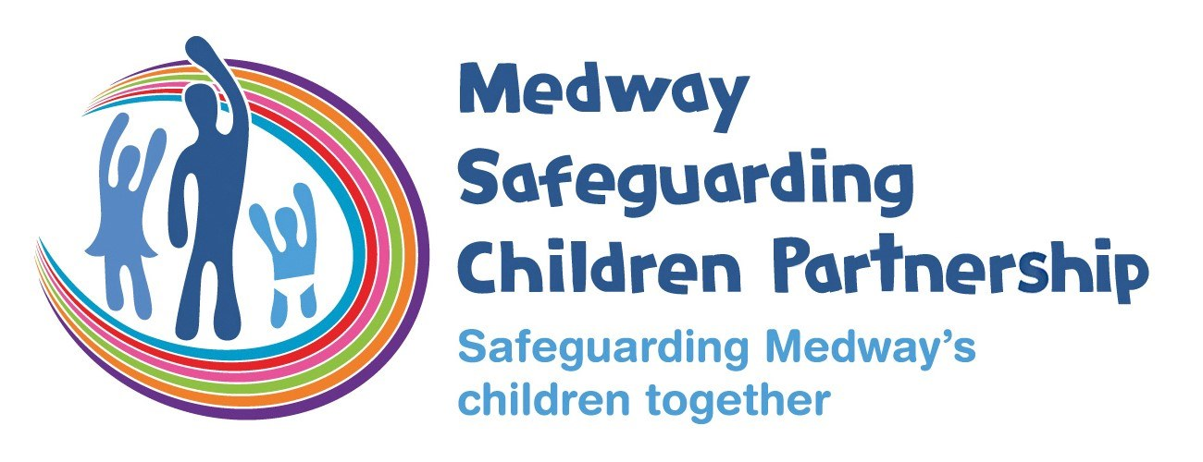

# Welcome to an extra edition of the MSCP bulletin.  Ahead of the school summer holiday this edition includes information you can share with children and families as well as some reminders, reading and listening recommendations for you.

# Who are MSCP and what is their role?

[Medway Council](https://www.medway.gov.uk/), [Kent Police](https://www.kent.police.uk/) and the [NHS Kent and Medway](https://www.kentandmedwayccg.nhs.uk/)are the three safeguarding partners that make up MSCP. We aim to support and enable local organisations and agencies to work together in a system where:-

* children are safeguarded and their welfare promoted
* partner organisations and agencies collaborate, share and co-own the vision for how to achieve improved outcomes for vulnerable children
* organisations and agencies challenge appropriately and hold one another to account effectively
* there is early identification and analysis of new safeguarding issues and emerging threats
* learning is promoted and embedded in a way that local services for children and families can become more reflective and implement changes to practice
* information is shared effectively to facilitate more accurate and timely decision-making for children and families.

# Activities and support for children and families.

Here are some online places where children and families can get information on activities, events, help and support:

Medway Family Hub App

Have you heard of the Medway Family Hub App?  It’s a free mobile phone app to provide support and advice for families across Medway.  The app brings together a wealth of resources and information into one place to make it easier for families living in Medway to access help, support, and advice.  The app allows residents to find out about local events and activities as well as allow families to connect with each and build their support networks so a great resource for the summer holiday.  [For more information.](https://www.medway.gov.uk/news/article/1678/new_app_to_support_medway_s_families)

Kent and Medway NHS Bump, Birth and Beyond

[The Kent and Medway Bump, Birth and Beyond](https://www.kentandmedwaylms.nhs.uk/) is a great website for new and expectant parents.  It includes the DadPad resource, a range of advice and guidance, contacts for Health Visitors and Midwives and details of local services.

Medway Local Offer

[The local offer](https://www.medway.gov.uk/localoffer) is an online hub that lets young people with special educational needs and disabilities (SEND) and their parents and carers know what services are out there and how they can access them.

Child Friendly Medway

Child Friendly Medway offer a variety of activities and events for children, young people and families in Medway.  Details can be found on the [website](https://www.medway.gov.uk/childfriendly) or follow them on [X](https://x.com/child_medway?ref_src=twsrc%5egoogle|twcamp%5eserp|twgr%5eauthor), [Instagram](https://www.instagram.com/childfriendlymedway/) and [Facebook](https://www.facebook.com/ChildFriendlyMedway/).

Medway Youth Service

Medway Youth Service provide programmes and activities for young people ages 8 to 19 and up to 25 with additional needs.  [Details of the summer activity holiday programme.](https://www.medway.gov.uk/youthsummeractivities)

MedwayGo

[MedwayGo](https://go.medway.gov.uk/) is where families can book holiday activities for children from Reception to Yr 11.  Children who are currently received benefits-related free school meals can attend free.

Medway Council

Medway Council have a dedicated summer space on their [website](https://www.medway.gov.uk/summer). It includes information on things to do, activities for children and staying well in summer.

Medway Foodbank

Operating all year round the [website](https://medway.foodbank.org.uk/get-help/) includes information on how to get foodbank vouchers and what is in their food parcel.

# Time to refresh your safeguarding knowledge?

August can be a great time to catch up on those things that get pushed down the ‘to do’ list.  If you need to refresh your safeguarding knowledge the MSCP has a range of e-Learning courses including safeguarding levels 1, 2 and 3 and topics such as trauma awareness and domestic abuse.  These courses are free and can be completed at your own pace.  If you are not already registered with MeLearning, [create an account](https://app.melearning.co.uk/auth/validate-key?registerKey=FXJKSRNW) and you can access a range of e-Learning courses.

If you have any queries regarding Me Learning or training please email [mscptraining@medway.gov.uk](mailto:mscptraining@medway.gov.uk).

# Autumn Training Dates

The MSCP has a range of virtual and in person training coming up in the autumn.

We’re recently received some great feedback on the Basic Safeguarding Children training including “I will now be able to support my workers with recognising the different signs of abuse, to ensure we can take the appropriate steps to ensure we safeguard the young people we work with."

As well as for Graded Care Profile 2 training "I really enjoyed the course and found it very informative. It helped me to identify families I can use to support."

* Local Authority Designated Officer (LADO) awareness sessions for MEDWAY, via Microsoft Teams, Wednesday 14th August 2024, 1:00pm-4:00pm.
* Reducing Parental Conflict, in-person, Thursday 19th September 2024, 9:30am-2:30pm.
* Threshold, via Microsoft Teams, Thursday 26th September 2024, 9:30am-11:30pm.
* Signs of Safety, via Microsoft Teams, Tuesday 1st October 2024, 9:30am-12:00pm.
* Local Authority Designated Officer (LADO) awareness sessions for MEDWAY, via Microsoft Teams, Wednesday 9th October 2024, 1:00pm-4:00pm.
* Working with Men and Fathers, via Microsoft Teams, Thursday 24th October 2024, 10:00am-12:00pm.
* Prevent awareness and radicalisation, via Microsoft Teams, Thursday 24th October 2024, 2:00pm-4:00pm.

Please note that our in-person courses are looking for alternative venues whilst Gun Wharf is temporarily closed. Please get in touch if you can offer a venue for around 20 delegates.

If you are interested in any training, you can enrol by [logging into your Me Learning account](https://app.melearning.co.uk/auth/login) or you can [create a Me Learning account](https://app.melearning.co.uk/auth/validate-key?registerKey=RGPNBJSW) instead, if you do not already have one.

If you have any queries regarding Me Learning or training please email [mscptraining@medway.gov.uk](mailto:mscptraining@medway.gov.uk).

# MSCP Neglect Conference - Hold the Date

Planning for the 3rd annual MSCP neglect conference is underway with the focus this year on hidden neglect. Further details to follow but for now hold the date of Friday 20 September 2024, 9:30 am - 12:30 pm.

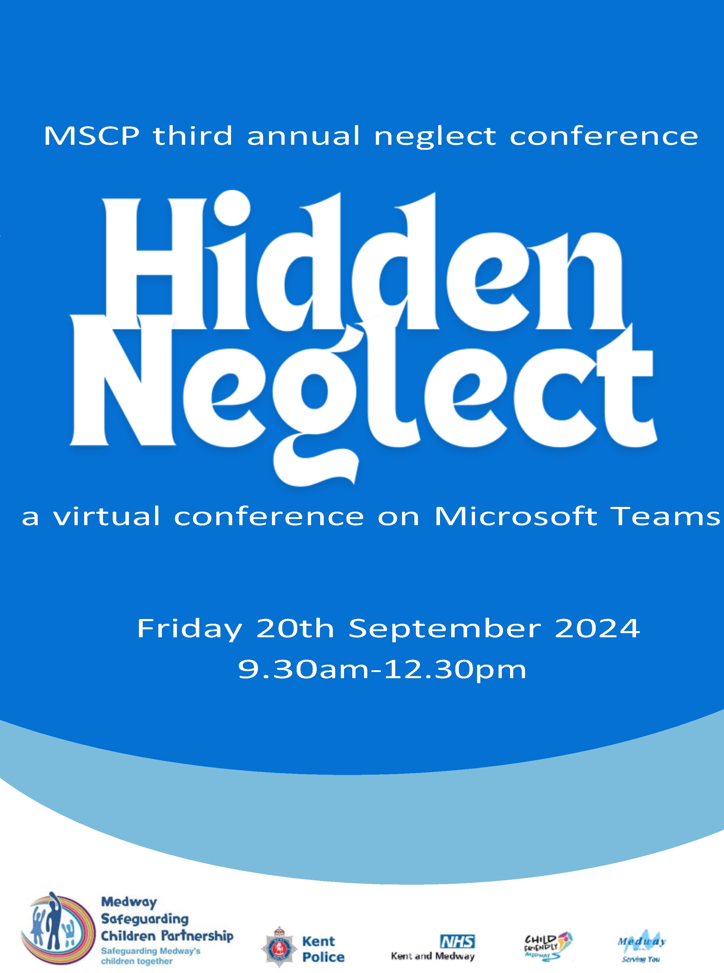

# Reading, Resources and Podcasts.

Reading:

Neglected Children and Their Families – if you haven’t read this book by Olive Stephenson, it comes highly recommended.  It explores recognising and detecting signs of emotional abuse and neglect, relevant to our children in Medway.

Resources:

Kent Police Child Exploitation Intelligence Portal – Amy Hewitt, Missing and Exploitation Lead (Medway Council Children’s Services) has produced a training video on the Kent police child exploitation intelligence portal. It includes what the intelligence portal is, the types of exploitation that can be referred through the portal, appropriate use and quality submissions.  You can [watch the video](https://www.medwayscp.org.uk/mscb/info/4/advice-resources-professionals/19/child-sexual-exploitation) on the MSCP website.

Podcasts:

NSPCC Learning – The NSPCC have a two-part podcast on child neglect.  In the first episode practitioners share their experiences of talking to parents about neglect and understanding the lived experience of babies and very young children.  The second episode explores why child neglect happens and how it is vital to keep children at the forefront of any responses to neglect.  Practitioners also talk about the Graded Care Profile 2 (GCP2) tool so if you are a licensed practitioner, it’s well worth a listen. [Listen to the podcast.](https://www.youtube.com/watch?v=6iMvwyBUPbs&list=PL_r_2Fqw0_0XtkRCJs3W-20sICj850oZQ&index=9)

# Drug Alerts - Kent

Two drug alerts have recently been issued following a large number of toxic reactions to substances which have occurred at Dreamland in Thanet.  We know that young people in Medway travel towards Thanet over the summer. Linked are the [details of drug and alcohol services for adults and young people in Medway](https://www.medway.gov.uk/info/200139/social_care_and_health/387/drug_and_alcohol_services).

# Kent Local Drug Information System



There continues to be the availability of a two main type of synthetic opioid drugs – nitazenes and fentanyls. Due to their unpredictable presence in the drug supply and toxicity, they pose a substantial risk of overdose, hospitalisation and death.

Cascade alert to: people working in drug and alcohol services, emergency services, health care settings and high-risk settings inc. pharmacies, prisons, probation services and Ambulance service.

June/July 2024: in North Kent (Dartford, Gravesham) there have been seven positive test results for nitazenes (self test kits) and four for fentanyl (in service urine tests) in the last four weeks. One overdose occurred – reversed by naloxone given by a friend.

These reports are the tip of the iceberg across Kent and Medway, and reflect ongoing, escalating risks to life.

There is good evidence that naloxone, the ‘antidote’ to opioid overdoses, works. The treatment required for an overdose that may be related to a potent synthetic opioid is the same as for other opioid overdoses, but delivering it rapidly and completely is even more critical, as progression to respiratory arrest, and recurrence of respiratory arrest, are more likely. Often, twice the normal dose of naloxone is needed due the toxicity of nitazenes and fentanyls.

Those in contact with all people who use drugs should be alert to the increased possibility of overdose arising from ‘heroin’ and many other reported drugs containing synthetic opioids, and be able to recognise possible symptoms of overdose and respond appropriately

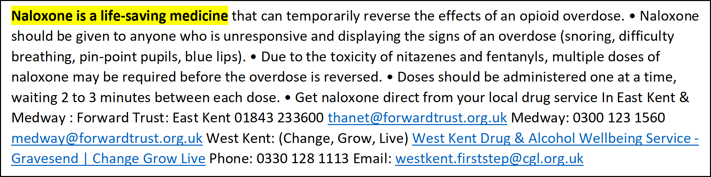





# MDMA (Ecstasy)

MDMA, commonly known as ecstasy, can cause severe health issues, including dehydration, overheating, heart problems, and even death. It is important to be aware of the risks and to avoid using unknown substances.

A large number of toxic reactions to substances occurred at Dreamland in Thanet, resulting in one death (lab-confirmed) and over 20 hospitalisations.

Consequences: significant risk of unexpected serious overdose and possible deaths, when taking substance at large event or given by somebody else.



* Be very cautious to decide what you take.
* It may not be what you think.
* Do not do it alone.
* Do not be afraid to seek urgent help.
* The Loops instagram account, which shares

up to date drug alerts regarding high

strength MDMA @theloop_uk

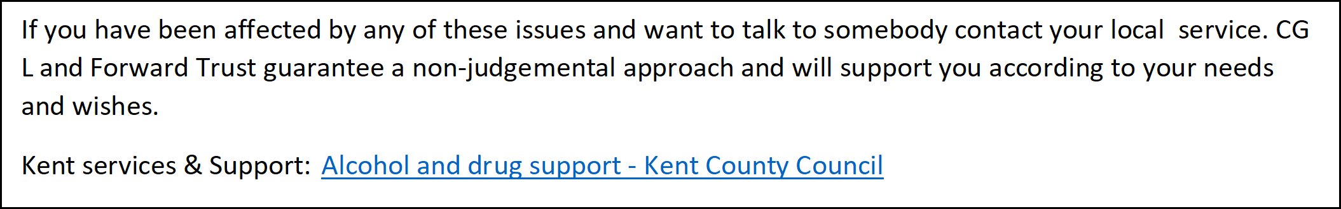

# Safeguarding Section 11 Audit - Deadline Reminder:

Don’t forget that the deadline for the Section 11 (S11) audit completion is 6 September 2024.  We hope all the S11 champions have had a chance to familiarise themselves with the new online tool.  If you have any questions or queries, please email [sally.millsted@medway.gov.uk](mailto:sally.millsted@medway.gov.uk)

Contacts and feedback

For general enquires email [mscp@medway.gov.uk](mailto:mscp@medway.gov.uk)

For training enquires email [mscptraining@medway.gov.uk](mailto:mscptraining@medway.gov.uk)

Social Media

[X](https://twitter.com/MedwaySCP)

[Linkedin](https://uk.linkedin.com/company/medway-safeguarding-children-partnership-mscp)

[YouTube](https://www.youtube.com/@medwaysafeguardingchildren7786)