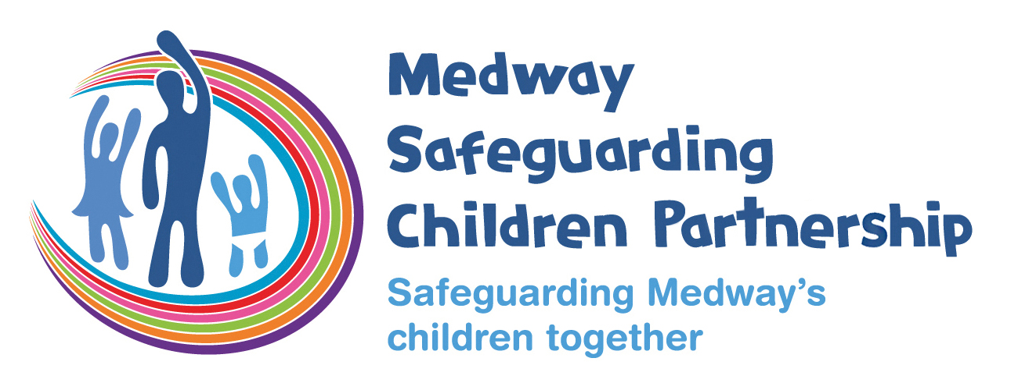

Guidance on completing the Conference Report

Please write the report based on your professional knowledge and understanding of the child and family.

What is working well?
Please include all information in relation to strengths and safety. Strengths are anything that you know of, have observed or have evidence of things going well for the child, family or network. Progress in relation to worries and who is doing what in relation to those worries. Safety is anything that you believe is reducing or managing the worries that have brought us to conference. Please be specific about who is doing what to reduce or manage risk.
What are you worried about?
Please include all information relating to harm and complicating factors. Harm is defined as behaviours that are negatively impacting the child/ren, in this instance, at a level of significant harm. Please include the severity (how bad), frequency (how often) and longevity (for how long) the behaviours have been going on for. For something to be defined as harm it must impact on the child/ren. Complicating factors are anything else that we are worried about, that makes life harder or make the harm harder to address.
What needs to happen?
Based on the information that you know about the child/ family, what do you think are the next steps that need to occur? Specifically, what can the family do, what can the professional network do and what can you do to improve the situation?

Voice of the Child/ Observations of the child/ren
This should reflect the child/young person’s views and lived experience within the family home and environment.

Safety Scale
This is for you to give a view, based on the information you hold and anything that has been shared with you, how worried you are about the child/ren. Please note that this is your view prior to the Child Protection Conference, and you are entitled to re-scale based on further information you receive in conference.

Chronology
This section should include details of any incidents, or significant events, both positive and negative, that your agency is aware of, the date, a brief summary of the event and action taken.

MULTI-AGENCY CHILD PROTECTION CONFERENCE REPORT

Agency details
Professionals Name
Job Title
Agency Name
E-mail address
Telephone Number

Meeting details
Meeting date
Meeting time

Child/ren’s Information
Name | NHS Number | Date of Birth
Address

Parent/Carer and significant family or household members information
Name | Date of Birth | Relationship
Address

What is working well?
Strengths
What do you know of, have observed or have evidence of things going well for the child, family or network?

What progress has there been in relation to worries and who is doing what in relation to those worries?
Safety
Who or what is reducing or managing the worries that have brought us to conference?

Please be as specific as possible.
What are you worried about?
Harm (please include both actual and potential harm)
For something to be defined as harm it must impact on the child/ren.

Harm is defined as behaviours that are negatively impacting the child/ren, in this instance, at a level of significant harm.

Please include the severity (how bad), frequency (how often) and longevity (for how long) the worries and behaviours have been going on for.

Complicating factors
What else are you worried about? What makes life harder for this family/ child? What makes the worries harder to address?

What needs to happen?
Next Steps
What do you think are the next steps that need to occur?
What can the family do, what can the professional network do and what can you do to improve the situation?

“Voice of the Child” / Observations of the child
What has the child/ren said to you or someone in your organisation? What observations of behaviour, interactions with family, peers and professionals have been made? Any other observations of the child/ren’s behaviour, presentation or interaction with others should be included here. Please be as specific as possible.

Safety Scale*
Based on the information you know at this moment in time. On a scale of 0-10, with 10 being there are some worries but I am confident the family/ network are managing all of the identified worries and the child/ren are safe and 0 is I am extremely concerned that the child/ren are very unsafe and are experiencing, or are at risk of experiencing, significant harm on a regular basis, where are you?

Please note that this is your view prior to the Child Protection Conference, and you are entitled to re-scale based on further information you receive in conference.
Reasons for your scaling score
 |  | YES | NO
Has this report been seen by the parents/ carers?
Has this report been seen by the child/ren/ young people?
What are the views of the parents/ carers and/or chid/ren/ young people on this report?

Report completed by:

Name |  | Job Title
Signature |  | Date

Chronology: please include both worries and evidence of progress
To insert a new row go to the menu bar, click on TABLE, then INSERT and select ROWS BELOW.
Date of contact/  intervention | Type of event  e.g. birth, death, ICPCC, Assessment, attendance at appointment, progress noted in relation to concern or improved behaviour by parent/ child/ren | Details and outcome i.e. what happened as a result of the event e.g. child remained in hospital following premature birth, father arrested following domestic abuse incident, child excluded from school, baby putting on weight and within expected centiles | Name of child/ren to whom events apply  (if not all) | Source of information e.g. police , other local Authority file, School etc | Safeguarding action taken by your organisation, if needed

HEALTH PROFESSIONALS SECTION
This section is only to be completed by Midwives and Public Health Nurses. Please complete the following sections for each child.

Child/ Young Person’s Name

Relevant ante-natal/ birth details

Growth
Date | Weight (centile) | Height (centile) | Head circumference (centile) | BMI
Comments/ Evaluation:

The routine immunization schedule from June 2020
Age Due | Vaccine | Date of immunisation
Eight weeks old | DTaP/IPV/Hib/HepB
Eight weeks old | MenB
Eight weeks old | Rotavirus
Twelve weeks old | DTaP/IPV/Hib/HepB
Twelve weeks old | Pneumococcal conjugate vaccine (PCV)
Twelve weeks old | Rotavirus
Sixteen weeks old | DTaP/IPV/Hib/HepB
Sixteen weeks old | MenB
One year old (on or after the child’s first birthday) | Hib/MenC
One year old (on or after the child’s first birthday) | PCV Booster
One year old (on or after the child’s first birthday) | MMR
One year old (on or after the child’s first birthday) | MenB Booster
Three years four months old or soon after | dTaP/IPV
Three years four months old or soon after | MMR (check first dose given)
Boys and Girls ages twelve to thirteen years | HPV (two doses 6-24 months apart)
Fourteen years old (school year 9) | Td/IPV (check MMR status)
Fourteen years old (school year 9) | MenACWY

POLICE INTELLEGENCE SECTION
This section is only to be completed by the Child Abuse Investigation Unit. Please complete the following sections for each member of the household.

Information about incident(s) leading to conference and/or current situation:

