Medway Safeguarding Children Partnership (MSCP) June 2024

# Welcome to the MSCP Bulletin - June 2024

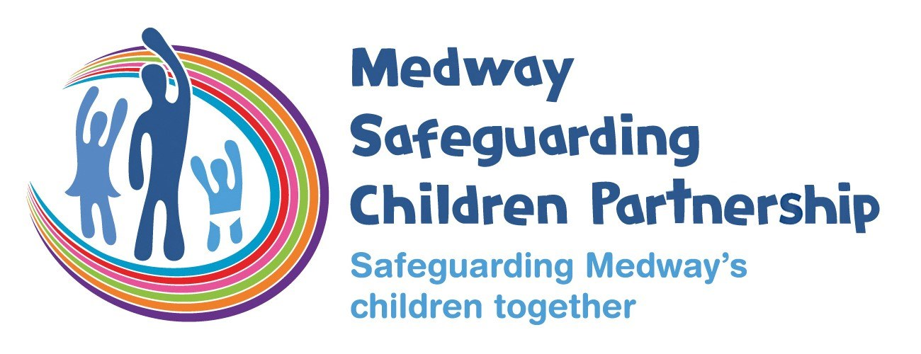

# Who are MSCP and what is their role?

[Medway Council](https://www.medway.gov.uk/), [Kent Police](https://www.kent.police.uk/) and the [NHS Kent and Medway](https://www.kentandmedwayccg.nhs.uk/)are the three safeguarding partners that make up MSCP. We aim to support and enable local organisations and agencies to work together in a system where:-

* children are safeguarded and their welfare promoted
* partner organisations and agencies collaborate, share and co-own the vision for how to achieve improved outcomes for vulnerable children
* organisations and agencies challenge appropriately and hold one another to account effectively
* there is early identification and analysis of new safeguarding issues and emerging threats
* learning is promoted and embedded in a way that local services for children and families can become more reflective and implement changes to practice
* information is shared effectively to facilitate more accurate and timely decision-making for children and families.

# Welcome the new MSCP Business Manager - Anna Batty

Hello, my name is Anna Batty, and I’m really pleased to have joined the Medway Safeguarding Children Partnership (MSCP) as the Business Manager.  I’m new to Medway having previously worked in early help partnership roles in Berkshire and Dorset and been enjoying getting to know the area and people.  As the MSCP Business Manager I have the privilege of working closely with colleagues from across agencies in Medway and although it’s early days for me I can see the commitment to working together locally to make a real difference for our children and their families. I’ve had a very warm welcome from the MSCP business unit team and colleagues that I have met across the partnership.  I look forward to working with you in the future.

Please do take 5mins to have a look at the June MSCP bulletin.  It has local and national information and updates as well as details of MSCP training opportunities.  If you have any feedback on the bulletin to help shape future editions, please email us on [mscp@medway.gov.uk](mailto:mscp@medway.gov.uk).

# Voice of the child

NSPCC Learning has published a briefing summarising learning from case reviews to support improved practice around the voice of the child. The briefing is based on a sample of case reviews published between 2019 and 2023 where practice issues around hearing the voice of the child were a key factor. Learning includes: understanding what the voice of the child is; incorporating the child’s voice into assessments and arrangements; gaining appropriate skills and knowledge to understand and reflect upon the child’s voice; and building relationships to ensure the child’s voice is heard and understood.

[Read the Voice of the child: learning from case reviews.](https://learning.nspcc.org.uk/research-resources/learning-from-case-reviews/voice-child?utm_campaign=20240520_KIS_CASPAR_May20&utm_content=Voice of the child%3A learning from case reviews&utm_medium=email&utm_source=Adestra)

# Keeping Children Safe in Education (2024)

The Department for Education (DfE) has now published the latest (for information) version of [Keeping Children Safe in Education](https://www.gov.uk/government/publications/keeping-children-safe-in-education--2) ready for September 2024. This is statutory guidance which schools and colleges in England must have regard to it when carrying out their duties to safeguard and promote the welfare of children.

# Absenteeism in schools

Education is a vital part of ensuring children get the best possible start in life, and there can be safeguarding implications for children who are absent from school. If children miss school, the ability that schools have to offer them the support they need is compromised. And missing school may be an indicator of broader child protection concerns.

The number of children who are persistently absent from school has increased since the COVID-19 pandemic. In this podcast episode, experts from the NSPCC and Childline discuss the potential causes for this, and what schools can do to address the problem. You’ll also hear two secondary school students share their thoughts on how the stresses and strains of school life can affect attendance.

The discussion covered:

* what school absenteeism is and how it is defined
* what the safeguarding implications could be for children who miss school
* the impact of the pandemic on absenteeism trends
* what schools can do to prevent absenteeism and support persistently absent children
* what Childline is hearing about why children miss school.

[Listen to the podcast on YouTube](https://www.youtube.com/watch?v=BvTYXJWPuV8)

# Medway Obesity Care pathway

Medway is fortunate to have commissioned More-Life to provide a Tier 3 weight management programme for children and families.  This service is generally for those with more complex needs and criteria include;

* >98th percentile
* Presence of Co-morbidity
* Anxiety or depression
* Emotional or behavioural issues
* Lives in Medway
* Ready to change.
* Needs further support.

If you have any children or young people that you have concerns about in relation to their weight, and who would fit these criteria, please contact them or their parent /carers to discuss and assess readiness to change.  If they are in agreement and would benefit from this support, please email [Tippingthebalance@nhs.net](mailto:Tippingthebalance@nhs.net) a complete Child/Young person Supporting Healthy Weight Referral Form that is below.

# Child/Young person Supporting Healthy Weight Referral Form

Please refer to the Medway Obesity Care Pathway for information prior to completing this form.

In addition, please review the criteria below before referring to **Tier 2 or 3** services

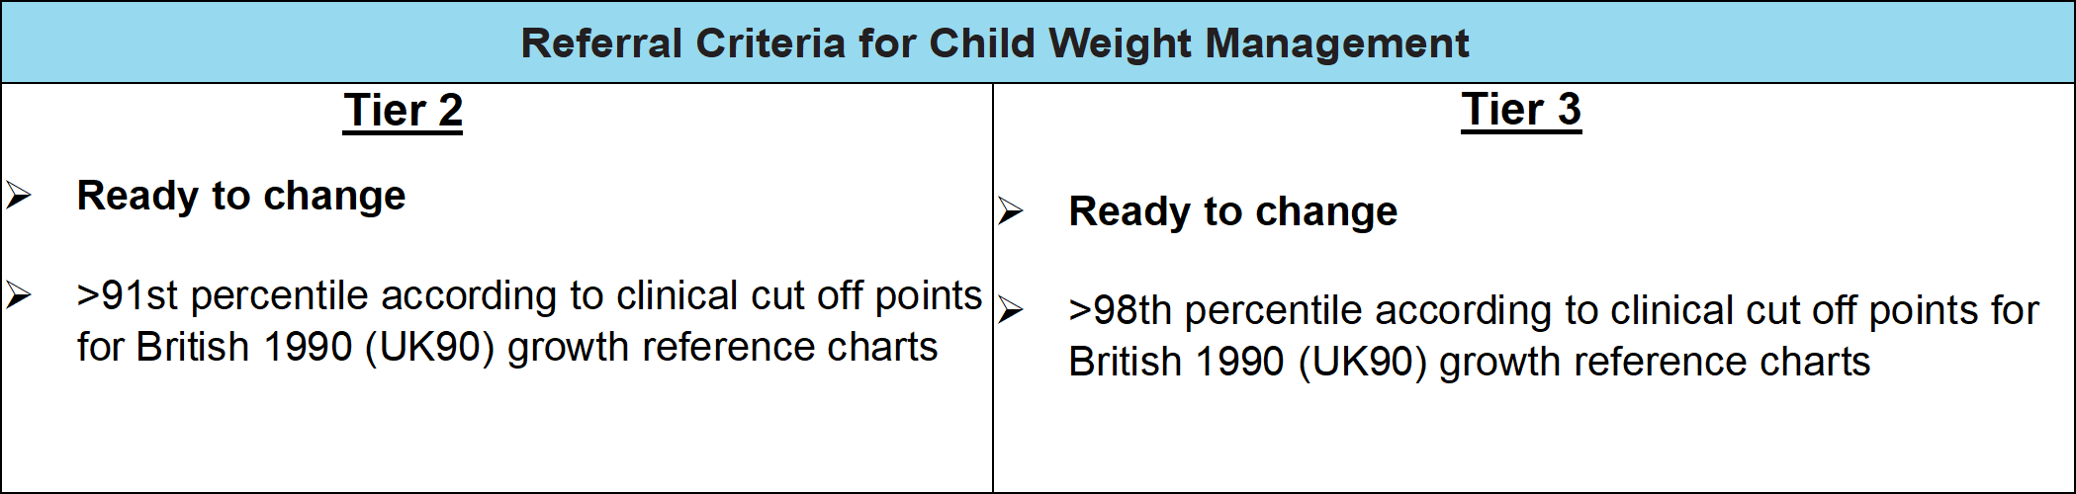

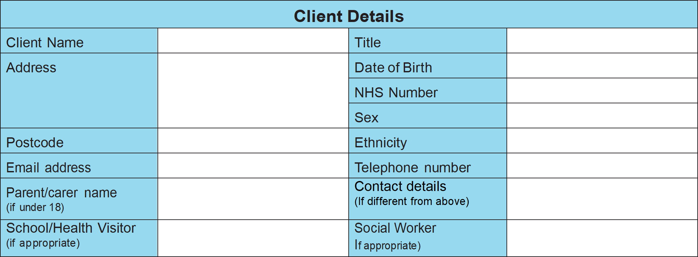

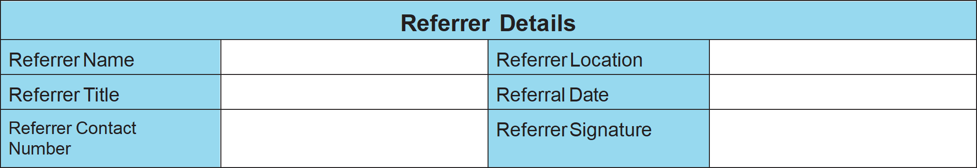

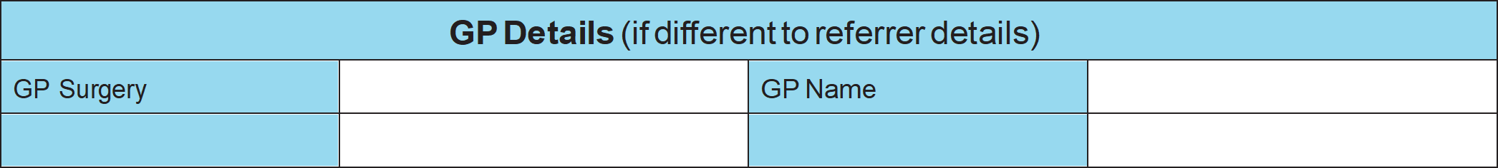

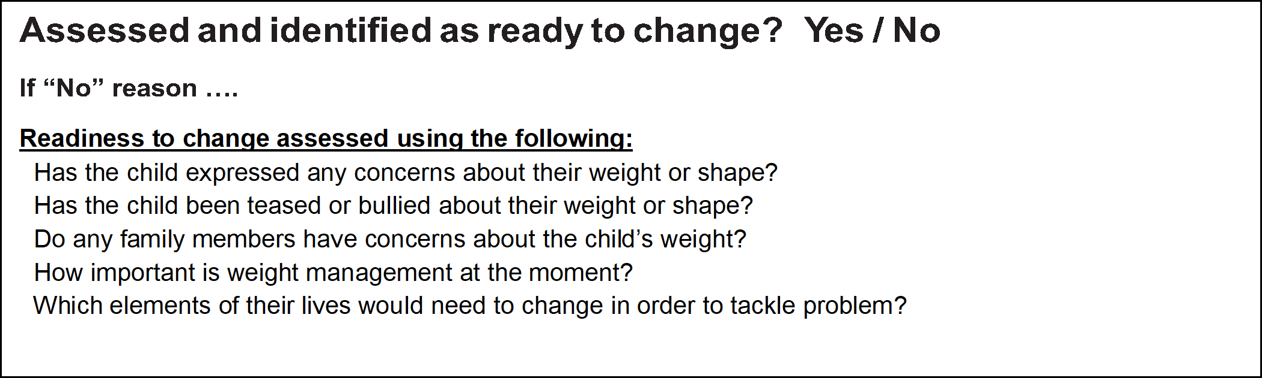

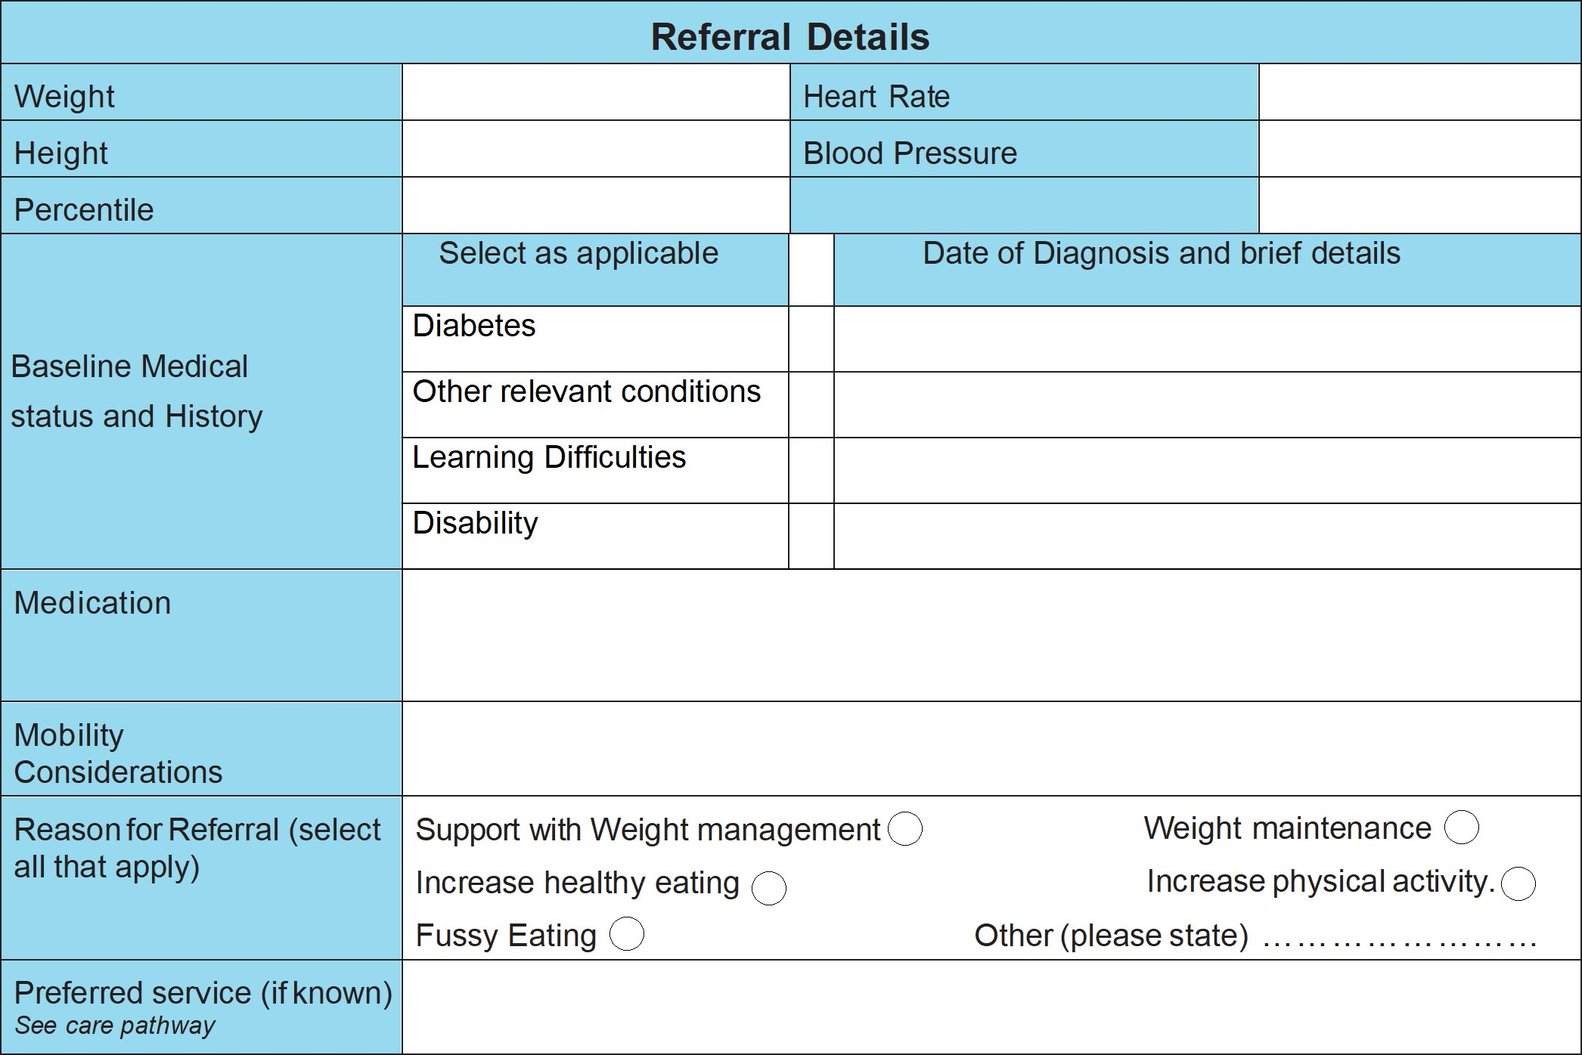

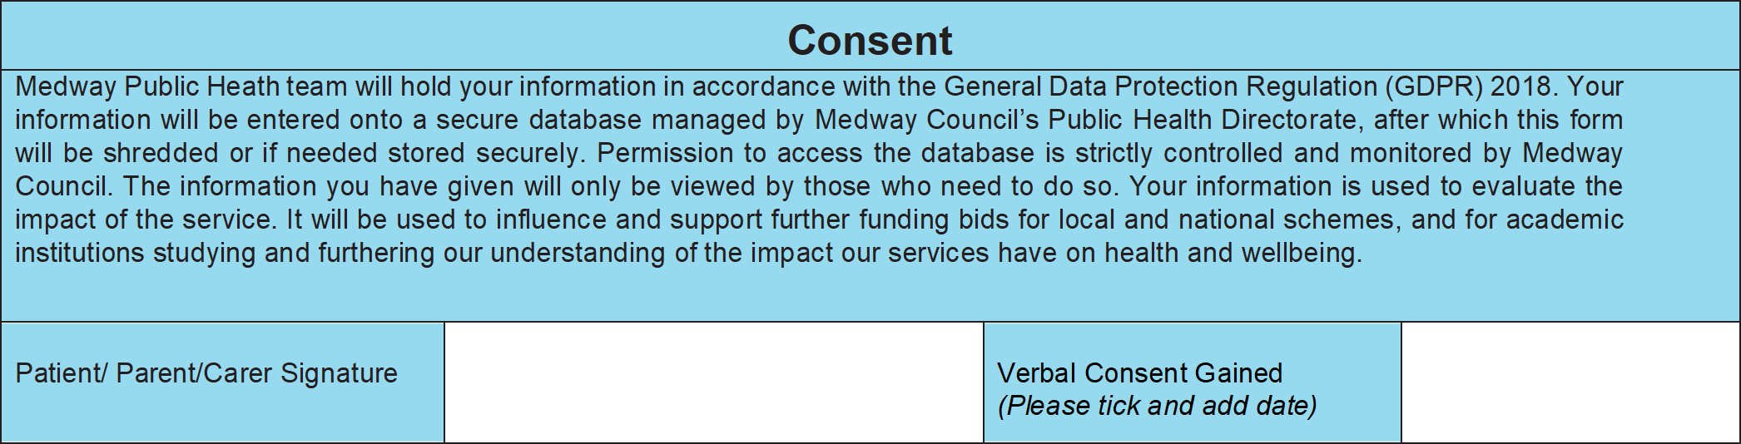

Please return this form to:

Supporting Healthy Weight Team Public Health, Gun Wharf (Level 2), Dock Road, Chatham, Kent, ME4 4TR

Tel: 01634 333101 Email: [tippingthebalance@nhs.net](mailto:tippingthebalance@nhs.net) Fax: 01634 333773

# A Reminder - Working Together to Safeguard Children (2023)

If you are new to your role or this if the first time you’ve received the MSCP bulletin a reminder that the Department for Education (DfE) published a new edition of its statutory guidance [Working together to safeguard children](https://assets.publishing.service.gov.uk/media/65803fe31c0c2a000d18cf40/Working_together_to_safeguard_children_2023_-_statutory_guidance.pdf) in December 2023. This 2023 edition replaces Working Together to Safeguard Children 2018, which underwent a limited factual update in 2020.

The guidance outlines what organisations and agencies must and should do to help, protect and promote the welfare of all children and young people under the age of 18 in England and should be read and followed by leaders, managers and frontline practitioners.

The guidance The NSPCC have published a helpful briefing – [Working together to safeguard children 2023: summary of changes](https://learning.nspcc.org.uk/research-resources/2023/working-together-to-safeguard-children-2023-summary-of-changes) – which includes updates around:

* multi-agency expectations for all practitioners
* working with parents and families
* clarifying the roles and responsibilities of safeguarding partners
* the role of education and childcare providers
* multi-agency practice standards
* support for disabled children
* tackling harm that occurs outside the home

# Child Safeguarding Practice Review panel: Safeguarding children in elective home education

The Panel has published a short briefing paper about safeguarding children in elective home education. The briefing explores common themes and patterns identified across reviews where children died or were seriously harmed while being electively home educated. It highlights practice issues raised by safeguarding partners and shares learning from reviews to help improve the quality of multi-agency safeguarding practice and thereby enhance how this group of children may be better protected in the future.

While the briefing is clear that home education is not, in and of itself, a safeguarding risk, the findings show that children who were the focus of safeguarding reviews were less visible to safeguarding agencies than those who attend school. Therefore, the Panel is joining calls for a statutory register of children who are electively home educated to help safeguarding agencies have better local knowledge about this group of children.

The Panel recommends that safeguarding partners assure themselves about the effectiveness of their local systems to help safeguard children who are electively home educated. Learning from reviews highlights the importance of ensuring there is good safeguarding training on offer for elective home education teams within local authorities, and also that these teams are well connected with other children’s services.

Over half of the children in this study were previously known to children’s social care; of those who were withdrawn from school or had never attended school, health practitioners were often the main professionals who had knowledge of the child before the serious harm or death occurred. Therefore, it is crucial that effective multi-agency working is at the heart of local responses to help and protect this group of children. We suggest that safeguarding partnerships take appropriate action to make sure that all professionals understand their roles and responsibilities with respect of this group of children.

[To read the report on safeguarding children in elective home education.](https://www.gov.uk/government/publications/safeguarding-children-in-elective-home-education)

# Rapid Review Learning - Child Safeguarding and Serious Violence (A collaboration by 4 partnerships)

In 2024, key professionals from 4 Safeguarding Children Partnerships came together to review a case of serious violence involving children. To protect the identity of those involved, the partnerships other than Kent will remain anonymous.

This local Rapid review explored themes of foster carers and looked after children, domestic abuse, over-optimism of mother as a protective factor, gangs, youth violence and child exploitation, cross border handover, Identify, culture and ethnicity. Professionals are encouraged to reflect upon their own knowledge and experience according to each theme, and undertake relevant training in their local area to supplement this briefing.

[To read the local rapid review.](https://sway.cloud.microsoft/2oUxOL3NKsprlu8o?ref=Link&loc=play)

# NHS Kent and Medway – Integrated Care Board (ICB) Summit

Medway Public Health in partnership with Kent and Medway ICB and funded by NHS Charities together, are delighted to invite you to attend our Kent and Medway Self Harm Summit that will be taking place Thursday 17th October 2024. The day will be held at The Village Hotel, Maidstone and will focus on supporting those that self-harm and how we as professionals can provide advice and guidance within our communities and professional settings. We are so excited to have confirmed a number of national and local experts to support the day, including Satveer Nijjar from Attention Seekers and Dr Faye Hinsley - Kent and Medway Clinical Lead for Children and Young People.

Who should attend:

This event is for professionals working with children and young people across Kent and Medway and may be of particular interest to colleagues working in health services, commissioning, education, youth services, safeguarding and pastoral roles.

[Regiester your place.](https://healthtraining.medway.gov.uk/training-courses/2cac0050-137d-11ef-a5c2-3bfa24046155/kent-and-medway-self-harm-summit)

# Dismantling the barriers: collaborative approaches to perinatal mental health care

The Institute of Health Visting are hosting a virtual half-day conference where they will focus on raising awareness of families whose perinatal mental health needs are less well met and understood. It will be suitable for all practitioners working with families in the perinatal period as well as service leads, commissioners, researchers and policy makers.

The conference themes will include:

* Young parent families
* Gypsy Roma and Traveller families
* Families with mothers in prison
* Asylum-seeking families

The virtual conference will be taking place Thursday 19th Septemeber 2024.

[To purchase tickets for the conference.](https://app.azavista.com/w/event/663e3610b779da6b04062991/?page_id=663e3615d6a1cedf1ea3eff5)

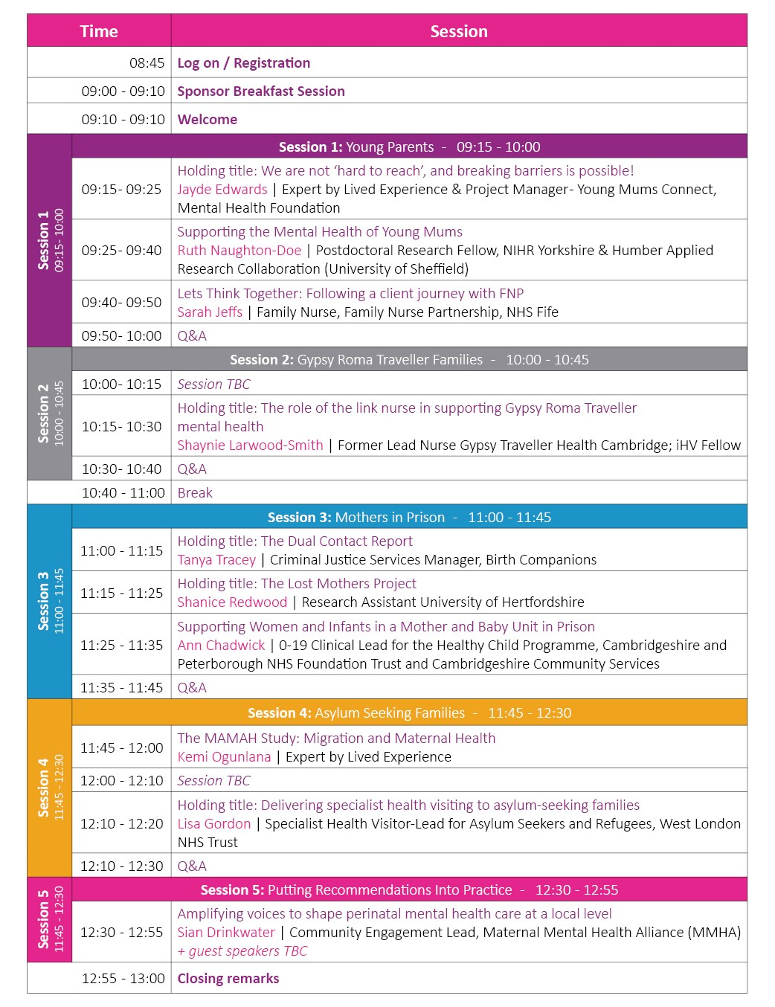

- The programme content is still being confirmed and subject to change.

# Information Sharing: [Advice for practitioners providing safeguarding services for children, young people, parents and carers](https://www.gov.uk/government/publications/safeguarding-practitioners-information-sharing-advice)

This is the latest version of the non-statutory guidance for:

* all individuals who are directly involved in safeguarding children, including frontline practitioners, managers and senior leaders.
* individuals and organisations that work with children, parents, carers and families, in sectors such as social care, education, health, justice and voluntary.

[The guidance](https://www.gov.uk/government/publications/safeguarding-practitioners-information-sharing-advice) highlights seven golden rules for information sharing:

1. All children have a right to be protected from abuse and neglect. Protecting a child from such harm takes priority over protecting their privacy, or the privacy rights of the person(s) failing to protect them.
2. When you have a safeguarding concern, wherever it is practicable and safe to do so, engage with the child and/or their carer(s), and explain who you intend to share information with, what information you will be sharing and why.
3. You do not need consent to share personal information about a child and/or members of their family if a child is at risk or there is a perceived risk of harm.
4. Seek advice promptly whenever you are uncertain or do not fully understand how the legal framework supports information sharing in a particular case.
5. When sharing information, ensure you and the person or agency/organisation that receives the information take steps to protect the identities of any individuals (e.g., the child, a carer, a neighbour, or a colleague) who might suffer harm if their details became known to an abuser or one of their associates.
6. Only share relevant and accurate information with individuals or agencies/ organisations that have a role in safeguarding the child and/or providing their family with support, and only share the information they need to support the provision of their services.
7. Record the reasons for your information sharing decision, irrespective of whether or not you decide to share information.

# Upcoming training sessions - booking through Me Learning

* Graded Care Profile 2 (GCP2), in-person, Tuesday 2rd July 2024, 9:30am-4:30pm.
* Refresher GCP2 training for licenced practitioners, via Microsoft Teams, Tuesday 9th July 2024, 9:30am-12:00pm.
* Intermediate safeguarding children training, in-person, Wednesday 17th July 2024, 9:30am-4:30pm.
* Local Authority Designated Officer (LADO) awareness sessions for MEDWAY, via Microsoft Teams, Wednesday 14th August 2024, 1:00pm-4:00pm.
* Basic safeguarding children training, in-person, Thursday 19th September 2024, 9:30am-4:30pm.
* Reducing Parental Conflict, in-person, Thursday 19th September 2024, 9:30am-2:30pm.
* Graded Care Profile 2 (GCP2), in-person, Thursday 26th September 2024, 9:30am-4:30pm.
* Threshold, via Microsoft Teams, Thursday 26th September 2024, 9:30am-11:30pm.
* Signs of Safety, via Microsoft Teams, Tuesday 1st October 2024, 9:30am-12:00pm.
* Local Authority Designated Officer (LADO) awareness sessions for MEDWAY, via Microsoft Teams, Wednesday 9th October 2024, 1:00pm-4:00pm.
* Intermediate safeguarding children training, in-person, Thursday 10th October 2024, 9:30am-4:30pm.
* Working with Men and Fathers, via Microsoft Teams, Thursday 24th October 2024, 10:00am-12:00pm.
* Prevent awareness and radicalisation, via Microsoft Teams, Thursday 24th October 2024, 2:00pm-4:00pm.

**Please note that our in-person courses are looking for alternative venues whilst Gun Wharf is temporarily closed. Please get in touch if you can offer a venue for around 20 delegates.**

If you are interested in any training, you can enrol by [logging into your Me Learning account](https://app.melearning.co.uk/auth/login) or you can [create a Me Learning account](https://app.melearning.co.uk/auth/validate-key?registerKey=RGPNBJSW) instead, if you do not already have one.

If you have any queries regarding Me Learning or training please email [mscptraining@medway.gov.uk](mailto:mscptraining@medway.gov.uk).

**Contacts and feedback**

For general enquires email [mscp@medway.gov.uk](mailto:mscp@medway.gov.uk)

For training enquires email [mscptraining@medway.gov.uk](mailto:mscptraining@medway.gov.uk)

**Social Media**

[X](https://twitter.com/MedwaySCP)

[Linkedin](https://uk.linkedin.com/company/medway-safeguarding-children-partnership-mscp)

[YouTube](https://www.youtube.com/@medwaysafeguardingchildren7786)