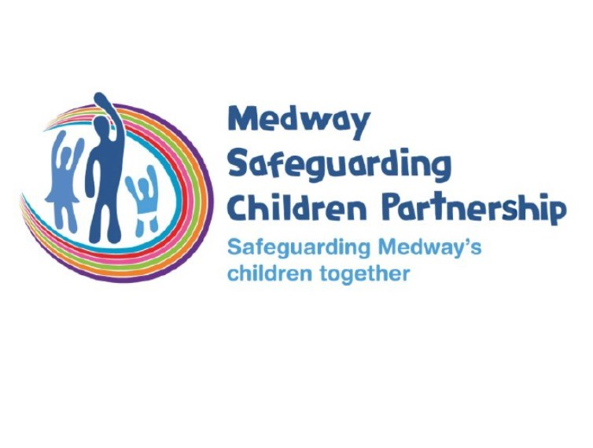

The Graded Care Profile 2 (GCP2) - Introductory information for colleagues working across Medway

April 2024

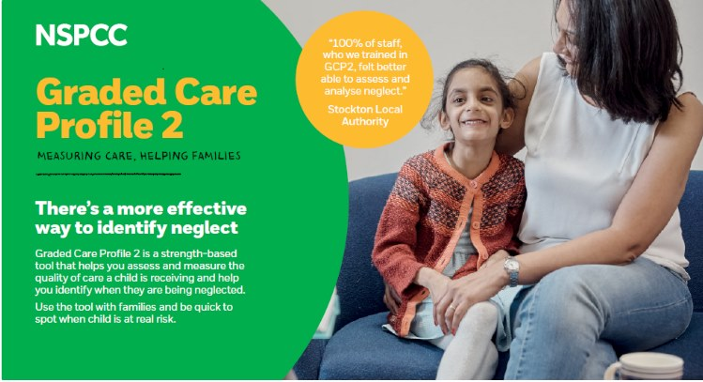

# The GCP2 was developed by the NSPCC to measure the quality of care a child receives. In Medway and other areas, it is used where neglect is known or suspected.

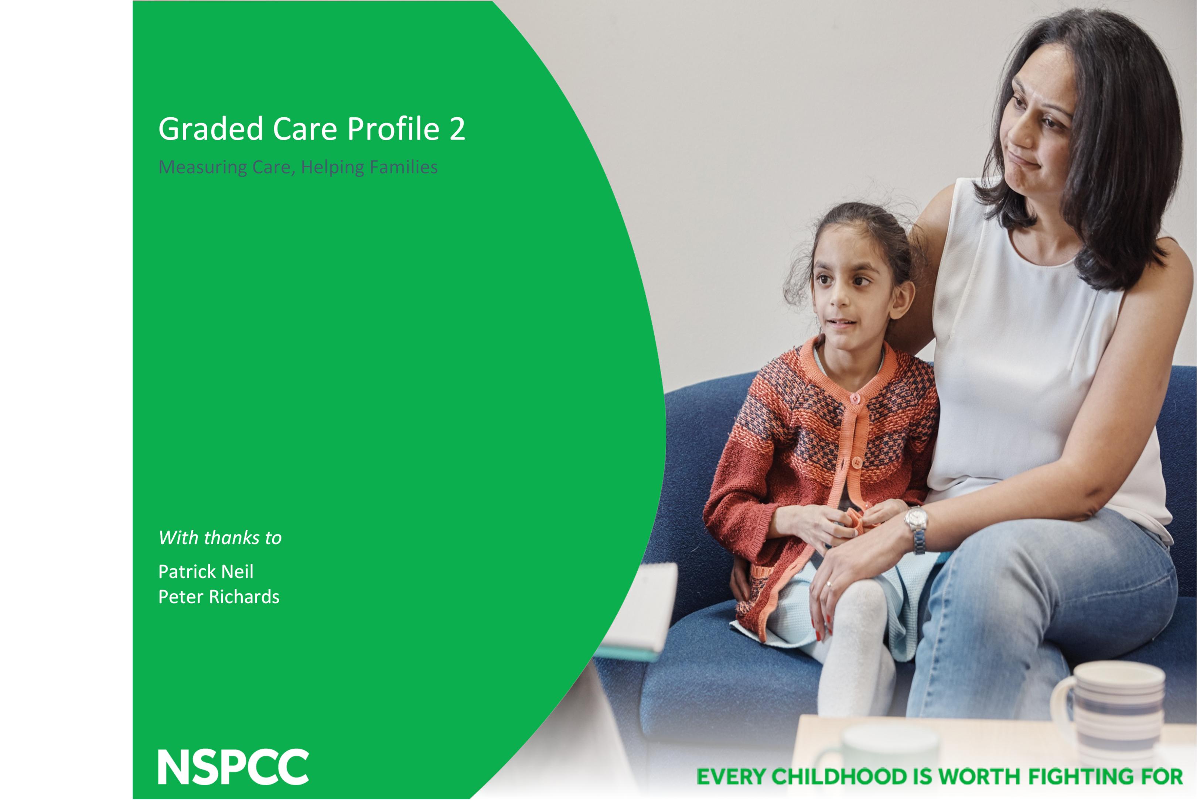

For further background and evidence on the development of the GCP2 tool please [click here](https://learning.nspcc.org.uk/services-children-families/scale-up/graded-care-profile-2-gcp2)

The GCP2 tool was introduced in Medway in 2019. Locally over five hundred practitioners are trained to use the tool.

# What is neglect?



It is the persistent failure to meet a child's physical and/or emotional needs likely to result in serious impairment of the child's development.....It may involve a parent or carer failing to provide adequate food, shelter and clothing, failing to protect a child from physical harm or danger, or the failure to ensure access to appropriate medical care or treatment......it may also include neglect of, or unresponsiveness to a child's basic emotional needs......" Department of health

[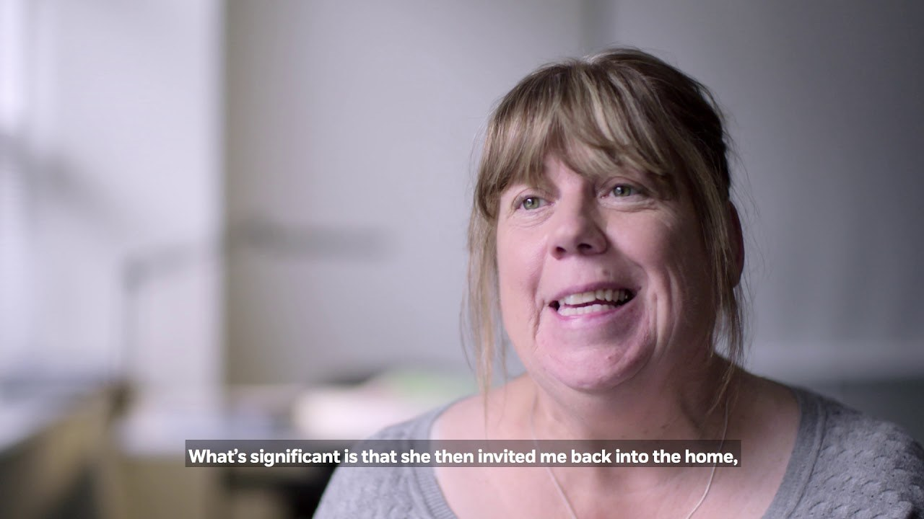](https://youtu.be/b2TZf5H5hKg)

1 - GCP2: measuring care, helping families

This short [NSPCC video](https://www.youtube.com/watch?v=tVE3bgHOnes) explains the different levels of care the tool assesses

What is the GCP2?

It is an evidence based assessment tool for evaluating levels of parental care

* Uses Maslow’s hierarchy of needs to ensure comprehensive coverage of child’s needs
* Uses a graded scale (1-5) to capture levels of child’s physical and emotional care
* Can help identify parental strengths and concerns
* Targets aspects of neglectful care
* Provides evidence that can inform intervention and care planning
* Is used with single assessments, early help assessments or specialist assessments

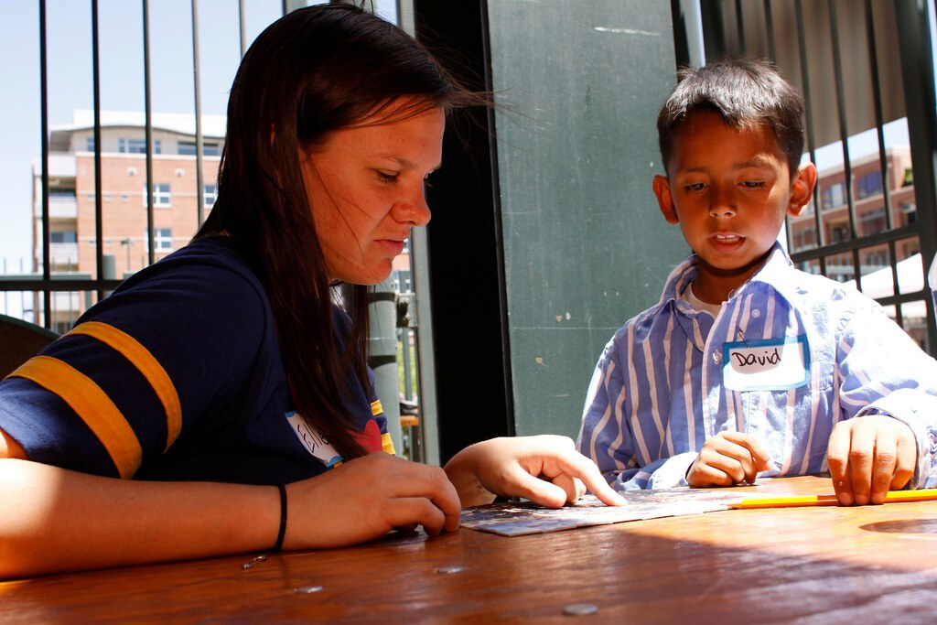

2 - Who can use the tool?

* Who can use the tool?
* Social workers
* Family Support workers
* Teachers
* Health staff
* Police
* Youth workers
* Voluntary sector
* Childcare providers
* Parents and young people



3 - Benefits to families:

Benefits to families:

Parents encouraged by strengths identified and seeing improvements in scores

Better understanding of how their behaviours may harm their child

Breaks concerns down in priority areas - more achievable

Supports adolescents understanding of hte care they should be receiving

Many examples of escalation and de-escalation

Medway Safeguarding Children's Partnership offers free GCP2 practitioner training to multi-agency colleagues.

To become a licenced GPC2 practitioner, you will need to attend a one-day face-to-face licensed training programme in Medway.

The course is suited to a range of professionals and those who carry out home visits.

Further information is available on our website [here](https://www.medwayscp.org.uk/mscb/info/6/training/42/graded-care-profile-training) or contact us at mscptraining@medway.gov.uk

Concerned a child is being neglected?

If you are concerned about neglect in a family you are working with, contact your safeguarding lead to make a referral to Children's Social Care and ask for a GCP2 tool to be completed with the family

Medway's First Response Service can be found [here](https://www.medway.gov.uk/info/200170/children_and_families/600/concerned_about_a_child/2)

Medway Children's Social Care 01634 334 466 or the 24 hour emergency number is 03000 419 191

Medway Police 0162 2690 690

Emergency 999

NSPCC 0808 800 5000