Medway Safeguarding Children Partnership (MSCP) No 16

# Welcome to the MSCP Bulletin - No.16

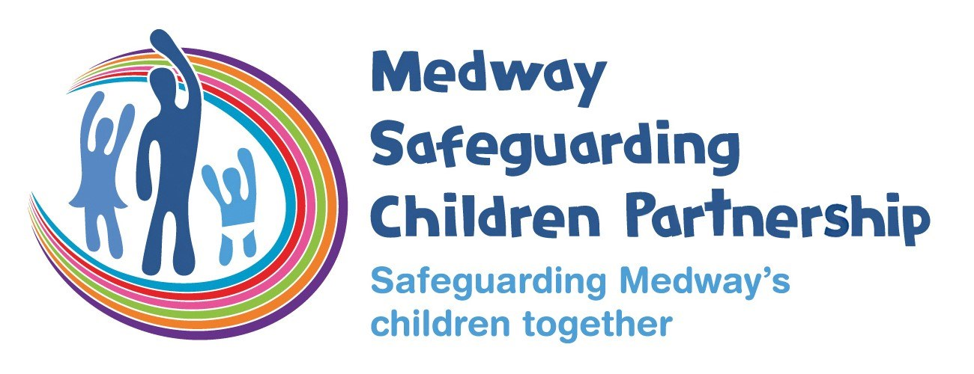

# Who are MSCP and what is their role?

[Medway Council](https://www.medway.gov.uk/), [Kent Police](https://www.kent.police.uk/) and the [NHS Kent and Medway](https://www.kentandmedwayccg.nhs.uk/)are the three safeguarding partners that make up MSCP. We aim to support and enable local organisations and agencies to work together in a system where:-

* children are safeguarded and their welfare promoted
* partner organisations and agencies collaborate, share and co-own the vision for how to achieve improved outcomes for vulnerable children
* organisations and agencies challenge appropriately and hold one another to account effectively
* there is early identification and analysis of new safeguarding issues and emerging threats
* learning is promoted and embedded in a way that local services for children and families can become more reflective and implement changes to practice
* information is shared effectively to facilitate more accurate and timely decision-making for children and families.

# What is Safer Sleep Week?

Safer Sleep Week is The Lullaby Trust’s national awareness campaign targeting anyone looking after a young baby. It aims to raise awareness of sudden infant death syndrome (SIDS) and the simple advice that reduces the risk of it occurring.

We know that greater awareness of safer sleep leads to a decrease in the numbers of babies dying. Sadly around 3 babies a week still die from SIDS and if all parents were aware of safer sleep advice many lives could be saved.

**The theme for this year’s Safer Sleep Week campaign is the safest place.**Babies’ airways are vulnerable, particularly in the first few months of life, so it is important that parents and carers are aware of this and the actions they can take to protect them. The simplest way to do this is by sleeping a baby on their back on a firm, flat surface with no padded or cushioned areas. This will help to keep their airways open and reduce the risk of suffocation and SIDS. A cot, Moses basket, bassinet, carry cot, or crib all fulfil these criteria.

KEY CAMPAIGN MESSAGES:

* Every baby needs a cot.
* The safest place for a baby to sleep is in a firm, flat, clear, separate sleep space.
* A baby’s airway is vulnerable and need to be protected. Sleeping a baby on their back on a firm, flat surface will help to keep their airway open and also reduce the risk of SIDS.
* It is not safe for babies to sleep on soft-sided pods or nests, hammocks, sleep positioners, or bean bags or have cot bumpers, weighted bedding blankets, pillows, and duvets in their sleep space. We would advise against buying these products.
* Bouncers and baby swings are only for use when a baby is awake, and they should not sleep, nap or doze in them. If baby falls asleep, move them to a firm, flat surface.
* Parents who co-sleep should still have a cot or Moses basket for their baby for nights when circumstances change and co-sleeping becomes high-risk. For example, a parent or carer has had any alcohol or taken any medication that makes them drowsy.
* Car seats are essential for safety but babies should not sleep in them when not travelling.
* The safest baby carrier to use will keep the infant firmly in an upright position where a parent can always see their baby’s face, and ensure their airways are free. The risk appears to be greatest when a baby’s airway is obstructed either by their chin resting on their chest or their mouth and nose being covered by a parent’s skin or clothing. When wearing a sling or baby carrier, keep in mind the TICKS guidelines. **T**ight, **I**n view at all times, **C**lose enough to kiss, **K**eep chin off the chest, **S**upported back)
* If you don’t have access to a cot or Moses basket, we can help advise on what to do and how to create a safer sleep space.
* Every family should have a safe space for their baby to sleep.

[For more information and examples of how to support parents and carers create a safe sleep space for babies.](https://www.lullabytrust.org.uk/about-us/safer-sleep-week/)

The MSCP will be posting advice all through safer sleep week on our social media.

# National child exploitation awareness day – Monday 18th March 2024.

Medway is shining a light on this day and is hosting its first conference at Priestfield Stadium called Be Aware, Be Brave, Be Curious on the day.   To register your interest please use the [booking form](https://forms.office.com/Pages/ResponsePage.aspx?id=kz5QaOc8Ikq_xf_uQhofV8Dhdsr5H01CoshtLNEQOfRUOVZJTzZJSlNMVkhHUlM3WVM5UU1KWTRFMy4u) your place will be confirmed in an email.

Medway has a strong Exploitation champions network that is supported by the MSCP.  We meeting quarterly on teams, to join us and receive copies of the minutes [please sign up here.](https://forms.office.com/pages/responsepage.aspx?id=kz5QaOc8Ikq_xf_uQhofVxQZ1XinviNEhAaDtefc2D9UNjFUNU9US0Y2VTJYUDdCNFcwRUlNMU0xRi4u)

Promoting awareness to everyone to help spot the signs of exploitation is an important step.  Here is a poster that you can print or share:

<https://www.stop-cse.org/download/5446/>

We are mindful that exploitation can often present to children as friendship, affection and care. They may not recognise that being given gifts, food, or money is part of the grooming process.

More resources, short information videos and ideas can be found here:

<https://sway.cloud.microsoft/CBGAWsQQUssEwLI8?ref=Link>

<https://stop-ce.org/national-child-exploitation-awareness-day/>

Last year colleagues marked the day with sharing pledges, promoting messages on social media, tag logos to your email address or twitter and online professional networks, drop in information sessions and a focus in safeguarding meetings.

# Compulsive and Obsessive Behaviour Intervention (COBI)

COBI is a challenging and intensive talking therapy for people who feel emotions intensely. The aim of the therapy is to help you to acknowledge, accept and recognise the difficult emotions and thoughts you experience that trigger your harmful behaviour towards others.

COBI is a treatment for people who have demonstrated thoughts and behaviour which could be described as obsessive. The police or another agency has asked you to participate in our programme because your behaviour has caused another person distress or harm.

While on the programme, you will learn to:

* Be aware of the here and now;
* interact healthily with others;
* manage your emotional distress and;
* healthily respond to your emotional distress without causing harm or distress to others.

For more information, read the [COBI leaflet.](https://interventionsalliance.com/wp-content/uploads/sites/4/2022/08/Compulsive-and-Obsessive-Behaviour-Intervention-COBI-Leaflet-for-participants.pdf)

# Domestic Abuse Support: Healthy Relationships Intervention



The Healthy Relationships Intervention aims to respond to domestic abuse by encouraging you to understand the choices needed to make a change. You will work with a professional to understand your thoughts, feelings and behaviours in a safe, supportive space, so you can develop the skills needed to manage these better in the future.

 By attending these sessions in a non-judgemental, supportive and safe space, you will benefit from:

* Learning what a healthy relationship looks like and how best to work to achieve that;
* Knowing how to communicate effectively whilst respecting another’s emotional and physical boundaries;
* Responding to your emotional responses with awareness, to create positive behavioural change and without causing harm or distress to others;
* Understanding the impact of harmful relationships on children.

To learn more and seek an initial enrolment conversation with the Healthy Relationships Intervention team, please email: BCSSU@interventionsalliance.com

# Volunteer for Holding On Letting Go

Holding On Letting Go is a children’s bereavement charity that covers the whole of Kent, our ethos is that we believe every child and young person who is grieving has the right to good quality bereavement support where they can share their story in a safe and supportive environment where they will be given coping strategies.  We rely on our amazing team of volunteers and are looking for more people to join us.  We have a variety of volunteer roles available and I have attached our digital volunteer booklet for you to share with your colleagues.  We are a friendly team who offer free training, pay mileage and provide food and refreshments.  Most of our volunteering opportunities are held over a weekend.  Please note all volunteers must be over the age of 21 and we do not have any student placements available.

If you are interested please complete the [application Form](https://holdingonlettinggo.org.uk/volunteering/) and then email it to [caroline.norman@holg.org.uk](mailto:caroline.norman@holg.org.uk)

# Implementing changes to Working Together to Safeguard Children

These webinars are part of a series of learning events led by the Department for Education to support the sector to understand and engage in the publications made in December 2023 on children’s social care reform. These sessions will focus on the changes made to the multi-agency statutory guidance Working Together to Safeguard Children.

This revision focuses on strengthening multi-agency working across the whole system of help, support and protection for children and their families, keeping a child centred approach whilst bringing a whole family focus and embedding strong effective and consistent multi-agency child protection practice.

These sessions will include a Q&A session for any questions you may have.

Please note that these sessions are open to all those who work with children and their families. Please register using your workplace email address.

To view Department for Education’s [privacy notice.](https://www.gov.uk/government/organisations/department-for-education/about/personal-information-charter)

[Wednesday 20th March 14:00 - 15:30](https://events.teams.microsoft.com/event/81fb93bb-07ba-4863-a628-f4e63258e30c@fad277c9-c60a-4da1-b5f3-b3b8b34a82f9)

[Thursday 25th April 10:30 - 12:30](https://events.teams.microsoft.com/event/04741dc4-7a09-4f83-a68b-2479d689b712@fad277c9-c60a-4da1-b5f3-b3b8b34a82f9)

[Tuesday 21st May 10:30 - 12:00](https://events.teams.microsoft.com/event/5899f409-dbe0-404e-bc47-5e5b01a7b159@fad277c9-c60a-4da1-b5f3-b3b8b34a82f9)

# Medway Council Pregnant Pupil Guidance

Medway Council have produced a new guidance document for Medway schools – [Pregnant Pupil Guidance.](https://www.medwayscp.org.uk/mscb/downloads/file/618/medway-council-school-guidance-for-pregnant-pupils)

Reducing conceptions of young people aged under 18 (under-18 conceptions) has been a long standing national and local priority and is a key indicator in the Public Health Outcomes. Considerable work has been undertaken locally to improve the provision of high-quality relationship and sex education which is considered key in reducing the number of teenage conceptions.

But we know that teenage pregnancy is a complex issue and finding out you are pregnant as a teenager can be daunting, especially if the pregnancy was not planned. [The guidance document](https://www.medwayscp.org.uk/mscb/downloads/file/618/medway-council-school-guidance-for-pregnant-pupils) provides advice to schools on good practice related to pregnancy testing for pupils, the disclosure of pupil’s pregnancy, support for pupils with the process of making pregnancy choices and the management and support of pupils who find themselves needing to prepare for teenage parenthood, ensuring that young people are able to continue their education.

# Jones Family

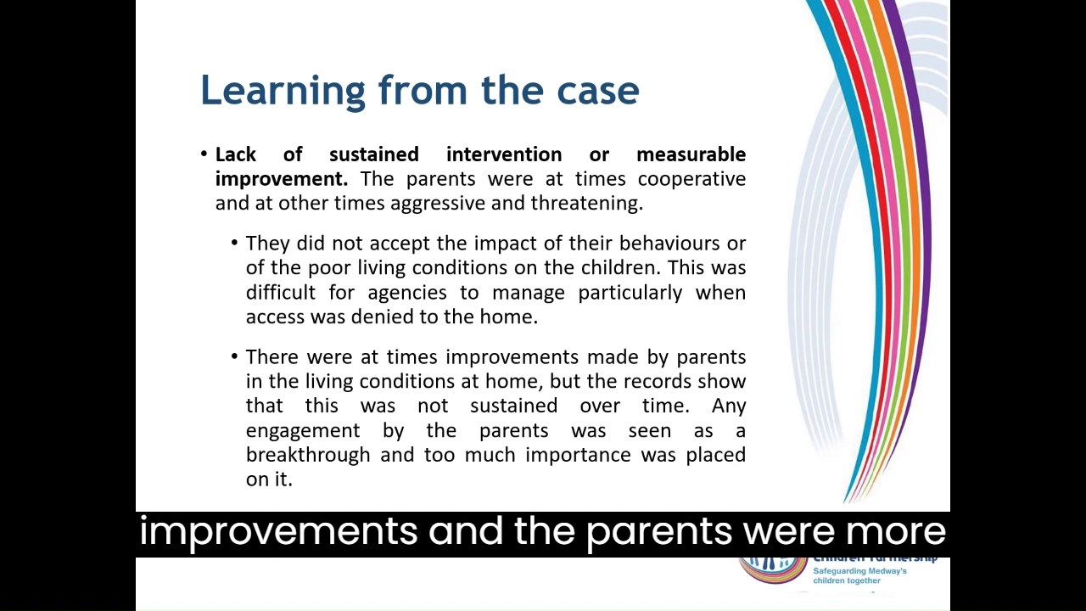

<https://sway.cloud.microsoft/UAo3S7rXSZmGEoWe#content=K8YNRV1By6zJgJ>

# Upcoming training sessions - booking through Me Learning

* Exploitation awareness conference with Medway Council, in-person, Monday 18th March 2024. To register your interest please use the [booking form](https://forms.office.com/Pages/ResponsePage.aspx?id=kz5QaOc8Ikq_xf_uQhofV8Dhdsr5H01CoshtLNEQOfRUOVZJTzZJSlNMVkhHUlM3WVM5UU1KWTRFMy4u) your place will be confirmed in Email. Please note, places can be cancelled up until noon on Friday 15 March. Non attendance on the day will result in a charge of £50.
* LADO, via Microsoft Teams, Wednesday 10th April 2024, 1:00pm-4:00pm.
* Making referrals, understanding and applying thresholds in Medway, Microsoft Teams, Tuesday 23rd April 2024. 09:30am-11:30am.
* Basic Child Protection Training, in-person, Tuesday 7th May 2024, 9:30am-4:30pm.
* Signs of Safety Briefing, via Microsoft Teams, Wednesday 22rd May 2024, 9:30am-12:00pm.
* GCP2 Training, in-person, Thursday 23rd May 2024, 9:30am-4:30pm.
* LADO, via Microsoft Teams, Wednesday 5th June 2024, 10:00am-1:00pm.
* Intermediate Safeguarding Children Training, in-person, Tuesday 18th June 2024, 9:30am-4:30pm.
* Reducing Parental Conflict, in-person, Thursday 20th June, 9:30am-2:30pm.
* Graded Care Profile 2 (GCP2), in-person, Tuesday 2rd July 2024, 9:30am-4:30pm.

**Please note that our in-person courses are looking for alternative venues whilst Gun Wharf is temporarily closed. Please get in touch if you can offer a venue for around 20 delegates.**

If you are interested in any training, you can enrol by [logging into your Me Learning account](https://app.melearning.co.uk/auth/login) or you can [create a Me Learning account](https://app.melearning.co.uk/auth/validate-key?registerKey=RGPNBJSW) instead, if you do not already have one.

If you have any queries regarding Me Learning or training please email [mscptraining@medway.gov.uk](mailto:mscptraining@medway.gov.uk).

**Contacts and feedback**

If you would like to give us some feedback on this bulletin or provide suggestions then please email us at [mscp@medway.gov.uk](mailto:mscp@medway.gov.uk)

**Social Media**

[X/Twitter](https://twitter.com/MedwaySCP)

[Linkedin](https://uk.linkedin.com/company/medway-safeguarding-children-partnership-mscp)