Medway Safeguarding Children Partnership (MSCP) No 15

# Welcome to the MSCP Bulletin - No.15

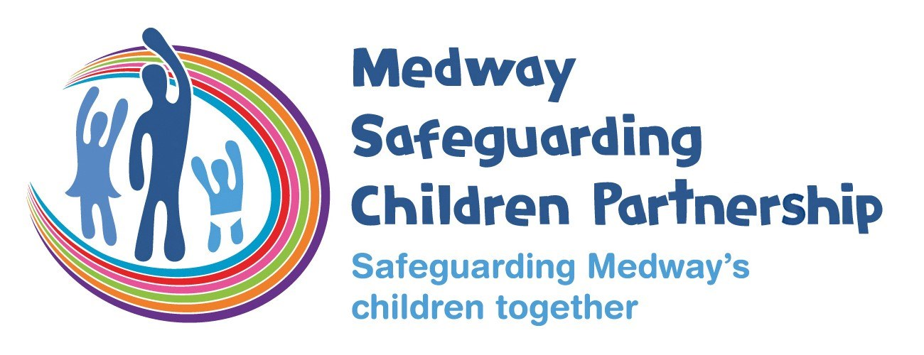

# Who are MSCP and what is their role?

[Medway Council](https://www.medway.gov.uk/), [Kent Police](https://www.kent.police.uk/) and the [NHS Kent and Medway](https://www.kentandmedwayccg.nhs.uk/)are the three safeguarding partners that make up MSCP. We aim to support and enable local organisations and agencies to work together in a system where:-

* children are safeguarded and their welfare promoted
* partner organisations and agencies collaborate, share and co-own the vision for how to achieve improved outcomes for vulnerable children
* organisations and agencies challenge appropriately and hold one another to account effectively
* there is early identification and analysis of new safeguarding issues and emerging threats
* learning is promoted and embedded in a way that local services for children and families can become more reflective and implement changes to practice
* information is shared effectively to facilitate more accurate and timely decision-making for children and families.

# Working Together

The Department for Education (DfE) published a new edition of its statutory guidance [Working together to safeguard children](https://assets.publishing.service.gov.uk/media/65803fe31c0c2a000d18cf40/Working_together_to_safeguard_children_2023_-_statutory_guidance.pdf) in December 2023. This 2023 edition replaces Working together to safeguard children 2018, which underwent a limited factual update in 2020.

The guidance outlines what organisations and agencies must and should do to help, protect and promote the welfare of all children and young people under the age of 18 in England.

This was published alongside new statutory guidance – the Children’s Social Care National Framework; which describes the outcomes that should be achieved so children and young people can thrive, and the Children’s social care: data and digital strategy; setting out the long-term plan for transforming data across children’s social care. These three documents outline the way in which agencies should work together and the outcomes they should aim to achieve.

The NSPCC have published a helpful briefing – [Working together to safeguard children 2023: summary of changes](https://learning.nspcc.org.uk/research-resources/2023/working-together-to-safeguard-children-2023-summary-of-changes) – which includes updates around:

* multi-agency expectations for all practitioners
* working with parents and families
* clarifying the roles and responsibilities of safeguarding partners
* the role of education and childcare providers
* multi-agency practice standards
* support for disabled children
* tackling harm that occurs outside the home

# Asthma training

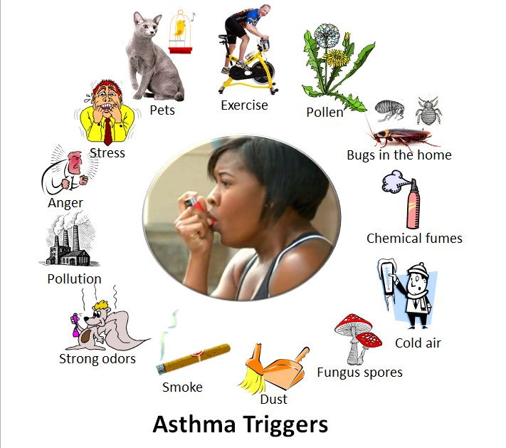

Medway Community Health are promoting free Asthma training for non-clinical professionals.

Asthma is the most common long-term medical condition among children and young people. It can be very serious, even life-threatening in certain situations, although this is rare.  Approximately 1,200 people in the UK die from asthma every year - 20 to 40 of these will be children and young people (British Lung Foundation, n.d.).

It's estimated that 90% of deaths may be preventable. Delays in receiving treatment and seeking medical help can lead to severe asthma attacks, increasing the risk of a life-threatening situation (Royal College of Physicians [RCP], 2014).

To access the eLearning training you will need to register and create an account with Education for Health and then complete the

[online training for asthma by NHSE](https://www.e-lfh.org.uk/programmes/children-and-young-peoples-asthma/).

 The recommended course takes around 45 minutes to complete and is Supporting children and young people’s health; Improving Asthma care together.  On successful completion you can download a certificate.

 This is recommended for anyone who supports children and young people including;

* Teachers and school support staff
* Youth workers
* Children’s group leaders including sport coaches
* Staff working in Children and Family centres
* Social care and housing staff
* Parents, carers and friends of young people with asthma

 Three tiers of training is offered tier 1,2,3 are all available, it is recommend tier 1 be completed unless you have a keen interest in asthma then tier 2 can also be completed.

 Medway Community Health and their Paediatric nurses for children and young people with asthma are happy to meet and support with training regarding asthma, the affects that poor housing can have on asthmatic children and when and how to refer to clinical practitioners.  Please email below if you want to arrange this:

[medch.cypasthma@nhs.net](mailto:medch.cypasthma@nhs.net)

# Alumina Facilitator Training

Medway Public Health, supported by NHS Charities Together will be providing Alumina facilitator training across Kent over the next year. Alumina is a ground breaking support programme for young people aged 14-19 years who are struggling with self harming behaviour. This is a fully funded training opportunity and will be accessible for all twelve boroughs of the county. This is a two day, face to face training course for professionals working with children and young people in Kent.

This course will provide you with the skills, knowledge, resources, and confidence to deliver Alumina sessions in your setting for young people with self–harming behaviour.

The second day particularly focuses on how to support children with Autistic Spectrum Condition and those who are Looked After Children and Young People.

This course is suitable for those working in schools in a PSHE capacity, pastorally, inclusion managers, school counsellors, early help workers and those in the youth service.

You must commit to deliver at least one course in your setting and provide evaluation feedback to Medway Public health.

To find out more about the course dates and locations or [book a course](https://healthtraining.medway.gov.uk/training-courses/ef899b20-da08-11ed-8152-191be317c7e0/alumina) you will need to [register for an account](https://healthtraining.medway.gov.uk/auth/register) on the A Better Medway Training Portal.

Current dates:

* Wednesday 7th & Thursday 8th February 2024 – Sevenoaks
* Monday 18th & Tuesday 19th March 2024 – Shepway – Folkstone & Hythe
* Tuesday 23rd & Wednesday 24th April 2024 – Tonbridge Wells
* Monday 13th & Tuesday 14th May 2024 – Tonbridge & Malling

# Basic Self Harm Training

Medway Public Health, supported by NHS Charities Together will be providing Basic Self harm Awareness training across Kent over the next year. This is a fully funded training opportunity and will be accessible for all twelve boroughs of the county. This is a short two hour online training course for professionals working with children and young people in Kent.

This online course is for professionals working with children and young people in Kent, who would like to learn more about self-harm and how to support children and young people that may be engaging in self-harming behaviours.

This session is open to all professionals but please note that the aim is to provide general information and guidance. The content will not cover SEND or Neurodiversity in detail and we will not be able to explore individual situations or concerns within the session as it wouldn’t be safe to do so.

We do provide signposting to other services and support for professionals to help support children and young people who self-harm following the training.

To find out more about the course dates and locations or [book a course you](https://healthtraining.medway.gov.uk/training-courses/ef899b20-da08-11ed-8152-191be317c7e0/alumina) will need to [register for an account](https://healthtraining.medway.gov.uk/auth/register) on the A Better Medway Training Portal.

Current dates:

* Wednesday 28th February 2024 – 10-12 pm & 1.30 – 3.30 pm
* Friday 22nd March 2024 – 1.30-3.30 pm & 6.00 – 8.00 pm
* Tuesday 16th April 2024 – 10-12 pm & 1.30 – 3.30 pm

# Joint Exploitation Group (JEG) December 2023

The Joint Exploitation Group (JEG) is a joint subgroup of the Medway Safeguarding Children Partnership (MSCP) and the Kent and Medway Safeguarding Adults Board (KMSAB).

Below is an update on some of the discussions at the meeting. For more information read the [JEG Bulletin.](https://www.medwayscp.org.uk/mscb/downloads/file/614/kent-and-medway-jeg-summary-for-partners-december-2023)

Updates from Partnerships:

* The KSCMP have been developing their Strategic Plan which will be launched in early 2024. KSCMP have recently produced a video explainer on [Operation Encompass](https://youtu.be/CehnwnR6pvU?si=MML4ZlMZBkNk4Pei) and have also launched their [father inclusive practice guidance.](https://www.kscmp.org.uk/guidance/father-inclusive-guidance)
* The KCST is currently managing 20 active DHR cases (with two new notifications pending commissioning decisions) that are at various stages of the process. Three cases have been published since the start of this financial year: [DHR Jean 2018](https://www.kent.gov.uk/__data/assets/pdf_file/0004/148504/Jean-2018-Domestic-Homicide-Overview-Report.pdf)**,** [DHR Kitty 2020](https://www.kent.gov.uk/__data/assets/pdf_file/0019/151048/Kitty-2020-Overview-Report.pdf) and [DHR Leanne 2019.](https://www.kent.gov.uk/__data/assets/pdf_file/0012/153021/Leanne-2019-Overview-Report.pdf)
* The Kent and Medway Violence Reduction Unit (VRU) are leading on work to develop a Serious Violence strategy. The strategy will be agreed by the Serious Violence Board and published by 31st January 2024.
* The [MSCP Annual Report for 2022-23](https://www.medwayscp.org.uk/mscb/downloads/file/613/mscp-annual-report-2022-23) has now been finalised and published on the MSCP website. The report provides an overview of the work carried out by the MSCP in the last year.
* The KMSAB have published their [Annual Report for 2022-23](https://www.kmsab.org.uk/p/about-kmsab-1/annual-report-and-strategic-plan) detailing what the board has done during the year to achieve its main objectives.

# Updates from the Child Safeguarding Practice Review Panel

**National Review Baby M**

 In November 2023, the National Child Safeguarding Practice Review Panel announced a national review following the death of Baby M. The review will examine the issues raised by what happened to Baby M to identify a number of areas of potential learning and system improvement. This includes working with people who conceal pregnancies, parents and carers who evade services, and collaboration across different jurisdictions. The review was endorsed by formal letter from the Secretary of State to Panel Chair, Annie Hudson.

The Terms of Reference are available [here](https://www.gov.uk/government/publications/national-review-following-the-death-of-baby-m-terms-of-reference) and the final report of the review is due to be published in May 2024.

**Child Sexual Abuse within the family environment**

 In December 2023, the Panel announced a national review into Child Sexual Abuse Within the Family Environment. The Panel initiated this review in the context of a range of themes and issues highlighted by rapid reviews and Local Child Safeguarding Practice Reviews (LCSPRs). The review is being led by Panel members, Jenny Coles and Simon Bailey. The lead reviewers are the Centre of Expertise on Child Sexual Abuse.

The review will explore the challenges of identifying, assessing and responding to child sexual abuse within the family environment, and will seek to make recommendations on how children can be better protected. The Term of Reference are available [here](https://www.gov.uk/government/publications/national-review-into-child-sexual-abuse-within-the-family-environment-terms-of-reference).

**Published LCSPRs**

 The following local child safeguarding practice reviews were published between 1 September and 30 November 2023:

* **South East** – Surrey: [Ash](https://www.us10.list-manage.com/track/click?u=033d1bbae0e224ce244ef5c48&id=2f8dd26fe2&e=55dc0712a9). Medway: [Isabel](https://www.us10.list-manage.com/track/click?u=033d1bbae0e224ce244ef5c48&id=5441000261&e=55dc0712a9)
* **Yorkshire & Humber** – Bradford: [The siblings](https://www.us10.list-manage.com/track/click?u=033d1bbae0e224ce244ef5c48&id=12d2d262e8&e=55dc0712a9), [Child A](https://www.us10.list-manage.com/track/click?u=033d1bbae0e224ce244ef5c48&id=19d08e066b&e=55dc0712a9), [Babies Who Sustained Injuries](https://www.us10.list-manage.com/track/click?u=033d1bbae0e224ce244ef5c48&id=e2c4870731&e=55dc0712a9)
* **North East** – Darlington: [Family H](https://www.us10.list-manage.com/track/click?u=033d1bbae0e224ce244ef5c48&id=edcedda520&e=55dc0712a9). Stockton-on-Tees: [Child Joe](https://www.us10.list-manage.com/track/click?u=033d1bbae0e224ce244ef5c48&id=8f73d44866&e=55dc0712a9)

# Challenge and Escalation Policy and video explainer



The MSCP have created a [video explainer](https://youtu.be/qwQnUgf6upg?si=yWDfEMrMruXONZZL) that is available on our YouTube channel. In this video it explains the challenge and escalation policy, why we need it, who is it for, when to use the policy and the required steps. Presenting the video is our Independent Scrutineer Rory Patterson.

Generally there is a good working relationship between agencies, but sometimes there may be a difference of professional views.

Recent reviews completed by the MSCP found that in some cases there was a lack of escalation of concerns and challenge when plans for children were not progressing as they should.

The safety of individual children is the priority consideration in any professional disagreement. Any unresolved issues should be addressed with consideration given to the potential risks for the child.

Professionals should be aware that we’ve published the Escalation Policy to give you clear routes to escalate concerns so agencies can agree a way forward.

Professionals should use the Escalation Policy if they have concerns about decisions made by other professionals or agencies that may be getting in the way of keeping a child safe.

You can also view and download the [MSCP's policies and procedures](https://www.medway.gov.uk/mscb/info/5/aims/30/resolving-professional-differences-escalation-policy) on the MSCP's website.

# Invisible children: What happens to the children when a parent goes to prison?

Children Heard and Seen is a charity which provides support and interventions for children with a parent in prison. The charity was set up in 2014, with a focus on reducing intergenerational offending, and mitigating the impacts of parental imprisonment for children and young people. Whilst we are primarily based in Oxfordshire, the introduction of online support during the pandemic means that we are now able to accept referrals to support families across the country.

They are inviting us to join the ‘Call to Action’ campaign in raising awareness of the impacts of parental imprisonment.  There are various one hour webinars that can be booked online through Eventbrite.

In the session you will watch a 11 minute film and then there will be a discussion of some of the myths around parental imprisonment. Questions will be welcomed.

[The tickets for this event are free](https://www.eventbrite.co.uk/e/what-happens-to-the-children-when-a-parent-goes-to-prison-tickets-780709552287) and you can watch the [trailer for the film on YouTube.](https://youtu.be/-k4kXnksNro?si=57wbe9YkH_xP6dE7)

# Upcoming training sessions - booking through Me Learning

* Intermediate safeguarding children training, in-person, Thursday 1st February 2024, 9.30am-16.30pm. FULL.
* Domestic Homicide Review Event with Medway Council, in-person, Wednesday 7th February 2024, 9.30am-12pm. 39 spaces available.
* Local Authority Designated Officer (LADO) awareness sessions for MEDWAY, taking place on Microsoft Teams, Wednesday 7th February 2024, 10am-1pm. 24 spaces available.
* Medway professionals: Child exploitation intel portal session with Kent Police, taking place on Microsoft Teams, Thursday 8th February 2024, 10am-12pm. Unlimited spaces available.
* GCP2, in-person, Tuesday 20th February 2024, 9.30am-4.30pm. 6 spaces available.
* Signs of Safety, taking place on Microsoft Teams, Friday 26th February 2024, 9.30am-12pm. Unlimited spaces available.
* Reducing Parental Conflict (RPC), in-person, Friday 8th March 2024, 9.30am - 2.30pm.
* DASH Training, in-person, Monday 11th March 2024, 9.30am-4.30pm. Invite only.
* Exploitation awareness conference with Medway Council, in-person, Monday 18th March 2024. To register your interest please use the [booking form](https://forms.office.com/Pages/ResponsePage.aspx?id=kz5QaOc8Ikq_xf_uQhofV8Dhdsr5H01CoshtLNEQOfRUOVZJTzZJSlNMVkhHUlM3WVM5UU1KWTRFMy4u) your place will be confirmed in Email. Please note, places can be cancelled up until noon on Friday 15 March. Non attendance on the day will result in a charge of £50.

**Please note that our in-person courses are looking for alternative venues whilst Gun Wharf is temporarily closed. Please get in touch if you can offer a venue for around 20 delegates.**

If you are interested in any training, you can enrol by [logging into your Me Learning account](https://app.melearning.co.uk/auth/login) or you can [create a Me Learning account](https://app.melearning.co.uk/auth/validate-key?registerKey=RGPNBJSW) instead, if you do not already have one.

If you have any queries regarding Me Learning or training please email [mscptraining@medway.gov.uk](mailto:mscptraining@medway.gov.uk).

# Independent Scrutineer Farewell

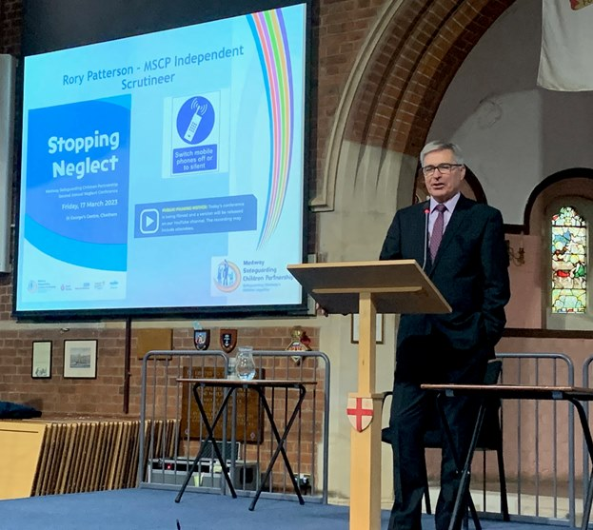

We will be saying farewell to our Independent Scrutineer, Rory Patterson.

A message from Rory:

It’s time for me to say farewell after 4 years working with Medway as Chair of the Improvement Board and the Medway Safeguarding Children Partnership Independent Scrutineer. It’s been a privilege to work with colleagues through what has been an extraordinarily difficult time. Following the demoralising outcome of the 2019 Ofsted Inspection it’s been a pleasure to collaborate with the dedicated and hardworking frontline staff and managers who have transformed outcomes for the most vulnerable families in the area. It’s been a tough journey, but everyone has shown a positive attitude and determination to improve services. I’d like to say a special thank you to Simon Plummer and his team from the MSCP who have provided me with tremendous support over the past few years. I’ve particularly enjoyed working with colleagues from the Police and Health who have supported improvement in local services and ensured that Medway has a strong partnership. I’ve had a wonderful time working with colleagues and know they will continue to provide great services for the children and families of Medway. In the meantime, I’ll be retiring and hoping to continue to pursue my many leisure pursuits.

# MSCP Business Manager Farewell

We will also be saying farewell to the MSCP's Business Manager, Simon Plummer.

A message from Simon:

After nine years as the Business Manager for the Medway Safeguarding Children Partnership and its predecessor the Board, I will be moving on to take up a role at the National Children’s Bureau.

It has been an incredible nine years working in Medway and during that time there have been a number of changes and challenges as well as things to celebrate. One thing that has made my time special is working with people from different agencies who are all so committed and passionate about supporting children. I want to thank all colleagues across Medway for your help and support in this role and particularly the fantastic MSCP team.

I am sure I will find an excuse in my new role to come visit Medway again!

**Contacts and feedback**

If you would like to give us some feedback on this bulletin or provide suggestions then please email us at [mscp@medway.gov.uk](mailto:mscp@medway.gov.uk)