Child/Young Person’s Name: | Date of birth: | EHM/Liberi ID/Mosaic: | NHS Number: | Unique Pupil Number: | Any other reference:

Please complete this form in conjunction with the Kent and Medway exploitation guidance document
1) What are you worried about regarding my safety and wellbeing at this time?
(If concerns are about any form of exploitation, such as sexual exploitation or criminal exploitation, or any harm outside of my family home. Please give specific details about any known locations and times. Consider my presentation or response. Do I appear to feel unsafe? Is there anything else from past incidents that might be relevant to your concerns? Do I show any behaviours that could indicate that I have been exposed to radicalisation and am being drawn into extremism?
My Views

My Parents/Carers

Professional Views

2) What creates or increases my vulnerability to the worries you have? Can you evidence these, or is it a suspicion/feeling that you are unable to evidence?
(Do you think, or know that, I have a learning disability/ any health concerns that might make me more vulnerable? Am I living in Foster Care or somewhere other than with my birth family? Has someone close to me recently died or have I suffered a loss in some other way? Are there any worries about my friendship group or associates ? A new relationship? Am I suffering from low confidence? Or other mental health/ emotional wellbeing worries? Have I been bullied? Are you aware of any other difficulties I might have, like alcohol or drug use? Do I have any escalating behaviours of concern, like Sexually Harmful Behaviour towards others, or do I engage in any other problematic behaviour or criminal acts? Have I been missing from home/school? Do I owe anyone any money? Are people demanding my attention? Do I seem overly linked to my phone? Am I being secretive, especially about where I am spending my time or what I am doing online? Have I changed my online identity, have more than one online identity? Do I have anywhere I need to be/people I must meet? Do I stay out a lot? Do I appear to have money/expensive items, with no reasonable explanation as to how I got them? Are you aware of any past/ recent traumatic events which I may have experienced? Is English my second language? Have I come to the UK/this County/Town from somewhere else? Am I unwilling to listen to other people's views? Showing sympathy for extremist causes and talking positively about people who promote hate? Am I refusing to engage with or becoming abusive to others who are different to me, because of their race, religion, gender or sexuality? Has my appearance and dress changed?
My Views

My Parents/Carers

Professional Views

3) What evidence is there, if any, that I might have limited freedom?
(Am I able to talk to professionals alone? Do I appear guarded/scared in the company of any peers /adults? Am I unable or reluctant to share personal information or detail about where I live? Am I socially isolated? Do you think I may have been trafficked, (transported to work or to be sexually abused by others? Could I be a victim of modern-day slavery? Do I appear malnourished, avoid eye contact, seem to have scripted/ rehearsed responses? Do I lack access to official documents or personal possessions? Do I appear destitute? Do I have any signs of physical abuse, bruising, cigarette burns/tattoos, indicating ownership or health conditions/anxiety, including a lack of awareness/ memory of a recent event?)

My Views

My Parents/Carers

Professional Views

4) How does my family and/or living environment impact on my needs and vulnerability?
(Do I have a positive relationship with anyone in my home? Am I able to talk to my parents/carers? Is there a worry about the impact of my behaviour on any of my siblings within the household? Is there any family event that is particularly difficult for me? E.g. a parent bringing someone new into the household or a family birthday/funeral or anniversary of a death? Is there anything about my family/home/cultural expectations, such as religion, ethnicity, criminality or patterns of behaviour like aggression in the family, alcohol/ drug use or parental mental health, which might be particularly difficult for me.)
My Views

My Parents/Carers

Professional Views

5) Do I feel safe in the community?
Outside the home, are there any times of day or places where I feel unsafe, such as waiting for the school bus/in the town centre? Is this because I have experienced an incident/threat in that location? Have I been linked in any way to any places/spaces for sexual violence, robbery, crime, or individuals/groups of concern? Have I been linked to County Lines? Do I have friends I can trust? Do I have safe places I can go to? What do we know about my friendship groups, including online relationships and activity? Are they of a similar age? How are we known to each other? What do we have in common? Are there any locations (places and spaces) and other factors in the locality and wider community that impact on my needs and vulnerability including online threats or risk of harm?
My Views

My Parents/Carers

Professional Views

6) What protective factors exist or could be developed? Do I have some friendships that are safer than others?
(Are there any relationships which could be intimate or coercive? Am I friends/linked with other young people who you suspect may be exploited? Do I have strong and supportive friendships with anyone in particular? Can these friendships or other relationships within the family be used to help protect me from the risk of future harm? Do I have any hobbies/interests? Activities I enjoy doing? Are there any locations (places and spaces) and other factors in the locality and wider community that impact on my needs and vulnerability including online threats or risk of harm?
My Views

My Parents/Carers

Professional Views

ACTIONS
Based on the responses above, what is it that makes you more worried about my behaviour compared to that of any other teenager/adolescent? What do you need to know more about?
Select ONE of the boxes below based on your professional opinion on the risk of harm, with possible actions to follow, (some prompts are included, which may help). Please consider frequency and intensity of what concerns you and where you are unsure what to do next speak to a manager or consult with the Integrated Children’s Service Front Door.
Next steps - What action needs to be considered?
(Consult with line manager – is immediate action required to safeguard me?) Share intelligence with police (Kent Safeguarding Children Multi-Agency Partnership - Partner information sharing form – link below). Provide immediate support and/or refer me to appropriate support services (support levels 1 & 2). Progress to assessment (support levels 3 & 4) request/arrange a multi-agency meeting, e.g. strategy meeting)

☐ No concerns of exploitation, concerns relate to behaviours appropriate to my age
No further action needed, although you should keep a copy of this form in line with your own record-keeping policy.

☐ Evidence of my vulnerability to exploitation
Talk to me to see if I need any further help or guidance. Explore opportunities to engage me in positive activities. Is there a need for work around online safety or my internet use or with regard to healthy relationships, e.g. tea consent video
(Can my parent/s or carer/s be given advice around parental controls online and increasing their parental presence? They can also access a wide range of support from Open Access Youth Services.
Talk to my parent/s or carer/s so that they can support me further. Direct my parents/carers to Youth Services at the link below)
https://www.kent.gov.uk/education-and-children/young-people
Medway Youth Service
Consider sharing intelligence with the police using the Kent Safeguarding Children’s Multi Agency Partners (KSCMP) information sharing form using the link below (covering both Kent and Medway).
partner information sharing link

☐ Evidence that I am being groomed or targeted for the purposes of exploitation
Continue to support me and ensure that I have a safe place or a safe person to talk to.
Share intelligence with the police using (KSCMP) information sharing form using the link below:
partner information sharing link
Send a request for support form for Kent or for Medway send a Medway Referral to Children's Services to Front Door Services so that I can be fully assessed and supported by the appropriate service/s.
Professional support
- Gillick competency and Fraser guidelines
- Medway Guidance for working with children who are sexually active
☐ Evidence that I am being exploited (sexual exploitation, criminal exploitation, modern day slavery)
Continue to support me and ensure that I have a safe place or a safe person to talk to.
Share intelligence with the Police using the KSCMP information sharing form using the link below:
partner information sharing link
Send a Kent request for support form Medway Referral to Children's Services to Front Door Services so that I can be fully assessed and supported by the appropriate service/s.
Name and role of worker completing assessment and plan:
Date:

Once completed please follow your organisation’s protocol for safe storage of information contained within his form.

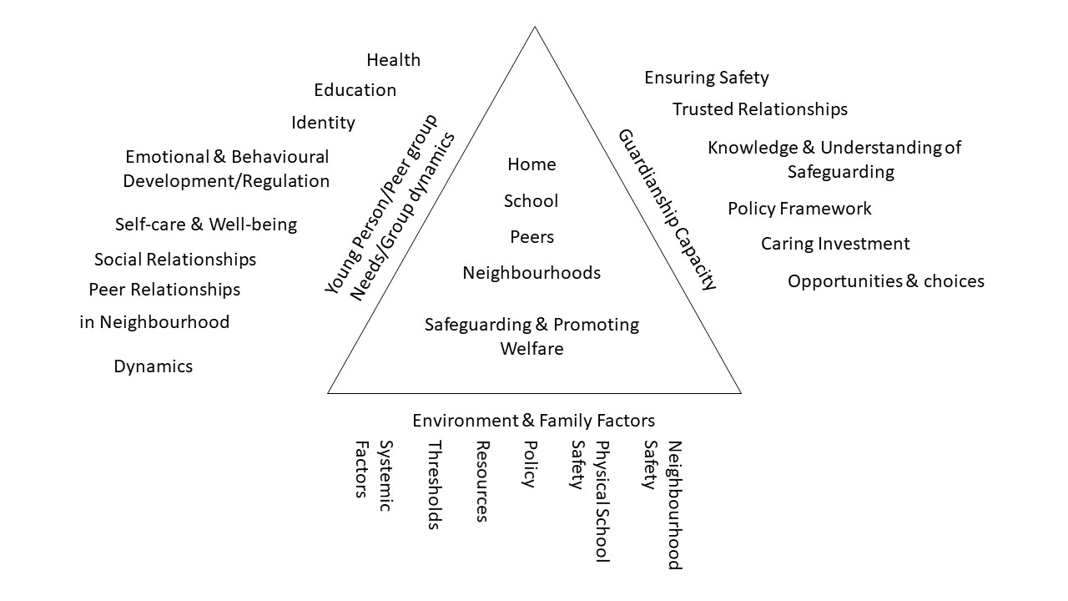
The diagram below provides a framework to explore the child or young person’s needs. You will need to work with the
child/young person and their parent(s)/carer to consider factors from each of the 3 domains

