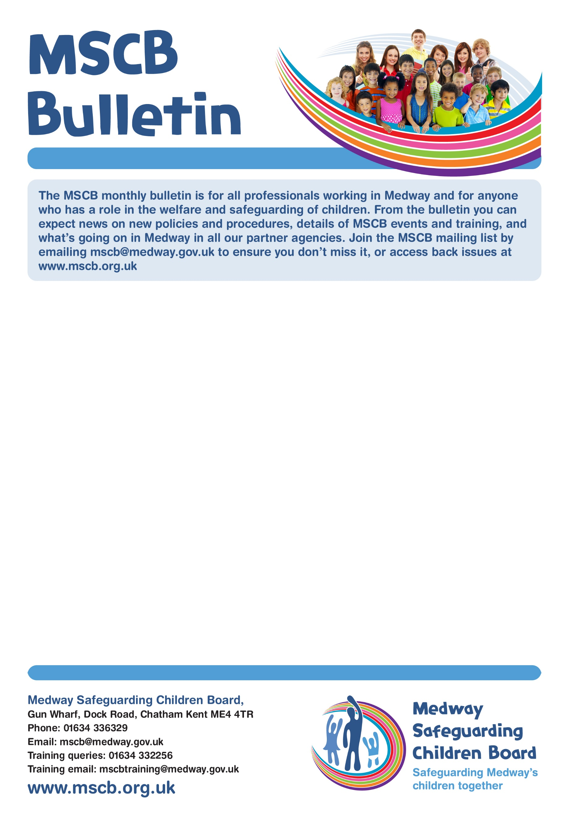

**National Consultation on Working Together**

**(Changes to statutory guidance)**

**Overview**

The Government have published a consultation on the proposed changes to the statutory guidance, Working Together to Safeguard Children. Working Together to Safeguard Children is the multi-agency statutory guidance that sets out expectations for the system that provides help, support and protection for children and their families. It applies at every level from senior leaders to those in direct practice with families, and across all agencies and organisations that come into contact with children. It gives practitioners clarity about what is required of them individually and how they need to work in partnership with each other to deliver effective services.

**Why your views matter**

Updating Working Together now is central to delivering on the first phase of plans to transform Children's Social Care, set out in [Stable Homes, Built on Love](https://www.gov.uk/government/consultations/childrens-social-care-stable-homes-built-on-love). They want to hear your views so that they can make sure the changes do what children and their families need them to do. We encourage you to read the consultation document and respond to the consultation which runs until 6 September 2023.If you wish to contribute to the MSCP response to the consultation please email [mscp@medway.gov.uk](mailto:mscp@medway.gov.uk).

**Give us your views.**

[Online Survey](https://consult.education.gov.uk/child-protection-safeguarding-division/working-together-to-safeguard-children-changes-to/consultation/)

MSCP

Bulletin

**Bulletin 13 July 2023**

**The MSCP bulletin is for all professionals working in Medway and for anyone who has a role in the welfare and safeguarding of children. From the bulletin you can expect news on policies and procedures, details of MSCP events and training, and what is going on in Medway in all our partner agencies. Join the MSCP mailing list by emailing** [**mscp@medway.gov.uk**](mailto:mscp@medway.gov.uk) **to ensure you don’t miss it, or access back issues at** [**www.medwayscp.org.uk**](http://www.medwayscp.org.uk)

Issue Number 6 – April 2021

**Baby Summer Safety - (The Lullaby Trust)**

The weather is getting warmer, which can make following safer sleep advice more complicated. It is harder to keep baby cool and holidays and travel can disrupt routines. The Lullaby Trust have put together some tips on baby summer safety so you can enjoy the summer and keep baby safe when the weather gets hot. These include:

|  |  |  |
| --- | --- | --- |
| * Co-sleeping more safely. * Room temperature. * Following a safer sleep routine on holiday. | * Keeping baby cool when out and about. * Making sure baby has enough fluids. * Travelling by car. |  |

For a full list of contents please [Visit the Lullaby Trust Website](https://www.lullabytrust.org.uk/safer-sleep-advice/baby-summer-safety/)

Please also visit the [link to the MSCP Keeping Babies Safe Factsheet](https://www.medwayscp.org.uk/mscb/downloads/file/433/keeping-babies-safe)

Worried about a child in Medway?  
Phone: **01634 334466** Out-of-hours: **0845 7626 777** Email: **ss.accessandinfo@medway.gov.uk**  
Police emergency: **999** Police non-emergency: **101**

**Medway Safeguarding Children Partnership**

Gun Wharf, Dock Road, Chatham Kent ME4 4TR

Phone: 01634 336329

Email: [mscp@medway.gov.uk](mailto:mscp@medway.gov.uk)

Training queries: 01634 332256

Training email: [mscptraining@medway.gov.uk](mailto:mscptraining@medway.gov.uk)

**www.medwayscp.org.uk**



Unwind with a healthy mind

Would you like to learn how to spot the signs of mental health conditions and how to help someone who needs mental health support, by guiding them to professional help? Connect 5 and Mental Health First Aid are courses that are available via the Medway Council Public Health Training Portal healthtraining.medway.gov.uk Mental health and wellbeing training is available to staff in Medway workplaces through the Workplace Health scheme medway.gov.uk/ healthyworkplace. for more information on other training they provide, or to book on a course please call 01634 334800 or visit abettermedway.co.uk. Please see the attached pdf leaflet for information.

If you have any questions about the leaflet and you want to speak to someone in your own language, please phone 01634 335577 or email cis@medway.gov.uk

**Have your say on Hybrid Child Protection Conferences**

Medway Children’s Services is seeking the views of professionals on your experience in Medway of Hybrid Child Protection Conferences.  During the Covid19 pandemic, all Child Protection Conferences were held ‘virtually’ using Microsoft Teams. Whilst these were well attended by both professionals and families, there is still much we have yet to understand about the implications for children, their families, and our practice.

When we were able to return to face-to-face meetings we took into consideration initial feedback from parents, and partners, and decided to implement ‘hybrid’ meetings for Child Protection Conferences. The intention was to keep some of the perceived advantages of ‘virtual’ conferences whilst removing some of the barriers inhibiting participation by family members. The findings from the service will be used to inform practice. You can complete the survey [here](https://surveys.medway.gov.uk/snapwebhost/s.asp?k=168363154629).

In addition, parents and carers can also complete a survey on hybrid child protection conferences [here](https://surveys.medway.gov.uk/snapwebhost/s.asp?k=168320995297).

**Kent and Medway Working with Children and Young People who are Sexually Active or Displaying Sexual Harmful Behaviours Procedure**

Kent and Medway are pleased to announce the Kent and Medway Working with Children and Young People who are Sexually Active or Displaying Sexual Harmful Behaviours procedures have now been published on the KSCMP website. The revised policy has moved away from the Brook sexual behaviour traffic light tool to the NSPCC Hackett’s sexualised behaviour Continuum. After significant multi agency consultation this shift was due to the ongoing licencing and training costs that now accompany the Brook tool.   Following direct discussions with Brook this tool can only be used when their training has been completed by a practitioner.

The Hackett’s Continuum is a freely and nationally recognised resource with helpful guidance and short video explainers (2-3 minutes each) on the NSPCC website.  The tool can be used without any additional training, please do read the Kent and Medway policy in full to support your understanding. The Hackett’s Continuum also uses the traffic light system to explain Developmentally typical behaviour (green), Problematic behaviours (amber) and Harmful sexual behaviours (red).

[Please visit the link to Kent and Medway Working with Children and Young people who are sexually active or displaying sexual harmful behaviours](https://www.kscmp.org.uk/__data/assets/word_doc/0003/154065/Kent-and-Medway-working-with-children-who-are-sexually-active-or-displaying-sexually-harmful-behaviour-v11-final.docx)

Link to: [NSPCC Understanding sexualised behaviour in children](https://learning.nspcc.org.uk/child-abuse-and-neglect/harmful-sexual-behaviour/understanding#skip-to-content)

Link to: [The Hackett’s Continuum](https://learning.nspcc.org.uk/media/2685/responding-to-children-who-display-sexualised-behaviour-guide.pdf)

[s](https://www.kscmp.org.uk/procedures/kent-and-medway-safeguarding-procedures)

Please cascade this link within your organisations.

**Kent and Medway Working with Children and Young People who are Sexually Active or Displaying Sexual Harmful Behaviours Procedure**

Kent and Medway are pleased to announce the Kent and Medway Working with Children and Young People who are Sexually Active or Displaying Sexual Harmful Behaviours procedures have now been published on the KSCMP website.

To view the procedures please visit:

<https://www.kscmp.org.uk/procedures/kent-and-medway-safeguarding-procedures>

Please cascade this link within your organisations.

**Kent and Medway Working with Children and Young People who are Sexually Active or Displaying Sexual Harmful Behaviours Procedure**

Kent and Medway are pleased to announce the Kent and Medway Working with Children and Young People who are Sexually Active or Displaying Sexual Harmful Behaviours procedures have now been published on the KSCMP website.

To view the procedures please visit:

<https://www.kscmp.org.uk/procedures/kent-and-medway-safeguarding-procedures>

Please cascade this link within your organisations.

**Kent and Medway Working with Children and Young People who are Sexually Active or Displaying Sexual Harmful Behaviours Procedure**

Kent and Medway are pleased to announce the Kent and Medway Working with Children and Young People who are Sexually Active or Displaying Sexual Harmful Behaviours procedures have now been published on the KSCMP website.

To view the procedures please visit:

<https://www.kscmp.org.uk/procedures/kent-and-medway-safeguarding-procedures>

Please cascade this link within your organisations.



**Worried about a child in Medway?**

Phone:

**01634 334466**

Out

-

of

-

hours:

03000 419191

Email:

**ss.accessandinfo@medway.gov.uk**

Police emergency:

**999**

Police non

-

emergency:

**101**