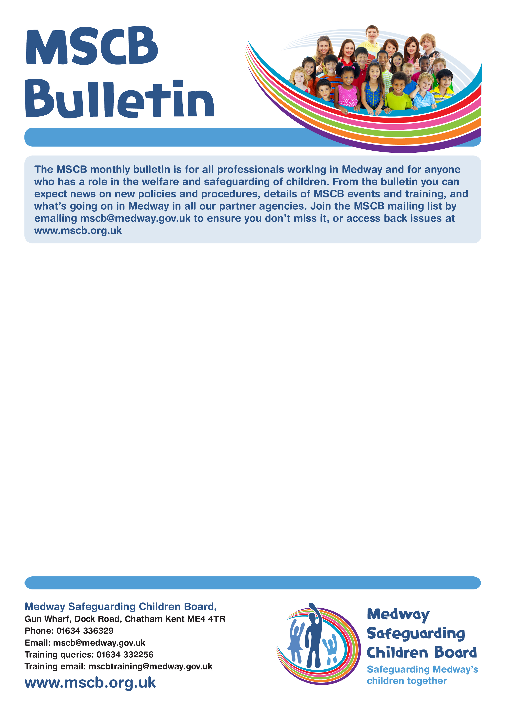

MSCP

Bulletin

**Bulletin 12 – April 2023**

**The MSCP bulletin is for all professionals working in Medway and for anyone who has a role in the welfare and safeguarding of children. From the bulletin you can expect news on policies and procedures, details of MSCP events and training, and what is going on in Medway in all our partner agencies. Join the MSCP mailing list by emailing** [**mscp@medway.gov.uk**](mailto:mscp@medway.gov.uk) **to ensure you don’t miss it, or access back issues at** [**www.medwayscp.org.uk**](http://www.medwayscp.org.uk)

Issue Number 6 – April 2021

**Factsheet Involving Men and Fathers**

The MSCP has recently published their Factsheet Involving Men and Fathers. Fathers can play a hugely constructive role in a range of child and family outcomes. However, when in contact with practitioners – from midwives and health visitors in a child’s early weeks through to child protection social workers – men say they feel overlooked, both as a resource for their children and in terms of the difficulties they might be facing with health, housing, money, or relationships (Bateson et al, 2017; Brandon et al, 2017; Hogg, 2014).

The Factsheet can be viewed on the MSCP Website. [See link to factsheet](https://www.medway.gov.uk/mscb/downloads/file/546/involving-men-and-fathers)

**The Forward Trust**

The Forward Trust empowers people to break the cycles of addiction or crime to move forward with their lives. Since 1991, they have been working with people to build positive and productive futures. They believe that anyone is capable of lasting change, as celebrated in their [More Than My Past](https://morethanmypast.org.uk/)and [Taking Action on Addiction](https://www.actiononaddiction.org.uk/)campaigns. Their services have supported thousands of people to make changes to create better lives with jobs, family, friends, and a sense of community.

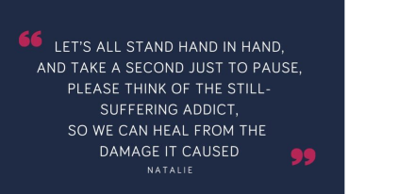

The Forward Trust is a national organisation, with services located in almost all regions of England (Southwest, Southeast, London, East of England, West Midlands, East Midlands, Northwest; and Yorkshire and the Humber) and Wales. Forward now have over 70 separate service delivery projects, with more than 20,000 clients per year supported by 700 staff and 150 volunteers. They are proud that around 30% of their workforce have lived experience of the issues they seek to address. [For more information, visit their website.](https://www.forwardtrust.org.uk/)

**Medway Contact Number: 01634 820390. General E-mail address: theforwardtrust.medway@nhs.net**

Worried about a child in Medway?  
Phone: **01634 334466** Out-of-hours: **0845 7626 777** Email: **ss.accessandinfo@medway.gov.uk**  
Police emergency: **999** Police non-emergency: **101**

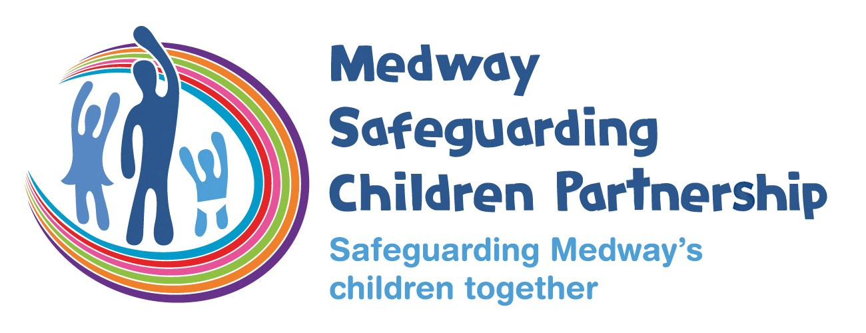

Medway Safeguarding Children Partnership

Gun Wharf, Dock Road, Chatham Kent ME4 4TR

Phone: 01634 336329

Email: [mscp@medway.gov.uk](mailto:mscp@medway.gov.uk)

Training queries: 01634 332256

Training email: [mscptraining@medway.gov.uk](mailto:mscptraining@medway.gov.uk)

www.medwayscp.org.uk

**Non-fatal strangulation training for professionals**

Non-fatal strangulation is a known way for perpetrators of domestic abuse to control and intimidate their victim. It is an insidious form of domestic abuse which recently became a standalone criminal offence in the [**Domestic Abuse Act 2021**.](https://www.legislation.gov.uk/ukpga/2021/17/section/70) Despite the strong link between non-fatal strangulation and domestic homicide, it can be difficult to identify due to a lack of visible injury.

**It is vital that professionals understand non-fatal strangulation and the risk it poses.**

Safer Lives are working with the [**Institute for Addressing Strangulation**](https://www.ifas.org.uk/)and are currently in the process of developing training for a range of professionals who encounter victims and survivors of non-fatal strangulation. They are **developing non-fatal strangulation training sessions and webinars for:**



If you're interested in keeping up to date with the progress of this new non-fatal strangulation training and would like to be told when registrations or applications open for their webinars and training sessions, [**please fill out this expression of interest form**](https://forms.office.com/Pages/ResponsePage.aspx?id=3-PxM72JakmYCACk2rHdwDanczKP1qVGsgV59Qj8BPJUMENVUE5IS1BMTFpEVURFSEc5MzAyUzFSSi4u&wdLOR=c5603B05C-3D86-4612-B59A-F94D5D99B2AE). Alternatively, you can email [**training@safelives.org.uk**](mailto:training@safelives.org.uk) to express your interest.

[For more information – visit the website.](https://safelives.org.uk/)



* Idva Services
* Isva Services
* Health Services
* Police
* Crown Prosecution Service
* Probation
* Adult and Children’s Social Care

**Oasis Helpline Information**

Due to unforeseen circumstances Oasis helpline hours are changing until further notice.

**As of Monday 3rd April 2023, the helpline will be open:**

**Monday, Tuesday, and Wednesday: 10am – 12pm** and **1pm - 3pm**

**Thursday and Friday: 10am – 12pm**

Out of these hours there will be a message confirming the above.

Please be mindful as to whether your (professional) call requires an immediate response or whether you could send an email, as your call could be preventing a victim from speaking to specialist staff. Should you have a professional query – please contact them via [helpline@oasisdaservice.org](mailto:helpline@oasisdaservice.org)

Referrals are to be sent as per their referral forms. If you are unable to use cjsm, please follow the instructions on the referral form and send the password separately to [helpline@oasisdaservice.org](mailto:helpline@oasisdaservice.org) for security purposes. Please do not call the helpline number.

Further contact information can be found on the website: [www.oasisdaservice.org](http://www.oasisdaservice.org)

**Helpline: 0800 9179948 Tel: 01843 269400 (main switchboard) Tel: 07961 021995**



**Worried about a child in Medway?**

Phone:

**01634 334466**

Out

-

of

-

hours:

03000 419191

Email:

**ss.accessandinfo@medway.gov.uk**

Police emergency:

**999**

Police non

-

emergency:

**101**