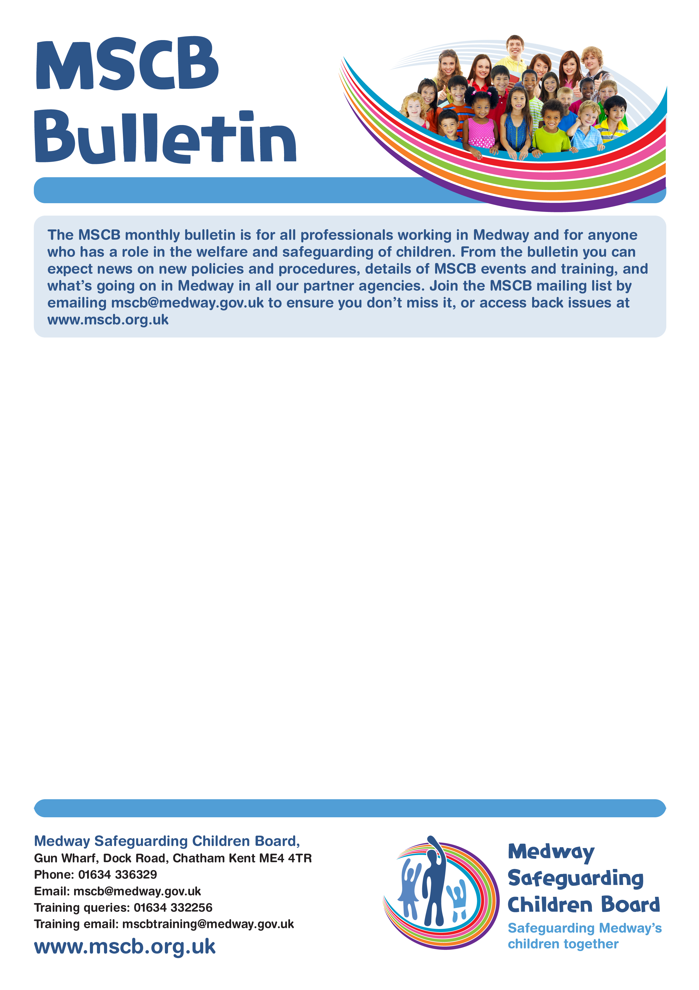
MSCP
Bulletin

Bulletin 10 – October 2022
Issue Number 6 – April 2021

The MSCP bulletin is for all professionals working in Medway and for anyone who has a role in the welfare and safeguarding of children. From the bulletin you can expect news on policies and procedures, details of MSCP events and training, and what is going on in Medway in all our partner agencies. Join the MSCP mailing list by emailing mscp@medway.gov.uk to ensure you don’t miss it, or access back issues at www.medwayscp.org.uk

Kent County Lines and Gangs – Catch-22 
Kent OPCC (Office of Police and Crime Commissioners and the VRU (Violence Reduction Unit) update: Kent County Lines and Gangs support commenced with effect from 1st July 2022.

Catch22 provide support to children and young people up to the age of 25 to reduce risk and prevent serious youth violence, exploitation, gang, and county line activity. Kent County Lines and Gangs - Catch22 (catch-22.org.uk)

Go Live for referrals are via the link Catch22 Kent Gangs & County Lines Referral form: referral form

Catch22 is a social business, a not-for-profit business with a social mission. For over 200 years they have designed and delivered services that build resilience and aspiration in people and communities.

As a social business they have the heart of a charity, and the mindset of a business.

What they do:
- Design and deliver services that build resilience and aspiration in people of all ages and within communities
across the UK.
Their vision:
- Everyone needs the same three things to thrive. Their vision is a strong society where everyone has a good place to live, a purpose and good people around them.
Their people:
- Catch 22 is made up of over 1,700 people from all over the country, brought together by common values. They reflect the communities they work in. They believe that diversity makes everyone stronger.
Their history:
- Catch 22’s history starts in 1788 with the formation of The Philanthropic Society, who aimed to ‘unite the spirit of charity with the principles of trade’ – their original definition of a ‘social business’.
Quality Delivery and Reform
- Catch 22 delivers services for young people, families, and adults, across justice, social action, education and into employment. Their strong frontline delivery expertise not only changes lives but gives them a direct insight into how the system is working and what needs to change. They invest in new ideas that will improve outcomes for their service users. They deliver reform through their existing services, in partnership with others and by building new organisations.

Worried about a child in Medway?
Phone: 01634 334466 Out-of-hours: 0845 7626 777 Email: ss.accessandinfo@medway.gov.uk
Police emergency: 999 Police non-emergency: 101

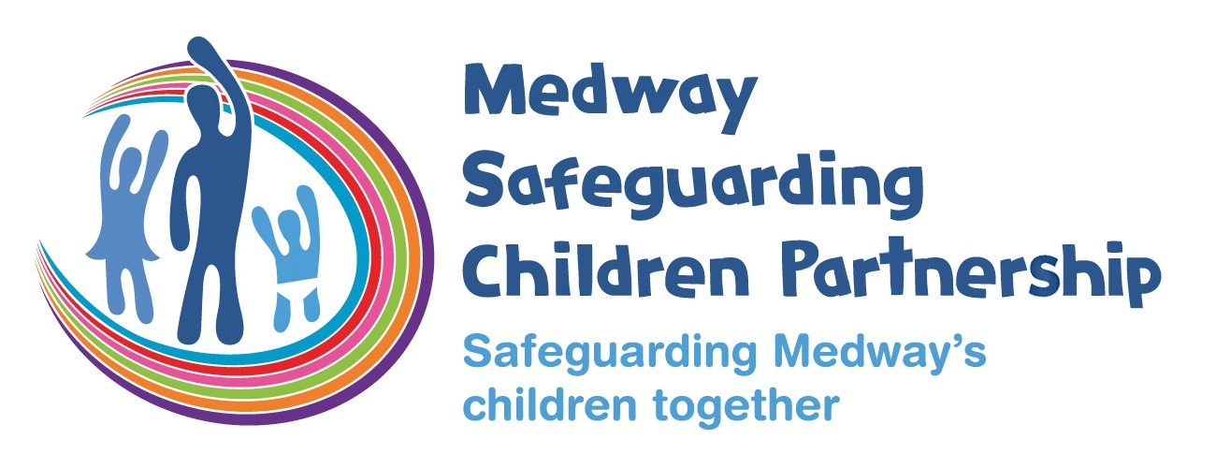
Medway Safeguarding Children Partnership
Gun Wharf, Dock Road, Chatham Kent ME4 4TR
Phone: 01634 336329
Email: mscp@medway.gov.uk
Training queries: 01634 332256
Training email: mscptraining@medway.gov.uk
www.medwayscp.org.uk

Kent Drug and Alcohol Strategy 2023-2028
The Kent Drug and Alcohol Strategy consultation is now live. The consultation closes on the 31st of October 2022. The Strategy is owned and overseen by the Kent Substance Misuse Alliance, a partnership of key stakeholders who work together to tackle alcohol and drug related harms. This is important for the wide-reaching nature of substance misuse and importance of tackling supply, crime, and disorder.

The heart of this Strategy is to empower, encourage and support individuals and communities to take a more active role in preventing and reducing the harmful effects of drugs and alcohol in Kent. It contains 13 strategic priorities, grouped under three areas: Prevention, Treatment and Recovery, and Community Safety.

The Strategy is driven by the Kent Drug and Alcohol Needs Assessments, which are available to view from the 'Useful links' section on the web page. The assessments include a variety of data sources, including hospital episode data, ONS and Kent substance misuse treatment service data, taking account of national guidance and reflecting the evidence base. Please use the attached link to have your say and for more information. www.kent.gov.uk/drugandalcoholstrategy

Webinar slides and recording:
National review into the murders of Arthur Labinjo-Hughes and Star Hobson

In June 2022, the National Child Safeguarding Practice Review Panel hosted five webinars about the national review into the murders of Arthur Labinjo-Hughes and Star Hobson. Over 1,500 people engaged in the sessions with lively Q&A and debate. Watch the recording here and download a summary of the key issues discussed here.

It is also possible to download the slides for each session on the following links:

- Solihull / Arthur
- Bradford / Star
- Safeguarding partners
- Business managers
- Frontline professionals

Independent Review of Child Sexual Abuse Published

Last week the final report of the Independent Review of Child Sexual Abuse was published. This was the culmination of 7 years of work and the amalgamation of thousands of children and young people’s experiences of abuse. It makes for sad, harrowing reading. Sadly, many times when children reported abuse, they were not believed, and no action was taken. There is a short (7 page) summary of the recommendations of the review here; the Executive Summary provided more context and key findings as well as recommendations. And finally, if you wish to read the full report (nearly 500 pages), you can find it here.

The STOP APP
Every human trafficking story, no matter how long or short, whether current or historic, is important and relevant. It may be the missing piece of the puzzle, contributing to a larger and more accurate picture of human trafficking, which can then inform efforts to combat it. Technology places the power to prevent into the hand of a person who holds a mobile device.

The STOP APP can be downloaded by anyone, anywhere in the world who has access to a smartphone. The app is anonymous, confidential, and secure – it is available in seven languages and allows you to submit suspicious activity quickly by sending text-based messages and uploading photos and videos. Use this link for more information:
(For more information, view link)

Worried about a child in Medway?

Phone:
01634 334466

Out
-
of
-
hours:
03000 419191

Email:
ss.accessandinfo@medway.gov.uk

Police emergency:
999

Police non
-
emergency:
101

