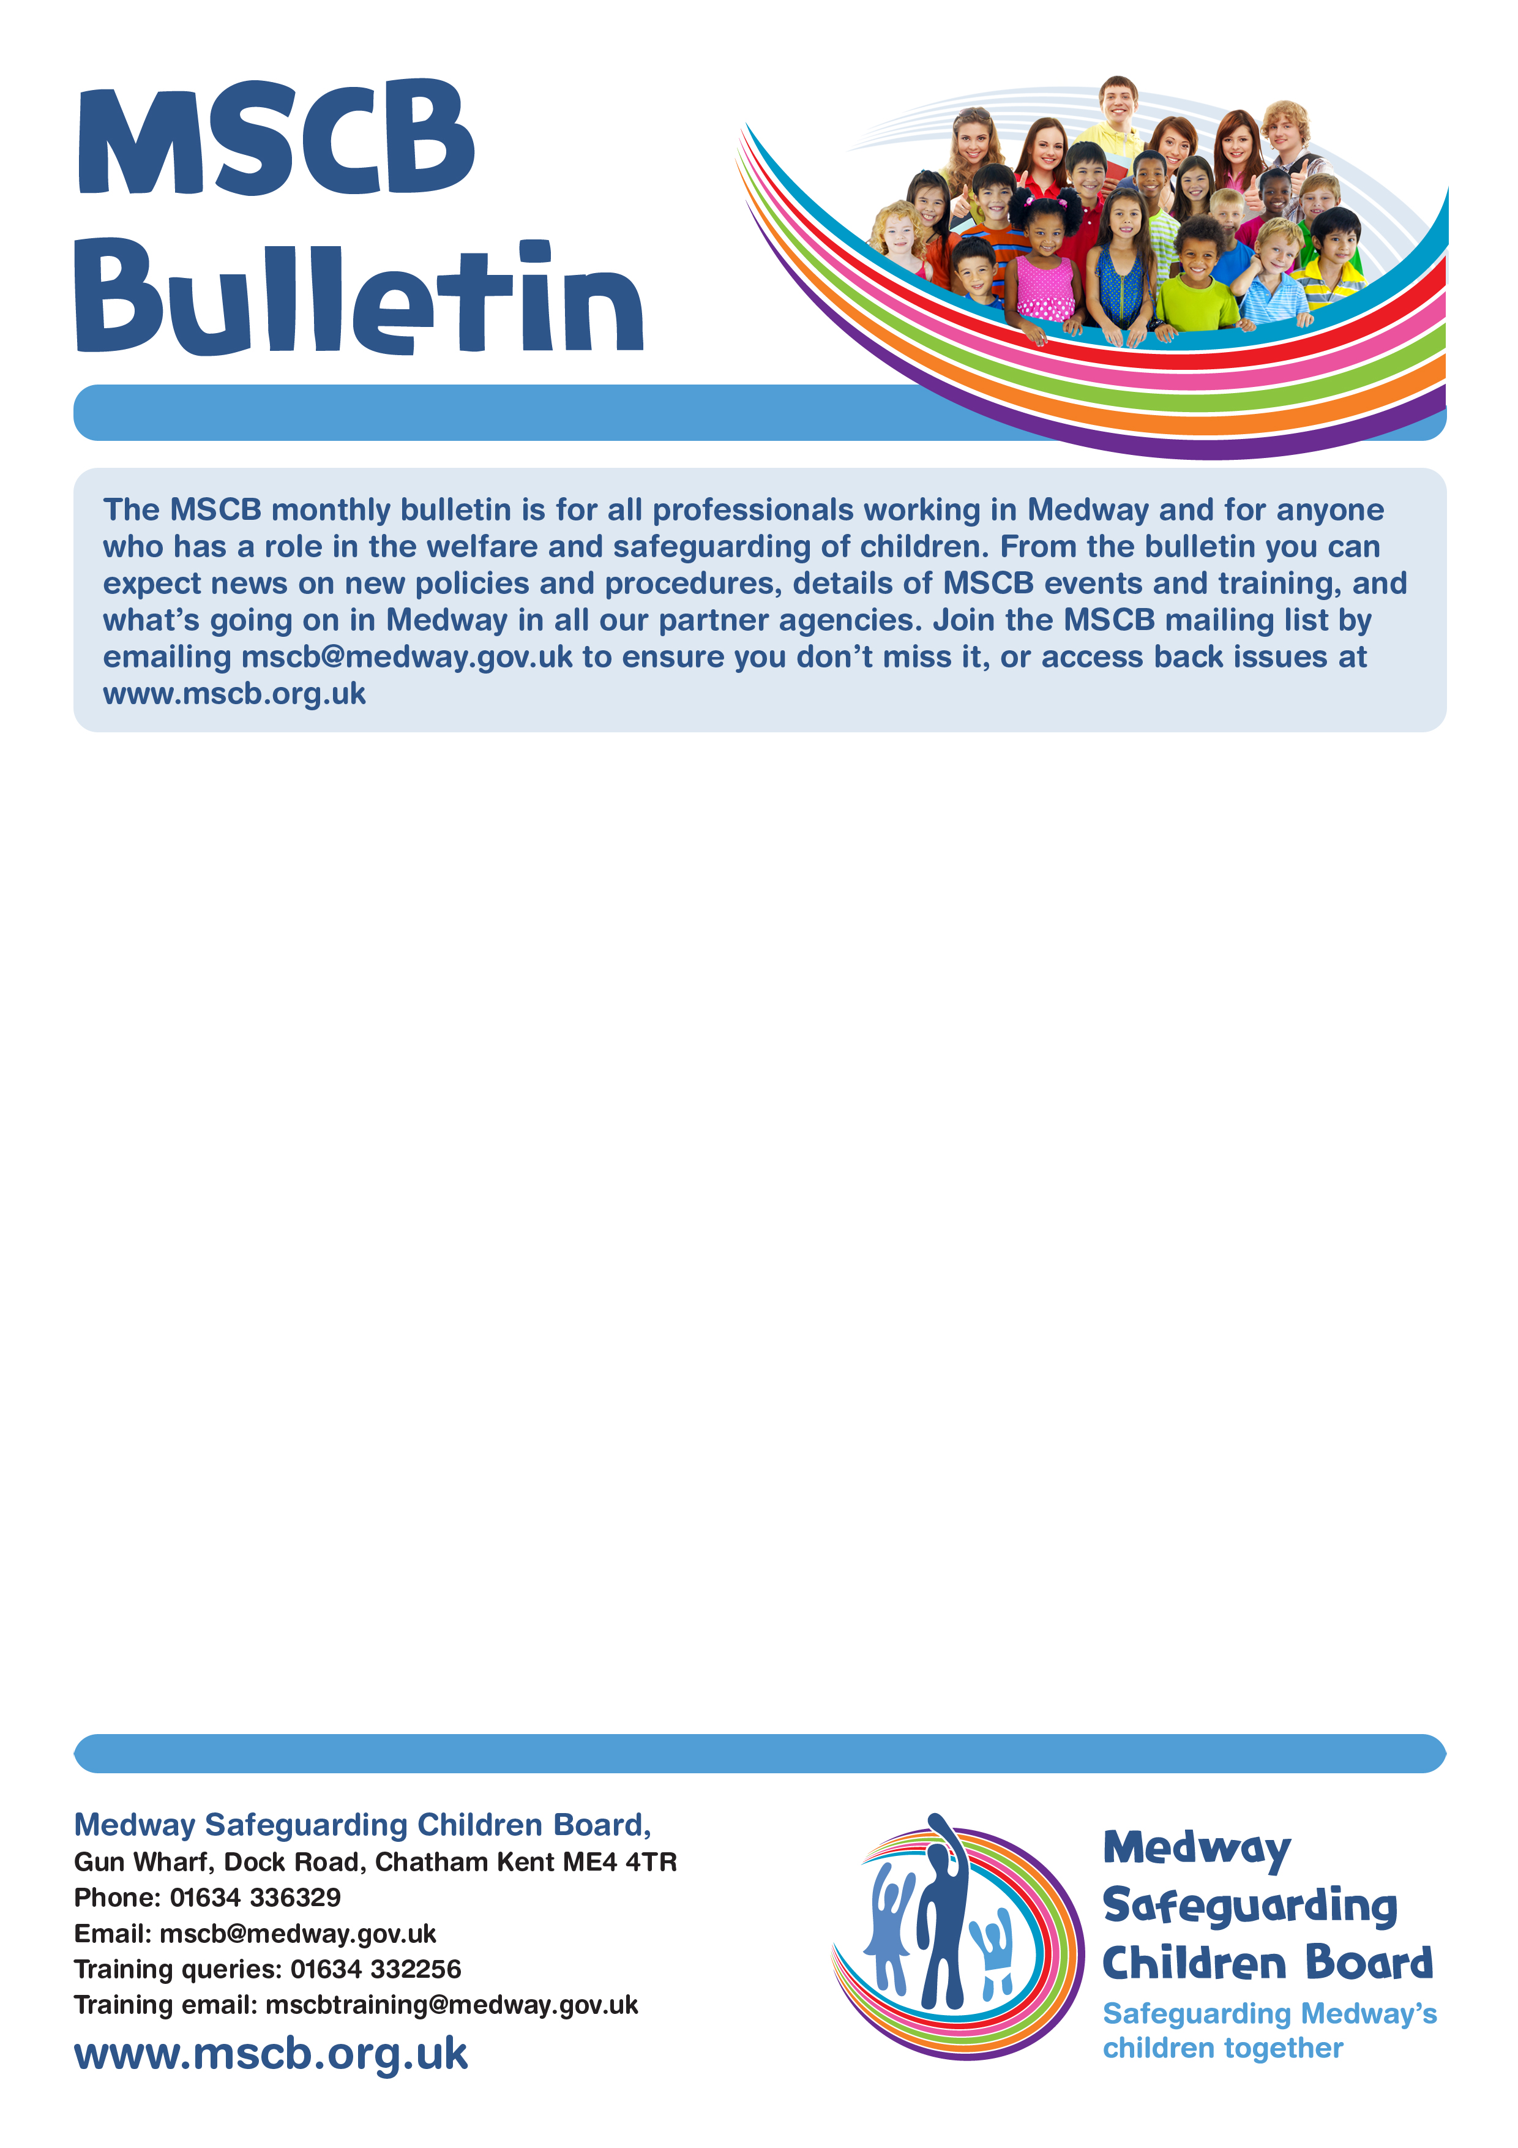
MSCP
Bulletin

Issue Number 3 – April 2020

The MSCP monthly bulletin is for all professionals working in Medway and for anyone who has a role in the welfare and safeguarding of children. From the bulletin you can expect news on policies and procedures, details of MSCP events and training, and what’s going on in Medway in all our partner agencies. Join the MSCP mailing list by emailing mscp@medway.gov.uk to ensure you don’t miss it, or access back issues at www.mscp.org.uk

COVID-19

During the current COVID-19 pandemic, the MSCP has had to cancel all face to face training. The MSCP are working with partners to keep you updated and provide you with up to date information and access to resources. (View Webpage).

Publication of SCR George

Serious Case Review George has recently been published following the death of three year old George. A copy of the report and a briefing sheet for professionals to help share the key findings and learning is available here. (View Overview Report). (View Briefing Sheet).

Safeguarding Practice Review Panel

The safeguarding system is facing organised criminal businesses that are skilled at identifying and entrapping children, using coercion, control and manipulation to push them into criminal activity. Too many children are dying or suffering from serious harm as a result of criminal exploitation and this is unacceptable. Investment in helping to protect this group is essential and urgent. Doing nothing is not an option.

The work of the national Child Safeguarding Practice Review Panel draws on the notifications, rapid reviews and serious case reviews that they receive every day. These supply a contemporary and detailed overview of incidents of serious and fatal child maltreatment across England. The Panel have recently published a report on a national review into adolescent deaths or serious harm where criminal exploitation was a factor. The review was a qualitative study of 21 cases from 17 local areas regarding children who died or experienced serious harm where criminal exploitation was a factor.

This is the first review of the National Child Safeguarding Practice Review Panel. The review sets out recommendations and findings for government and local safeguarding partners to protect children at risk of criminal exploitation

The review makes four national recommendations and sets out a number of learning points for local organisations to focus on including:

- understanding the nature and scale of the problem and identifying children engaged with and at risk from criminal exploitation
- tailored support for front line staff
- service design and practice development
- quality assurance.

For more information, click the attached link to view the whole document: (View Document). Published March 2020.

Worried about a child in Medway?
Phone: 01634 334466 Out-of-hours: 0845 7626 777 Email: ss.accessandinfo@medway.gov.uk
Police emergency: 999 Police non-emergency: 101

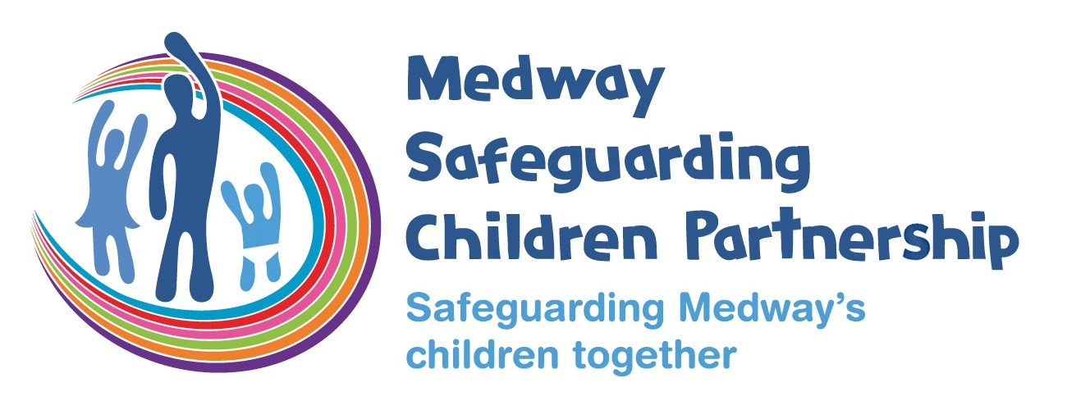
Medway Safeguarding Children Partnership
Gun Wharf, Dock Road, Chatham Kent ME4 4TR
Phone: 01634 336329
Email: mscp@medway.gov.uk
Training queries: 01634 332256
Training email: mscptraining@medway.gov.uk
www.medwayscp.org.uk

NSPCC Campaign – Share aware
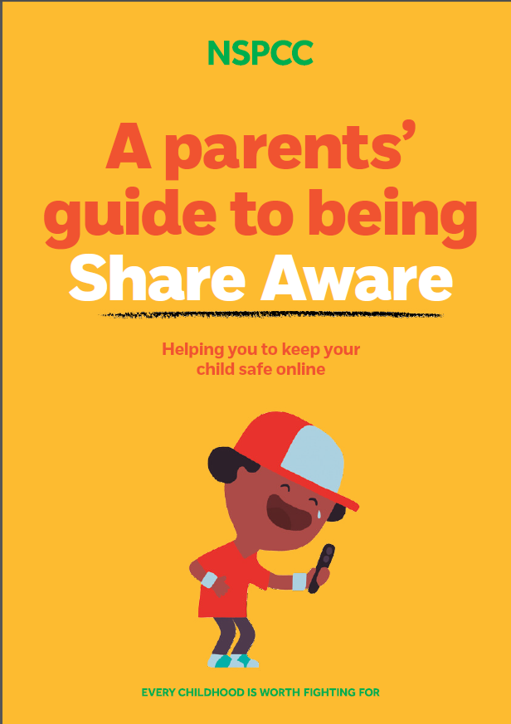
Kent and Medway Joint Exploitation Group (JEG)

The Joint Exploitation Group (JEG) is a joint sub group of the Kent Safeguarding Children Multi-agency Partnership (KSCMP), Medway Safeguarding Children Partnership (MSCP) and Kent and Medway Safeguarding Adults Board (KMSAB). The group oversees multi-agency activity around:

- Sexual Exploitation
- Gangs/County Lines
- Human Trafficking/Modern Slavery
- Online Safeguarding
- Radicalisation/Extremism
- Unaccompanied Asylum Seeking Children

The Group have developed a Briefing Sheet to update partners following each meeting. To view The Key Messages from the 28th February 2020 Meeting please use the attached link. (View Document).

MSCP's e-learning Update!

\
Due to the COVID 19 restrictions, the MSCP will not be delivering face to face training until further notice. We would like to remind professionals we have e-learning courses available for free to Volunteers and Practitioners in Medway working with children and their families. Some the courses include (not an exhaustive list)

- Level 1 and 2 Safeguarding Children.
- Safeguarding Children and Young People from Abuse by Sexual Exploitation.
- Basic Awareness of Domestic Abuse including the impact on children.
- An introduction to FGM, forced Marriage, and Honour Based Violence.
- Gangs and Youth Violence
- Hidden Harm – Parental Substance Misuse, Parental Mental Ill-Health.
- Human Trafficking and Modern Day Slavery.

All courses are certified. To access the MeLearning Page, you will find it on the ‘Safeguarding Training page on the MSCP Website under ELearning. http://www.mscb.org.uk/safeguardingtraining/e-learning.aspx
To create an account, all you need to do is follow the instructions on the ‘self-register’ tab. For Sector – Medway Council, Service – ‘Other’ and Location – ‘Medway’.

What would you like to see in the MSCP Bulletin?
Please email mscp@medway.gov.uk to suggest future bulletin themes or articles.

Worried about a child in Medway?
Phone: 01634 334466 Out-of-hours: 0845 7626 777 Email: ss.accessandinfo@medway.gov.uk
Police emergency: 999 Police non-emergency: 101

Follow us on Twitter @MedwaySCB

