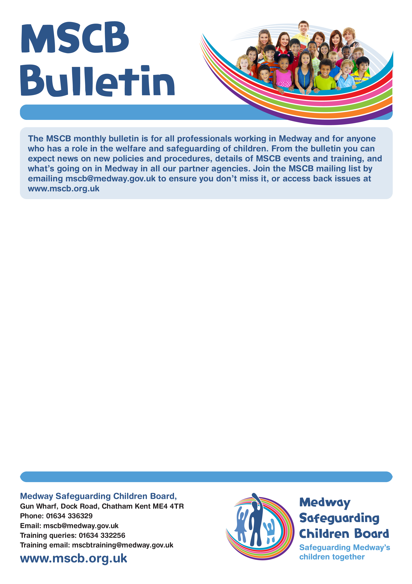
MSCP
Bulletin

Issue Number 5 – August 2020

The MSCP monthly bulletin is for all professionals working in Medway and for anyone who has a role in the welfare and safeguarding of children. From the bulletin you can expect news on policies and procedures, details of MSCP events and training, and what’s going on in Medway in all our partner agencies. Join the MSCP mailing list by emailing mscp@medway.gov.uk to ensure you don’t miss it, or access back issues at www.mscp.org.uk

Introducing the New E-Learning Adult Self-Neglect Course

This is a new course in the E-Learning Library – Introducing Self-neglect. Self-neglect can be difficult to recognise, and it can also be difficult to know how to help. It's important to know the signs and symptoms of self-neglect and hoarding, and how to respond. We’ll be exploring these areas in this course, as well as recognising when you should be concerned about an individual and understanding Safeguarding Adult Reviews. After completing this course, you will have knowledge of:

Interested in this course? Contact our account manager, visit our website or contact enquiries@melearning.co.uk
Tel: 01273 091 301

- What self-neglect is and why it may occur
- The different types of self-neglect
- The characteristics of hoarding and why it occurs
- Financial Abuse
- How to spot signs of self-neglect
- The importance of working with other professionals
- How to respond to your concerns about an individual

- Self-Neglect and Mental Capacity Act
- Sharing information with and without consent
- Safeguarding Adult Reviews and whey they are important
- Making a Safeguarding Enquiry
- Recognising vulnerable adults as witnesses
- The importance of appraisals and supervision

Kent and Medway Joint Exploitation Group (JEG)
Summary for Partners June 2020

The Joint Exploitation Group (JEG) is a joint sub group of the Kent Safeguarding Children Multi-agency Partnership (KSCMP), Medway Safeguarding Children Partnership (MSCP) and Kent and Medway Safeguarding Adults Board (KMSAB). The group oversees multi-agency activity around:

- Sexual Exploitation
- Gangs/County Lines
- Human Trafficking/Modern Slavery
- Online Safeguarding
- Radicalisation/Extremism
- Unaccompanied Asylum Seeking Children

The Group have developed a Briefing Sheet to update partners following each meeting. To view The Key Messages from the 22nd May 2020 Meeting please use the attached link. (View Document).

Worried about a child in Medway?
Phone: 01634 334466 Out-of-hours: 0845 7626 777 Email: ss.accessandinfo@medway.gov.uk
Police emergency: 999 Police non-emergency: 101

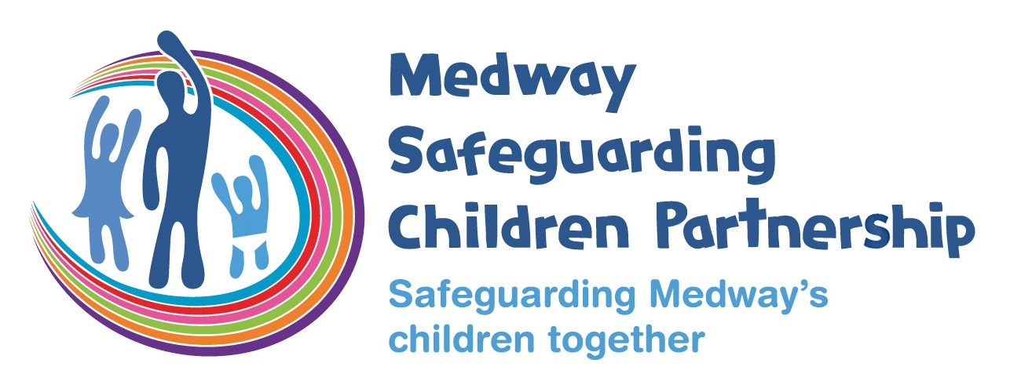
Medway Safeguarding Children Partnership
Gun Wharf, Dock Road, Chatham Kent ME4 4TR
Phone: 01634 336329
Email: mscp@medway.gov.uk
Training queries: 01634 332256
Training email: mscptraining@medway.gov.uk
www.medwayscp.org.uk

NSPCC Campaign – Share aware
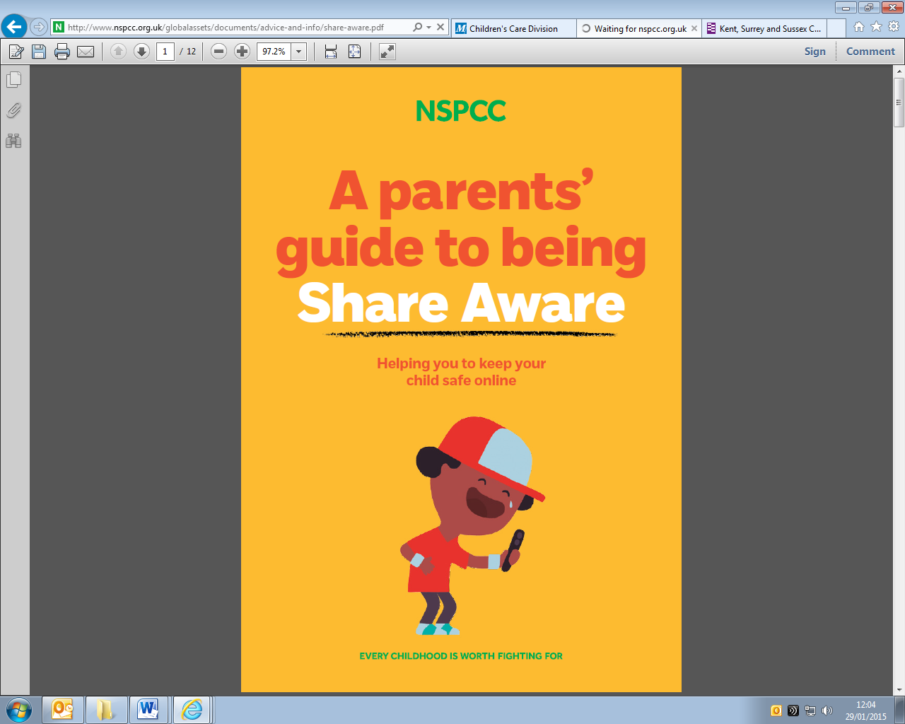
Medway Children’s Improvement Plan Update

The Medway Children’s Improvement Plan has now been refreshed and updated. The Plan on a Page is below. If you would like A4 copies of the full plan document, please e-mail Sue Brunton-Reed, Head of Improvement at: sue.bruntonreed@medway.gov.uk

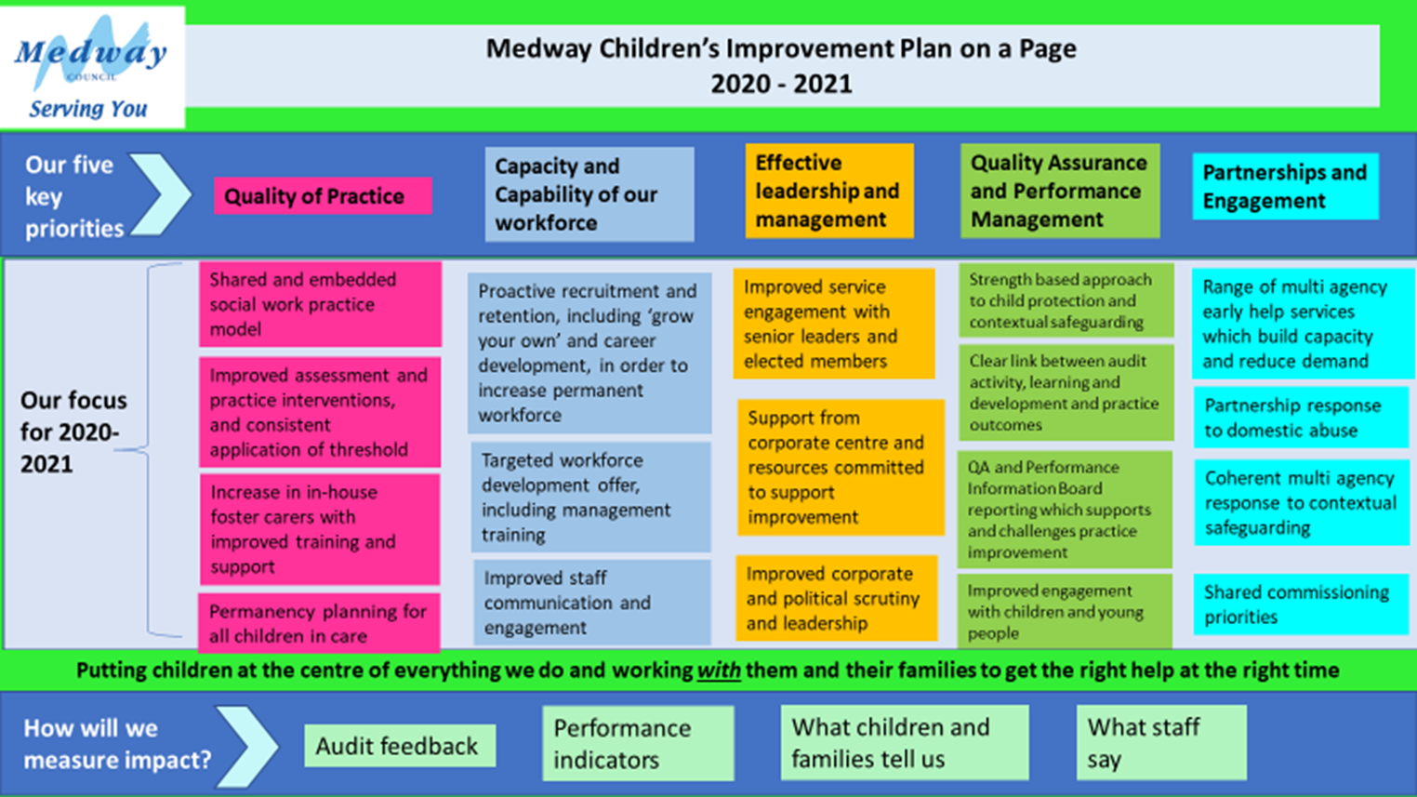

Medway Children’s Services will continue to have a real focus on the quality of their practice, particularly assessments, plans and interventions, and will work with all their partners to develop their early help services, services in relation to domestic abuse, and contextual safeguarding. Their practice model, Signs of Safety, will underpin all their interventions.

Their other key focus of activity will be on building the capacity and capability of their workforce as they know that moving to a more permanent workforce, who are supported and can develop their skills, will be essential to the success of their improvement plan. A new and updated Workforce Development Strategy will support this area of the improvement plan.

Ofsted Monitoring Visits

Ofsted will be starting their programme of Monitoring Visits again from August and the first Monitoring Visit is scheduled for the 20th and 21st August. The focus of this visit will be on the assessment service, and the interface with early help and child in need plans. This is an opportunity to evidence the real progress made over the last year

